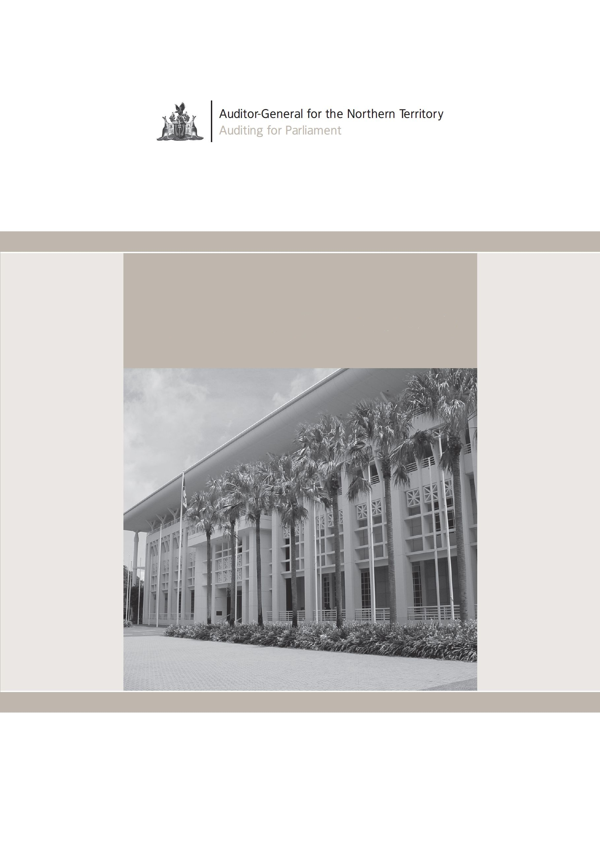
Annual Report
2012 – 2013

Contents
Foreword | 3
Purpose of the report | 4
The role of the Auditor-General | 6
Relationship between the Auditor-General and the Legislative Assembly | 7
The NTAGO as an Agency | 8
The NTAGO’s Internal Resources | 8
Authorised Auditors | 8
The activities of the NTAGO | 9
Provision of audit and other assurance services | 10
Financial Statement audits | 10
Compliance audits | 11
Audits of Information Technology Systems | 11
Performance Management Systems | 11
Allocation of NTAGO resources between classes of audit | 12
The auditing process – the service delivery relationship | 15
Our governance framework | 16
Reviewing the performance of our Authorised Auditors | 17
Overview of the NTAGO’s Financial Performance for the Year | 18
How was the Office funded during the year and how were those funds applied? | 19
Compliance with legislation | 20
Reporting against Employment Instructions | 21
The Office’s insurance arrangements | 22
Environmental policies | 22
Equal employment opportunity | 22
Work health and safety | 23
Table of Figures | 25
Appendix A – Summary Financial Statements | 27

Foreword
This page deliberately left blank.
It is my pleasure to present the annual report of the Northern Territory Auditor-General’s Office (NTAGO) for the year ended 30 June 2013.
The Office is exempt from the normal requirements to submit an annual report to the Legislative Assembly. However, the preparation of a summary document such as this offers the opportunity to outline the performance of the NTAGO for the year.
The Office’s activities are governed largely by Acts of Parliament that require the Auditor-General to conduct audits of what is known as the Public Account, and of statutory bodies and corporations established by legislation. Statutory audits required by legislation were completed in line with the requirements of the various Acts, but the level of audit work conducted across the General Government Sector continued to contract in response to declines in the real levels of output revenue appropriated by the Legislative Assembly in recent years.
The level of resources available to the NTAGO has become a matter of concern and it is an issue that will need to be pursued actively during 2013-14.

Purpose of the report
The purpose of this annual report is to provide interested readers with a picture of the operations and performance of the Northern Territory Auditor-General’s Office (NTAGO) for the year ended 30 June 2013.
The annual reporting requirements of the NTAGO differ from those of other public sector entities. The Audit Act requires the Auditor-General to report to the Legislative Assembly at least once in each financial year. That requirement is generally satisfied by the submission of reports that outline the results of audits and such other matters as considered by the Auditor-General to be relevant to the Legislative Assembly. Two reports were submitted to the Speaker during the year (in October and March) for tabling in the Legislative Assembly. These publications are available from our web site.
In addition, the Audit Act also requires that the audited accounts of the NTAGO be tabled in the Legislative Assembly each year. Summarised financial statements for 2012-13 are included in Appendix A.
Given the requirements of the Audit Act and bearing in mind the “arms-length” relationship between the Auditor-General and the Executive, the Public Sector Employment and Management (Exemption) Regulations exempt the Auditor-General from the requirement to submit an annual report to the Minister.
Notwithstanding the legislative provisions governing reporting by the NTAGO, it is important to ensure that those who may have an interest in the overall activities of the NTAGO should receive information on the performance of the Office. This report is the vehicle through which that information is disseminated.

Our mission
To contribute to the Legislative Assembly’s scrutiny of the performance of government administration by providing independently analysed and credible information derived from audits of financial information, internal controls, and performance management systems of the Northern Territory public sector.

Our vision
Be recognised as effective and efficient in identifying and analysing issues of substance about the performance of Northern Territory government administration, and in so doing encouraging improvement in public administration practices.

Our desired outcomes
- Better informed Members of the Legislative Assembly.
- Better informed Agency managers.
- Improved public understanding of public sector performance.
- Increased attention within the Northern Territory public sector to:
  - accuracy of financial information;
  - timeliness of financial and performance information;
  - compliance with internal control and other governance requirements; and
  - implementation of performance management systems and reporting of performance information.
- Assurance about the credibility of information contained in statutory financial reports prepared by public sector entities.

The role of the Auditor-General
The role of the Auditor-General is set out in section 13 of the Audit Act. The Act requires the Auditor-General to audit the Public Account and other accounts (including the accounts of a Territory controlled entity) in such manner as he or she thinks fit having regard to the character and effectiveness of internal control and recognised professional standards and practices. The Act also permits the Auditor-General to conduct audits of performance management systems and it requires the Auditor-General to carry out audits as may be directed by the Minister, either generally or specifically, by an instrument in writing.

Relationship between the Auditor-General and the Legislative Assembly
The Auditor-General is appointed by the Administrator and is deemed to be an officer of the Crown. Nevertheless the Act does require the Auditor-General to submit a report to the Legislative Assembly at least once in each year.
The process through which the Auditor-General reports to the Legislative Assembly establishes a relationship between the Legislative Assembly and the Auditor-General, through the activities of the Public Accounts Committee. The Committee has, as part of its role, the scrutiny of Auditor-Generals’ reports and the Committee is the Auditor-General’s principal point of access to the Legislative Assembly.
The Auditor-General’s concerns are a reflection of his or her mandate under the Audit Act and can be summarised as:
- Accountability – have entities given full and accurate accounts of their activities and of their compliance with the Legislative Assembly’s intentions through the annual reporting cycle and are governance and management arrangements suitable to address the concerns identified above?
- Authority – have activities, resourcing and accountability requirements been undertaken within the authority granted by the Legislative Assembly?
- Probity and Financial Prudence – are entities meeting parliamentary and public expectations of an appropriate standard of behaviour in the public sector?
In the discharging of functions under the Act, the Auditor-General is assisted by the Northern Territory Auditor-General’s Office, an Agency established pursuant to the provisions of the Financial Management Act.

The NTAGO as an Agency
The NTAGO is established as an Agency under Administrative Arrangements Orders and in this capacity it is subject to the same legislative requirements that apply to other Agencies. Thus while the Auditor-General may be independent in terms of performing the functions set down under the Audit Act, he or she is answerable to the Chief Minister for the stewardship of the public resources provided to the NTAGO.

The NTAGO’s Internal Resources
The Office has a staffing compliment of five positions, two Executive Contract officers, one senior administrative officer position, and two administrative officer positions. The Auditor-General and the Principal Auditor positions are responsible for managing contracts with Authorised Auditors, for ensuring the Office’s audit plans are adhered to and for conducting a number of audits. The administrative function is responsible for managing the human resources, information technology, records management, work health and safety, financial services and general office functions.

Authorised Auditors
In addition to its internal resources, the NTAGO works closely with a number of private sector firms, from which Authorised Auditors are drawn, to achieve the Auditor-General’s mandate. Authorised Auditors are appropriately qualified and experienced persons who are appointed by the Auditor-General pursuant to section 17 of the Audit Act.
Authorised Auditors were drawn from the following Darwin-based firms during the year:
- BDO;
- Deloitte;
- KPMG;
- Merit Partners; and
- TDH Chartered Accountants.

The activities of the NTAGO
As with any organisation, the NTAGO operates in an environment of increasing costs. Those increases are driven by the promulgation of new accounting standards, increasing “black letter” content in auditing standards and increasing costs for Authorised Auditors. The first two elements affect the planning and conduct of audits and result in increased hours being required to complete audits at a professional standard, while the third element increases the cost per audit hour.
Figure 1 highlights the trend of total audit expenses compared to output revenue received. The graph highlights that the overall expenses incurred in conducting audits has increased steadily over time at a higher rate than output revenue appropriated by the Legislative Assembly. Over the 7 years from 2006-07 to 2012-13 audit costs increased at an average annual rate of 3.4% compared with the growth in Output Revenue of 0.94% for the same period. The growth in the auditing expenses reflects a range of factors including growth in authorized auditors’ hourly rates and an increase in the number of entities that comprise the public sector.
Figure 1 – Audit expenses compared to output revenue
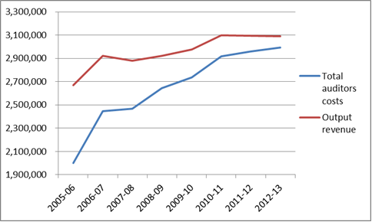

The activities of the NTAGO cont…
One effect of the decline in the real value of output revenue has been the need to direct an increasing proportion of output revenue to meet overhead expenses, most of which are fixed in the short to medium term. As a response to earlier funding shortfalls the NTAGO implemented a limited cost recovery initiative that saw the costs of audits recovered from entities that lie outside the Public Account. While that initiative has been useful, the value of those revenues has been eroded progressively by efficiency dividends with the result that operating losses have emerged over the past four years accompanied by operating cash flow deficits. One response to this has been the provision by the Central Holding Authority to the NTAGO of equity injections intended to maintain the NTAGO’s equity position. That approach, while appreciated, has not addressed the underlying issue of the NTAGO’s budget base.

Provision of audit and other assurance services
The Office conducts a range of audit activities on behalf the Legislative Assembly. During 2012-13, 108 separate audits were undertaken (2011-12: 105 audits), requiring 18,135 audit hours (2011-12: 16,442 audit hours).

Financial Statement audits
This class of activity relates to the Auditor-General’s statutory duty to carry out audits of financial statements prepared by the Treasurer, statutory bodies, Government Business Divisions and Government Owned Companies. Also included in this category are audits of funding acquittals prepared by agencies generally for submission to the Commonwealth.
Financial statement audits lead to two main outputs:
- An audit report that is addressed to readers of the financial statements. It provides the auditor’s opinion on whether the financial statements fairly reflect the financial performance and position of the entity being audited. In cases where the Auditor-General is satisfied that the information contained in a set of financial statements is reliable, an unqualified opinion is issued. However, if a material error or omission should be identified in the financial statements or if the financial statements depart from Australian Accounting Standards, a qualified opinion is issued.
- A management letter that is addressed to the board of a statutory body or a corporation, or the Accountable Officer of an Agency, as the case may be. The management letter sets out any significant issues identified by the auditor during the audit and provides recommendations for improving the entity’s controls, systems and processes.

The activities of the NTAGO cont…

Compliance audits
The accounts of Agencies are generally not audited thus no audit opinion is issued on their annual financial statements. Agencies are viewed as an aliquot part of the Northern Territory Government, with their financial information being audited as part of the audit of the Treasurer’s Annual Financial Statement. Given this, Agency compliance audits are performed by the NTAGO to establish the extent to which Agencies have implemented systems that enable compliance with the prescribed financial management and accountability requirements. Compliance audits also include reviews of selected internal control systems.

Audits of Information Technology Systems
All organisations depend to varying degrees upon information technology to hold data and to generate information intended to meet the needs of a range of users. Audits were undertaken during the year to assess the system controls in place with a view to forming opinions about the integrity of data held in systems and the reliability of information generated from those systems. These audits were undertaken as part of either financial or compliance audits and the hours incurred are included in either of these classes.

Performance Management Systems
Performance management system audits were conducted at the Departments of Health and Housing, Local Government and Regional Development.

The activities of the NTAGO cont…

Allocation of NTAGO resources between classes of audit
The allocation of the NTAGO’s resources between various classes of audit (as measured by actual payments to Authorised Auditors) for 2012-13 is summarised in Figure 2.
Figure 2 – Audit hours by audit type (% of total hours)
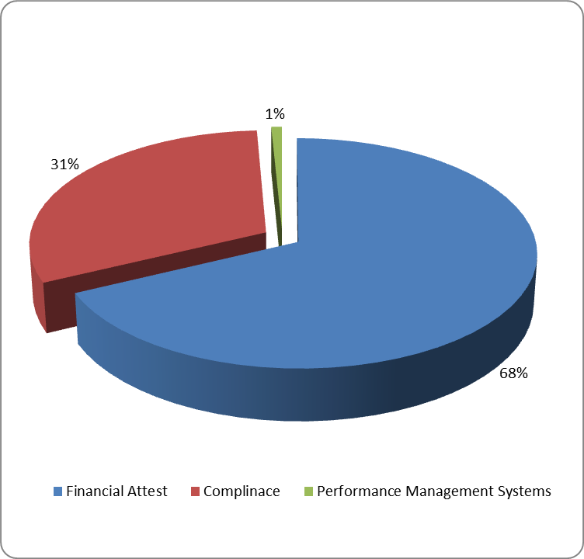

The activities of the NTAGO cont…
The trend in the total of audit hours committed to all classes of audit is shown at Figure 3.
Figure 3 – Comparison of total annual audit hours committed
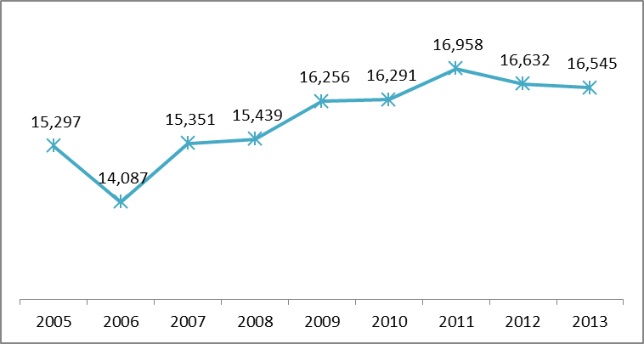
The Office’s level of activity for the past four years, as measured by its outputs, is illustrated in Figure 4 and shows the level of audit activity ended 30 June 2013 as measured by the number of completed audits.
Figure 4 – Comparison of total number of new audits commenced
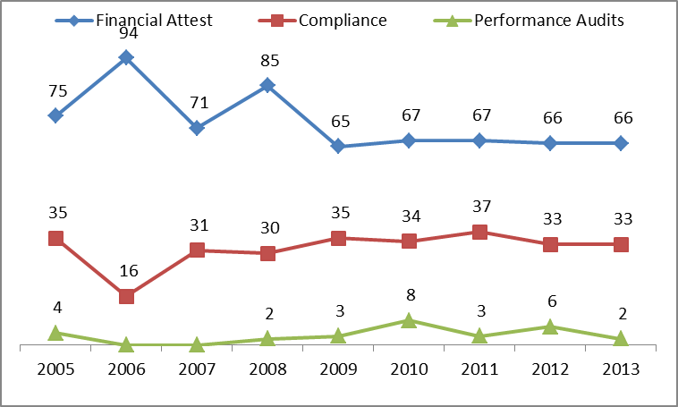

The activities of the NTAGO cont…
Figure 5 highlights the costs per annum of the audits committed during the respective year, based on the actual costs for the year.
Figure 5 – Comparison of total costs per annum
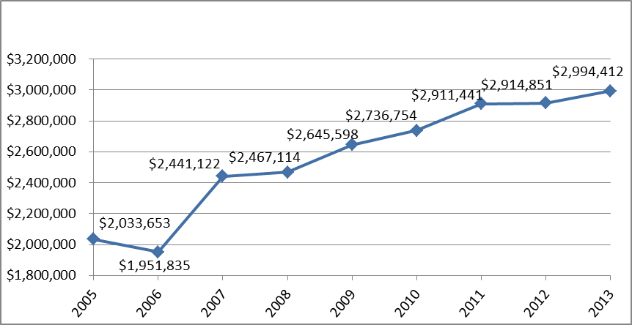
Figure 6 highlights the weighted averages costs per annum of the audits during the respective period.
Figure 6 – Weighted average cost per audit hour
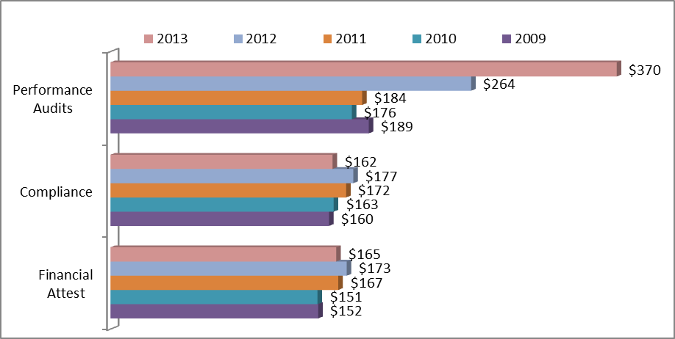

The auditing process – the service delivery relationship
There is a close working relationship between the NTAGO and the private sector Authorised Auditors. NTAGO staff work collaboratively with the Auditor-General to undertake planning, prepare guidelines for individual audit assignments, provide information and technical support, manage the contracts with the Authorised Auditors and conduct a limited number of “in-house” audits.
The majority of field audit work is undertaken by the Authorised Auditors and they prepare the necessary working papers, draft reports, opinions and management letters for review by the Auditor-General and his staff. The responsibility for the content of correspondence to Agency managers and for reports submitted to the Legislative Assembly rests solely with the Auditor-General.
The heavy reliance upon private sector firms recognises the difficulties in recruiting appropriately qualified and experienced public sector auditors in a small jurisdiction and in providing suitable opportunities for career development. However, the approach adopted does allow the Office to take advantage of the significant pool of private sector audit experience that is available.
For 2012-13 the expense incurred by the Office in having private firms provide audit services amounted to $3.0 million from Authorised Auditors. This figure is comparative to the previous year cost of $2.9 million for the 2011-12 period.
The relationship between the number of hours acquired from Authorised Auditors and the cost incurred by the NTAGO is affected by several factors. For example, the relative weighting between partners, managers and audit seniors can vary between audits, depending upon the nature and complexity of the audit in question. At the same time, the types of audits undertaken will also affect the mix of audit skills employed. For example financial, information technology or specialist insurance auditors may be used depending upon the nature of the audit and this, in turn, affects that average hourly cost of any particular audit.

Our governance framework
Good corporate governance is intended to assist an organisation to achieve its outcomes and obligations through planning, decision-making and risk management.
The Office’s corporate governance framework is intended to ensure the efficient use of resources, compliance with statutory and other external requirements, adherence to sound administrative and financial management practices and provides the framework within which the Auditor-General is accountable:
- to the Legislative Assembly for the discharge of the responsibilities allocated under the Audit Act, including the ways by which the strategies and goals of the Office are set, promoted and achieved; and
- to the Chief Minister for the stewardship of resources entrusted to the NTAGO.
These obligations are discharged through:
- Submission of reports to the Legislative Assembly each year, setting out the results of audits, together with any observations that may be relevant.
- Appearances by the Auditor-General before the Public Accounts Committee during which the Committee has the opportunity to question the Auditor-General and their other staff about the content of reports to the Legislative Assembly, and current and planned audits.
- Annual appearances before the Estimates Committee during which the Committee has the opportunity to question the Auditor-General about the activities of the NTAGO.
- Annual financial reporting. The annual financial reports of the NTAGO are audited by an auditor appointed by the Administrator, and the audited reports are tabled in the Legislative Assembly. An unqualified audit opinion on the NTAGO’s financial statements was issued for 2012-13 and a summary of those statements are included at Appendix A to this report.
Section 26 of the Audit Act requires a strategic review of the NTAGO to be conducted at least once every three years. The terms of reference and the appointment of the reviewer are recommended by the Chief Minister to the Administrator, after consultation with the Public Accounts Committee and the Auditor General.
The review was conducted during this financial year.

Our governance framework cont…

Reviewing the performance of our Authorised Auditors
Authorised Auditors are appointed under contracts for periods of three years. The current contract covers the period 1 January 2012 to 31 December 2014.
Authorised Auditors are subject to annual performance appraisals by the Auditor-General and as part of that process the Authorised Auditors also provide an assessment of the performance of the Auditor-General and the NTAGO.
The NTAGO has issued two manuals that define the working relationship between Authorised Auditors and the NTAGO. These are:
- the Audit Contract Management Manual which sets out the contractual arrangement between the NTAGO and Authorised Auditors, including qualifications and experience for appointment, and standard operating procedures; and
- the Audit Handbook that outlines the types of audits that are conducted and the standards that are to be applied when conducting audits.
The processes for the management of audits generally consists of:
- The issue of Audit Task Assignment forms (ATA’s) and audit guidelines to Authorised Auditors by the NTAGO. These documents set the scope and cost of audit tasks, together with guidelines on how the task should be conducted.
- The provision to the NTAGO of weekly progress reports by Authorised Auditors on the status of tasks relative to the completion of the audit.
- The provision of comments by the NTAGO following the completion of the review of audit working papers following the completion of each audit task.
- A formal two-way review of performance standards achieved by the contract auditors and the NTAGO. This process commences at the end of each calendar year and concludes early in the following year.

Our governance framework cont…

Overview of the NTAGO’s Financial Performance for the Year
The financial performance of the NTAGO for 2012-13, resulted in a deficit of $254,655 compared with a deficit of $153,719 for the prior year. The principal contributors to the operating result were increased expenses from the use of Authorised Auditors with post-implementation reviews of asset management systems having a significant effect, together with an increase in employment expenses, coupled with small reductions in output revenue and recoveries of audit expenses.
As in past years, the largest source of revenue of the NTAGO has been output revenue that is appropriated by the Legislative Assembly pursuant to annual Appropriation Act. Output revenue represented 80 per cent of the total income of the NTAGO for 2012-13, unchanged from the prior year, while audit costs recovered represented 15 per cent, also unchanged from the prior year.

How was the Office funded during the year and how were those funds applied?
The sources of funds available to the Office and the ways in which the funds were applied for the year were as follows:
Figure 7 – Source of funds
Source of funds | $'000
Output Revenue | 3,090
Recoveries of audit costs | 574
Goods received free of charge | 220
Equity injection | 170
Increase in payables | 152
Increase in non-current provisions | 18
Decrease in prepayments | 8
Total Source | $4,232

and those funds were applied as follows:
Figure 8 – Application of funds
Application of funds | $'000
Operating expenses | 4,138
Decrease in payables | 63
Decrease in other provisions | 31
Total Application | $4,232

As can be seen from the above table, the largest sources of funds for the year were revenues received as part of output appropriation and recoveries of audit costs. Also notable was the increase in the cash balances of $63,000 attributable to the Office (as noted in the Statement of Cash Flows at Appendix A) and which as a result of an equity injection of $170,000 at 30 June 2013.

Compliance with legislation
The NTAGO complied with the provisions of the Information Act throughout the year insofar as that Act affected the Office. Section 49A of the Act exempts the Office from requests for information obtained or created as a result of an audit. Information held by the NTAGO is mainly derived from the conduct of audits and this information is specifically exempted from this disclosure requirement of the Information Act.
Employment Instructions issued pursuant to the Public Sector Employment and Management Act provide direction to agencies on human resource management matters. The NTAGO’s performance against each instruction is outlined below.

Compliance with legislation cont…

Reporting against Employment Instructions
The NTAGO provides information through its report to the Commissioner for Public Employment against the Employment Instructions. A summary of our results are included below:
Figure 9 – Employment Instructions
Employment Instruction | Agency Requirement/Action
No. 1 (& 9). Advertising, Selection Appointment, Transfer and Promotion.  No. 2. Probation  No. 5. Medical Incapacity.  No. 6. Inability to Discharge Duties.  No. 7. Discipline.  No. 8. Grievances. | The Office incorporates the requirements of the NTG policies and procedures within its own internal policies for these Employment Instructions. During the reporting period, there were no changes or adjustments to positions or any action required against any of these Employment Instructions.
No. 3. Natural Justice. | Staff have access to information about the principles of natural justice. The Office incorporates these principles into its internal code of conduct.
No. 4. Performance Management. | The Office has a focus on training and development to meet the CPD requirements for the professional positions. One of the administrative positions is participating in a higher education program. The other administrative position receives day-to-day training and other training to assist in the performance of their role within the agency. The employees meet regularly with the Auditor-General both on an ad-hoc basis as well as regular-timed sessions to discuss performance and commitments. Information is contained within the induction process for new employees.
No. 10. Employee Records. | The Office commenced processes to incorporate EDRM in 2011-12 and continued this year. Records will be progressively stored electronically rather than paper based files.
No. 11. Equal Employment Opportunity.  No. 12. Occupational Health and Safety.  No. 14. Part-Time Employment. | See below.

Compliance with legislation cont…

The Office’s insurance arrangements
In November 2008, a Treasurer’s Direction issued pursuant to the Financial Management Act required all Agencies to include insurance related information in their annual reports. The Office had no insurance claims for the year and the ongoing risks are considered to be low.

Environmental policies
The Office is developing records policies and procedures intended to encourage a progressive shift to “paperless” administration. In pursuit of this objective the Office has continued to introduce changes during the year to promote the use of electronic records.

Equal employment opportunity
The NTAGO has an Equal Opportunity Management Policy which also incorporates the following:
- Work Life Balance – The NTAGO attempts to provide opportunities for staff to take advantage of work life balance principles. Staff members are encouraged to access training and study opportunities, and to explore opportunities for flexible work arrangements that take account of family and study commitments. Staff are also encouraged to participate and contribute to the Office’s day to day operating objectives and directions.
This policy has assisted administrative staff to:
- work part-time while completing professional qualifications; and
- work part-time to assist in meeting the needs of a young family.

Compliance with legislation cont…

Work health and safety
The Office incorporates the NTG policies and procedures into own operating procedures. Office staff participate in information workshops and meetings arranged by the NTG WH&S unit with other government Agencies. The NTAGO conducts weekly discussions during staff meetings with regard of WH&S and any associated matters. WH&S matters are recorded in the minutes of weekly staff meetings.
During this reporting year, there were no accidents or risks identified. In accordance with the Treasurer’s Directions for Insurance Reporting (R2.1 – Insurance Arrangements), due to the low risk that accompanies the NTAGO’s activities, the agency has self-assessed as being of low risk and, accordingly, no commercial insurance is considered necessary.

This page deliberately left blank.

Table of Figures

Figure 1 – Audit expenses compared to output revenue | 9
Figure 2 – Audit hours by audit type (% of total hours) | 12
Figure 3 – Comparison of total annual audit hours committed | 13
Figure 4 – Comparison of total number of new audits commenced | 13
Figure 5 – Comparison of total costs per annum | 14
Figure 6 – Weighted average cost per audit hour | 14
Figure 7 – Source of funds | 19
Figure 8 – Application of funds | 19
Figure 9 – Employment Instructions | 21

Appendix A – Summary Financial Statements
This page deliberately left blank.

This page deliberately left blank.

Northern Territory Audit-General’s Office
Comprehensive Operating Statement
 | 2013 | 2012
 | $’000 | $’000
Income
Appropriation
Output | 3,090 | 3,094
Sales of goods and services | 574 | 590
Goods and services received free of charge | 220 | 191
Total income | 3,884 | 3,875
Operating expenses
Employee expenses | (811) | (784)
Administrative expenses
Purchases of goods and services | (3,107) | (3,053)
Repairs and maintenance | - | (1)
Other administrative expenses | (220) | (191)
Total expenses | (4,138) | (4,029)
Net surplus / (deficit) | (254) | (154)
Other comprehensive income
Changes in accounting policies | - | -
Changes of prior period errors | - | -
Total other comprehensive income | - | -
Comprehensive result | (254) | (154)

Northern Territory Audit-General’s Office
Balance Sheet
 | 2013 | 2012
 | $’000 | $’000
Current assets
Cash and deposits | 247 | 184
Receivables | 241 | 209
Prepayments | - | 8
Total current assets | 488 | 401
Liabilities
Current liabilities
Payables | (207) | (55)
Provisions | (114) | (98)
Total current liabilities | (321) | (153)
Non-current liabilities
Provisions | (56) | (53)
Total non-current liabilities | (56) | (53)
Total liabilities | (377) | (206)
Net assets | 111 | 195
Equity
Capital | 370 | 200
Accumulated funds | (259) | (5)
Total equity | 111 | 195

Northern Territory Audit-General’s Office
Statement of Changes in Equity
 | Equity at  1 July | Comprehensive Result | Transactions with owners in their capacity as owners | Equity at  30 June
2012-13 | $’000 | $’000 | $’000 | $’000
Accumulated Funds | (5) | (254) | - | (259)
Capital - Transactions with Owners
Equity Injections
Capital Appropriation | 26 | - | - | 26
Equity Transfers In | 53 | - | - | 53
Other Equity Injections | 431 | - | 170 | 601
Total Equity Injections | 510 | - | 170 | 680
Equity Withdrawals
Capital Withdrawals | (310) | - | - | (310)
Total Equity Withdrawals | (310) | - | - | (310)
Total Capital - Transactions with Owners | 195 | (255) | 170 | 111
2011-12
Accumulated Funds | 149 | (154) | - | (5)
Capital - Transactions with Owners
Equity Injections
Capital Appropriation | 26 | - | - | 26
Equity Transfers In | 53 | - | - | 53
Other Equity Injections | 431 | - | - | 431
Total Equity Injections | 510 | - | - | 510
Equity Withdrawals
Capital Withdrawals | (310) | - | - | (310)
Total Equity Withdrawals | (310) | - | - | (310)
Total Capital - Transactions with Owners | 349 | (154) | - | 195

Northern Territory Audit-General’s Office
Statement of Cash Flows
 | 2013 | 2012
 | $’000 | $’000
Cash flows from operating activities
Appropriation - Output | 3,090 | 3,094
Receipts from sales of goods and services | 535 | 610
Equity injection | 170 | -
GST Received | 316 | 303
Payments to employees | (793) | (778)
Purchase of Goods and Services | (2,948) | (3,098)
GST Paid | (307) | (309)
Net cash from operating activities | 63 | (178)
Cash at beginning of financial year | 184 | 362
Cash at end of financial year | 247 | 184

