Our Purpose – To assist Parliament in the oversight of the performance of the Northern Territory Government by providing independent analysis through the conduct of audits and reviews

Auditing for Parliament
August 2022
Report to the
Legislative Assembly
Northern Territory
Auditor-General’s Office
https://ago.nt.gov.au

Contact Details
Northern Territory Auditor-General’s Office
Level 9
22 Mitchell Street
Darwin, Northern Territory 0800
GPO Box 4594
Darwin, Northern Territory 0801
+61 8 8999 7155

We continually strive to improve our communication to our stakeholders and invite you to provide feedback on this report via our email address NT.Audit@nt.gov.au.
ORDERED TO BE PRINTED BY THE
LEGISLATIVE ASSEMBLY
OF THE
NORTHERN TERRITORY
ISSN 1323-7128

August 2022 Report
to the Legislative Assembly

Contents
 | Page
Transmittal Letter to the Speaker | 5
Auditor-General’s Overview | 6
Financial Statement Audits
Charles Darwin University | 8
Bridging the Gap Foundation Limited | 14
Charles Darwin University Foundation | 18
Cobourg Peninsula Sanctuary and Marine Park Board | 22
Menzies School of Health Research | 26
Nitmiluk (Katherine Gorge) National Park Board | 30
Performance Management System Audits
Grant Management | 34
IT Audits
NAB Transact Banking | 55
Operations and Service Management | 59
Systems Change Control | 62
Compliance Audits
Agency Compliance Audit | 65
Data Analysis
Compliance with Travel Policy | 72
Public Information Act | 83
Appendices
Appendix 1: The Role and Responsibilities of the Auditor-General | 86
Appendix 2: Guide to Using this Report | 86
Appendix 3: Audit Opinions Issued | 94
Appendix 4: Status of Audit Activity | 96
Appendix 5: Proposed Audit Activity in the Six Months Ending 31 December 2022 | 97
Appendix 6: Abbreviations | 98
Appendix 7: Agencies not subject to audit relating to the year ended 30 June 2022 | 99
Contents by Entity | 100

The Honourable Speaker of the Legislative
Assembly of the Northern Territory
Parliament House
Darwin NT 0800

30 August 2022

Dear Mr Speaker,
Accompanying this letter is my report to the Legislative Assembly on matters arising from audits, reviews and assessments completed during the five months ended 31 July 2022 and I request that you table the report in the Legislative Assembly.
This report presents the results of financial statements audits completed during the period. Two performance management system audits designed to test the adequacy of performance management systems relating to grant management were completed and the findings included in this report.
This report contains a summary of findings from agency compliance audits conducted at 16 agencies and the results of analysis of travel data across government.
The report also presents the findings from audits of information technology systems that were undertaken to assess whether access to those systems together with controls over data maintained within such systems were adequate.
Yours sincerely,

Julie Crisp
Auditor-General for the Northern Territory

Auditor-General’s Overview

Summary of this Report
This report outlines the results of 29 separate audits and other tasks completed during the period 1 March 2022 to 31 July 2022. This report summarises the results of the following types of audits and legislated tasks conducted during the period:
- Statutory Audits of Financial Statements;
- Controls and Compliance Audits;
- Information Technology Systems Audits;
- Performance Management Systems Audits; and
- Data Analysis.
The report presents the results of audits that were performed to assess the adequacy of selected aspects of controls over accounting and material financial transactions at 16 Northern Territory Government agencies. Findings arising from these audits have been reported to the affected agencies to enable them to address control weaknesses as required. Agency Compliance Audits are undertaken in accordance with Section 13 of the Audit Act 1995 and provide support to the audit of the Treasurer’s Annual Financial Statement.
Also included are the results of audits of financial statements for seven entities where the audits were completed prior to 31 July 2022 and the results have not been previously reported.
The report contains findings from an analysis of data pertaining to travel across 15 government controlled entities.
Three audits were undertaken in relation to controls supporting across government information technology systems and the results included in this report.
Agencies and entities are provided with the opportunity to comment on any of the matters reported in relation to their audit results. Where they choose to do so, their responses are detailed at the end of the relevant section.
The Audit Act 1995 provides a legislative requirement for the Auditor-General to report to the Legislative Assembly on at least an annual basis. This is the first report provided for tabling within the Legislative Assembly for the year ending 30 June 2023. The last report was tabled during March 2022.
A number of audits scheduled to be completed prior to 30 June 2022 are still to be completed. The outcomes of these audits (listed in Appendix 4) will be presented in future reports to the Legislative Assembly.

Reports on the Results of Audits, Reviews and Assessments

Charles Darwin University

Audit Findings and Analysis of the Financial Statements for the Year Ended 31 December 2021

Background
Charles Darwin University (the University) is established under the Charles Darwin University Act 2003. The University controls the following entities:
- Menzies School of Health Research (Menzies) including the Bridging the Gap Trust; and
- Charles Darwin University Foundation, a company limited by guarantee and which acts as trustee of the Charles Darwin University Foundation Trust.
The financial results of Menzies are consolidated within the financial statements of the University. The financial results of the Charles Darwin University Foundation Trust are also consolidated into the financial statements of the University.
The University provides both higher education and vocational education and training (VET). Higher education funding is provided to the University by the Commonwealth Government through direct grants and through the proceeds of student loans under the auspices of the HECS-HELP Scheme. VET funding is provided by the Northern Territory Government (NTG) through monies appropriated by the Legislative Assembly through the Department of Industry, Tourism and Trade.
The University is required by its enabling Act to prepare financial statements as at 31 December each year and to submit those statements to the Auditor-General by 31 March each year.

Scope and Objectives
The objective of the audit was to complete sufficient audit procedures to enable an opinion to be expressed upon the financial statements of the University for the year ended 31 December 2021.

Audit Opinion
The audit of the University for the year ended 31 December 2021 resulted in an unmodified independent audit opinion, which was issued on 27 May 2022.
Charles Darwin University cont…

Audit Observations
The audit did not identify any material weaknesses in internal controls.

Performance Overview
The University (parent entity only) generated a net profit for the year ended 31 December 2021 of $62.2 million (2020: $42.8 million). The increase in profit was predominantly due to an increase in Australian Government funding (aligned to the increase in domestic student numbers) and an increase in other Northern Territory Government (NTG) grants. The significant movements between the reported results for the year ended 31 December 2021 when compared to the prior financial year are:
- Australian Government Grants revenue increased by $20.5 million reflecting the increase in domestic student numbers.
- NTG Financial Assistance revenue increased by $31.1 million mainly due to grant revenue of $45 million for the Education Community Precinct project.
- Fees and charges decreased by $7.2 million consistent with the reduction in VET students of 14%.
- Other revenue in the prior year included gifted land with a value of $14.3 million. No similar gift was received in the current year, consequently other revenue decreased by $15.9 million from the prior year.
- Employee related expenses decreased by $2.4 million as there were recruitment restrictions associated with COVID-19 and a reduction in staff levels.
- Other expenses increased by $5.4 million as a result of grant payments to Menzies during the year.
- Materials expenses increased by $3.1 million due to student related expenses.
The University (parent entity only) had a net asset position of $625.7 million as at 31 December 2021 in comparison to a net asset position of $549.5 million as at 31 December 2020. The following significant movements were observed:
- Cash increased by $58.3 million mainly due to the favourable net result for the year as explained above.
- Other non-current financial assets increased by $23.5 million mainly reflecting the increase in the market value of the IDP Education Limited shares.
- Other liabilities increased by $14.6 million due to increased income received in advance.
At a consolidated level, the Group generated a net profit of $64.4 million (2020: $44.7 million) and recorded net assets of $661.0 million (2020: $582.6 million). The individual results of each of the entities consolidated within the Group are analysed separately within this report.
Charles Darwin University cont…

Discontinued Operations
On 30 September 2021, the Directors of the Charles Darwin University Foundation as trustee for the Charles Darwin University Foundation Trust resolved that the Charles Darwin University Foundation and Charles Darwin University Foundation Trust be dissolved. In accordance with the Trust Deed, the Directors resolved that the remainder of the Trust funds will be transferred to Charles Darwin University. At the time of the audit, this transfer was expected to take place in the first half of 2022.
The University will need to ensure that the transfer of the Trust funds, which may carry obligations to external parties, is managed appropriately.

Underpayment issue
During 2021, the University contracted Clayton Utz to conduct an internal audit of selected payroll transactions covering the period 1 January 2015 to 30 December 2020. The internal audit assessed the University’s compliance with its obligations under relevant industrial instruments in order to determine whether any underpayments of entitlements for casual staff had occurred. The resultant internal audit report found 12 instances of non-compliance and two conditionally compliant findings.
The University has conducted a further review of payments made to casual employees based on underpayment claims received. Based on this review, the University believes that there are underpayments due to non-payment of minimum engagement periods. The initial estimate of the underpayment over a six-year period is between $2 million and $4 million. A project has now been established to perform a detailed review of historical records to determine the liability for underpayments more accurately and to rectify the issue.
Charles Darwin University cont…

Financial Performance for the year
 | 2021 | 2020
 | $’000 | $’000
Revenue from continuing operations
Financial assistance and grants from the Commonwealth | 143,031 | 125,718
Financial assistance from the Northern Territory Government | 56,536 | 19,492
Fees and charges | 96,484 | 103,642
Other revenue (HECS, fees, interest) | 41,547 | 59,453
Total revenue from continuing operations | 337,598 | 308,305
Less expenses from continuing operations
Employee expenses | (158,477) | (160,916)
Administration, operational and other expenses | (116,936) | (104,583)
Total expenses from continuing operations | (275,413) | (265,499)
Surplus | 62,185 | 42,806

Charles Darwin University cont…

Financial Position at year end
 | 2021 | 2020
 | $’000 | $’000
Cash and cash equivalents | 174,333 | 116,011
Receivables and other current assets | 34,044 | 15,108
Less current liabilities | (114,322) | (97,079)
Working capital | 94,055 | 34,040
Add non-current assets | 535,491 | 520,742
Less non-current liabilities | (3,896) | (5,335)
Net assets | 625,650 | 549,447
Represented by:
Restricted and accumulated funds | 267,758 | 295,477
Reserves | 357,892 | 253,970
Equity | 625,650 | 549,447

Charles Darwin University cont…
Charles Darwin University has commented:
In relation to the casual underpayment, the University wishes to note that this is an issue that has occurred across the sector and has been fully reported to Fair Work Australia. The University has since made changes to its processes around timesheets and casual salaries calculations to stop future underpayment errors from occurring. The University has communicated with staff and unions around the issue. The project to identify the casual staff affected and the amount of underpayment is underway.

Bridging the Gap Foundation Limited

Audit Findings and Analysis of the Financial Statements for the Year Ended 31 December 2021

Background
Bridging the Gap Foundation Limited (the Foundation) is a company limited by guarantee. The Foundation is a fundraising arm of the Menzies School of Health Research and is a controlled entity of the University within the meaning of section 41 of the Charles Darwin University Act 2003.
The Foundation’s purpose is to support and assist Menzies School of Health Research, Charles Darwin University and other such organisations in the health, research and education sectors and to encourage and foster the interest and financial support of those persons and organisations interested in assisting and promoting these entities.

Scope and Objectives
The objective of the audit was to complete sufficient audit procedures to enable an opinion to be expressed upon the financial statements of the Foundation for the year ended 31 December 2021.

Audit Opinion
The audit of the Foundation for the year ended 31 December 2021 resulted in an unmodified independent audit opinion which was issued on 31 March 2022.

Audit Observations
The audit did not identify any material weaknesses in internal controls.

Performance Overview

Financial Analysis
The Foundation recorded a deficit of $25,758 (2020: surplus of $151,618).
The Foundation reported total income of $624,166 (2020: $1,558,901) derived from grant funding and donations received during the period. The decline in income results from there being only one grant agreement with the Commonwealth Department of Health in the year ended 31 December 2021, whereas there were two grant agreements in 2020.
Total expenses includes disbursement of grant payments in 2021 of $450,000 (2020: $1,407,283). The decrease in grant payments is consistent with the reduced receipt of grant funding. The year ended 31 December 2021 included donations of $198,982, primarily for scholarships at the Menzies School of Health Research (2020: Nil).
As at 31 December 2021, the Foundation’s net assets comprised cash of $121,695 (2020: $151,703) and trade receivables of $4,250 (2020: Nil). There were no payables recorded in either year.
As the Foundation reported a deficit of $25,758 for the year ending 31 December 2021 (2020: surplus of $151,703) and had negative operating cash flows of $30,008 for the 2021 financial year (2020: positive operating cash flows of $22,975), I recommended that the Foundation monitors its cash flows closely to ensure any going concern risks are adequately mitigated.
Bridging the Gap Foundation cont…

Financial Performance for the year
 | 2021 | 2020
 | $’000 | $’000
Grant income | 450 | 1,407
Donations and interest | 174 | 152
Grant expense | (450) | (1,407)
Donations expense | (199) | -
Other | (1) | -
(Deficit)/surplus | (26) | 152

Bridging the Gap Foundation cont…

Financial Position at year end
 | 2021 | 2020
 | $’000 | $’000
Cash and cash equivalents | 122 | 152
Receivables and other current assets | 4 | -
Less current liabilities | - | -
Working capital | 126 | 152
Add non-current assets | - | -
Net assets | - | -
Represented by:
Retained earnings | 126 | 152
Contributed sum | - | -
Equity | 126 | 152

Bridging the Gap Foundation cont…
Bridging the Gap Foundation has commented:
Bridging the Gap Foundation Limited acknowledges the summary of findings and audit recommendation, and will carefully monitor cash flows to ensure any going concern risks are adequately mitigated.

Charles Darwin University Foundation

Audit Findings and Analysis of the Financial Statements for the Year Ended 31 December 2021

Background
The Charles Darwin University Foundation (the Foundation) is a company limited by guarantee that acts as trustee of the Charles Darwin University Foundation Trust (the Trust). The Foundation incurs liabilities on behalf of the Trust and discharges those liabilities out of the assets of the Trust.
The Foundation and the Trust were established as the fundraising arm of Charles Darwin University (the University) and both are controlled entities of the University within the meaning of section 41 of the Charles Darwin University Act 2003.
The purpose of the Foundation is to enhance the relationship between the University and the wider Northern Territory community, and to raise funds for the University. In pursuit of this objective, the Foundation seeks donations and other contributions while also providing assurance to donors that bequests and donations will be applied in accordance with the wishes of the testator or donor.

Scope and Objectives
The objective of the audit was to complete sufficient audit procedures to enable an opinion to be expressed upon the financial statements of the Foundation and the Trust for the year ended 31 December 2021.

Audit Opinion
The audits of the Foundation and Trust for the year ended 31 December 2021 resulted in unmodified independent audit opinions for both entities, which were issued on 10 May 2022.

Audit Observations

Going Concern Assumption
The financial statements of the Foundation and the Trust have been prepared under a realisation basis to reflect that the going concern assumption is not appropriate as the Directors have resolved to dissolve the Foundation and the Trust in their current form. Assets and liabilities in the Foundation and the Trust have been consequently measured on a realisation basis.
My audit reports included an emphasis of matter to draw attention to the relevant financial statement disclosures in relation to the alternative basis of accounting.

Attendance at Directors’ meetings
Corporate records show that one Director did not attend either of the two Directors’ meetings held during the financial year. I recommended consideration be given to clause 13 (d) of the Constitution to ensure that an appropriate ‘special leave of absence’ was granted to avoid any perception that the Director has not fulfilled their fiduciary obligations.
Charles Darwin University Foundation cont…

Financial Analysis
The Trust’s total income (excluding changes in the fair value of investment property) decreased from $869,708 in 2020 to $618,874 in 2021. The decrease was mainly attributable to reduced donations and investment income.
Total expenses of the Trust decreased from $1,684,794 in 2020 to $672,167 in 2021. In the previous year student COVID-19 hardship payments of $68,000 were paid. No similar payments were made during 2021. The Jai Sing Clock Tower project, to which $130,000 was directed in 2020, was completed during the prior year. Scholarship payments to attract indigenous students paid from the Alicia Johnson Memorial fund and the Kingsland Jackson Indigenous Scholarship fund decreased by $40,000 from the prior year.
The Trust recorded a deficit of $53,293 in 2021 (2020: $815,086 deficit).
The Trust reported a marginal increase in net assets from $5,245,249 in 2020 to $5,253,707 in 2021 reflecting a $74,000 increase in financial assets and investment property and a $66,000 decrease in cash and cash equivalents.

Cash donations
The Trust has determined that it is impractical to establish control over the collection of cash donations received ‘over the counter’ prior to entry of the donation onto its financial records. My understanding is that the only control regarding cash donations received is that donors generally request a receipt for tax purposes, however, this is not always the case.
As the evidence available to me regarding revenue from this source was limited, my audit procedures with respect to over the counter cash donations had to be restricted to the amounts recorded in the financial records. As the number of individual cash donations made to the Trust is not significant, I determined that it was not necessary to issue a modified audit opinion in relation to completeness of revenue.
Charles Darwin University Foundation cont…

Financial Performance for the year
 | 2021 | 2020
 | $’000 | $’000
Revenue | 599 | 905
Increase/(decrease) in market value of investment property | 20 | (35)
Trust donations disbursed | (670) | (1,664)
Donations in kind – operational | (2) | (20)
Other | - | (1)
Deficit | (53) | (815)

Charles Darwin University Foundation cont…

Financial Position at year end
 | 2021 | 2020
 | $’000 | $’000
Cash and cash equivalents | 630 | 696
Receivables and other current assets | 4,624 | 4,106
Less current liabilities | - | -
Working capital | 5,254 | 4,802
Add non-current assets | - | 443
Net assets | 5,254 | 5,245
Represented by:
Investment revaluation reserve | 236 | 174
Retained surplus, including Trust donation balances | 5,018 | 5,071
Total trust funds | 5,254 | 5,245

Cobourg Peninsula Sanctuary and Marine Park Board

Audit Findings and Analysis of the Financial Statements for the Year Ended 30 June 2021

Background
The Cobourg Peninsula Sanctuary and Marine Park Board (Cobourg) was formed in 1981 under the Cobourg Peninsula Aboriginal Land, Sanctuary and Marine Park Act 1981 to acknowledge and secure the right of Aboriginals to occupy and use certain land on the Cobourg Peninsula, to vest that land in trust for Aboriginals, to declare that land to be a national park, to make provisions relating to the management of adjacent marine areas and related purposes.

Scope and Objectives
The objective of the audit was to complete sufficient audit procedures to enable an opinion to be expressed upon the financial statements of the Cobourg Peninsula Sanctuary and Marine Park Board for the year ended 30 June 2021.

Audit Opinion
The audit of the Cobourg Peninsula Sanctuary and Marine Park Board for the year ended 30 June 2021 resulted in an unmodified independent audit opinion, which was issued on 21 June 2022.

Audit Observations

Key Findings

Governance practices within the Board require improvement.
The Board met once in the financial year ended 30 June 2021 and no Board meetings were held in the financial year ended 30 June 2020. As the Board met only once during the 2021 financial year, this may suggest that the Board has not effectively discharged its duties as prescribed by the Cobourg Peninsula Aboriginal Land, Sanctuary and Marine Park Act 1981.
During the November 2021 Board meeting, it was agreed that the Board would waive banteng bull animal fees totalling $26,100. The $26,100 relates to a debt receivable from a related party. In the November 2020 Board meeting, the Board waived banteng bull animal fees totalling $87,000, of which $29,100 was receivable from an entity entirely owned by a Board member.
There was a large discrepancy between the value of receivables agreed to be waived by the Board (as recorded in the minutes of the Board Meeting held on 22 November 2021), and the value recorded as waived in the financial statements. Personnel at the Department of Environment, Parks and Water Security (who provide financial and governance services to the Board) advised, ‘The information they [the Directors] are using as receivable balance in the meeting is incorrect and includes invoices from FY17 – we have informed our Board liaison officer about the error in the numbers used in the minutes and they are aware of the actual $69,600 receivable balance that is being waived’. The Board were not provided with accurate financial information as a basis for decision making relating to related party waivers which impaired the ability of the Board to make effective and accurate decisions.
Cobourg Peninsula Sanctuary and Marine Park Board cont…

Receivable impairment
Information presented for audit demonstrated that a conflict of interest, relating to a waiver of receivables, was not appropriately mitigated. It is the responsibility of the Board to demonstrate that appropriate steps have been put in place to ensure that conflicts of interest have been successfully identified and managed.

Processes to ensure the completeness of income could be enhanced
As reported in my management letters to the Board relating to the audits of the financial years ending 30 June 2017, 2018, 2019 and 2020, the Board’s processes to ensure the completeness of income are insufficient.
The Board relies on tour operators to provide concessionaire returns outlining the royalties they owe to Cobourg. There were no internal audits undertaken by the Board on these concessionaire returns and the tour operators do not provide audited concessionaire returns to provide assurance that the figures provided are accurate and complete.
The Board responded to my findings with ‘In response to the same audit issue being raised in the 2019-20 Financial Statements, the Department developed and implemented the Parks and Wildlife – Commercial Operator Reporting Procedure to address the risk of completeness of income. This was implemented in August of 2021 hence requiring this audit issue to be noted for the 2020-21 financial year.’
The new processes will be revisited during future audits.

Delays in preparation of financial statements
The Cobourg Peninsula Aboriginal Land, Sanctuary and Marine Park Act 1981 requires the Board to prepare a report of operations within 6 months of year end. Initial information was not provided for audit until January 2022, some six months after the end of the financial year.
On 18 December 2021, the Acting Minister for Parts and Rangers approved an extension for the submission of the 2020/21 Financial Statements to 31 March 2022. On 7 April 2022, the Minister for Parks and Rangers approved an extension for the submission of the 2020/21 Financial Statements to 31 May 2022.

Performance Overview
Cobourg reported a surplus of $84 thousand compared to prior year’s deficit of $42 thousand. The movement of $126 thousand is attributed to:
- A $52 thousand increase in park income (2021: $318 thousand, 2020: $266 thousand) demonstrating revenue returning to normal pre-COVID-19 levels after the 2020 financial year park income decreased from the 2019 financial year by $76 thousand.
- Payments to Traditional Owners reducing by $150 thousand (2021: $183 thousand, 2020: $333 thousand) reflecting the reduction associated with the $69 thousand write off and a decrease in other revenue resulted from Crocodile Egg Royalties reducing from $109 in 2020 to $0 in 2021.
- Operational costs and other revenue consist of $148 thousand in charges from the Department of Environment, Parks and Water Security (who provide financial and governance services to the Board). As the services are free of charge, the recorded income and expense offset each other.
Cobourg Peninsula Sanctuary and Marine Park Board cont…

Financial Performance for the year
 | 2021 | 2020
 | $’000 | $’000
Income
Park income | 318 | 266
Payments to Traditional Owners | (183) | (333)
Other revenue | 149 | 195
Total income | 284 | 128
Expenditure
Operational costs | (200) | (170)
Total expenditure | (200) | (170)
Surplus/(deficit) | 84 | (42)

Cobourg Peninsula Sanctuary and Marine Park Board cont…

Financial Position at year end
 | 2021 | 2020
 | $’000 | $’000
Cash and cash equivalents | 320 | 335
Receivables and other current assets | 111 | 45
Less current liabilities | (77) | (110)
Working capital | 354 | 270
Add non-current assets | - | -
Less non-current liabilities | - | -
Net assets | 354 | 270
Represented by:
Accumulated funds | 354 | 270
Equity | 354 | 270

Menzies School of Health Research

Audit Findings and Analysis of the Financial Statements for the Year Ended 31 December 2021

Background
The Menzies School of Health Research (the School) was established under the Menzies School of Health Research Act 1985 and operates as a medical research institute within the Northern Territory. The School is deemed to be controlled by Charles Darwin University by virtue of section 11(1) of the Menzies School of Health Research Act 1985 which, at the time of the audit, specified that the Vice-Chancellor of the University will be a member of the School’s Board, and that five Board members, but no more than nine Board members, will be appointed by the Council of Charles Darwin University.

Scope and Objectives
The objective of the audit was to complete sufficient audit procedures to enable an opinion to be expressed upon the financial statements of the Menzies School of Health Research for the year ended 31 December 2021.

Audit Opinion
The audit of the Menzies School of Health Research for the year ended 31 December 2021 resulted in an unmodified independent audit opinion, which was issued on 19 May 2022.

Audit Observations
The audit did not identify any material weaknesses in internal controls.

Performance Overview
The School recorded a surplus of $2.3 million in the current year (2020: surplus of $1.0 million). The increase of approximately $1.3 million has been influenced by an increase of $10.9 million in total income, partially offset by an increase in total expenditure of $9.7 million.
The increase in revenue resulted from:
- An increase in funding from the Commonwealth National Health and Medical Research Council of $6.4 million and increased activity from active projects during the current year following COVID-19;
- An increase in funding from other Commonwealth Government agencies of $1.2 million, mainly from the Department of Health;
- An increase in Northern Territory Government funding of $1.0 million, being the recognition of funds received in the previous financial year as income under AASB 15 Revenue from Contracts with Customers and AASB 1058 Income of Not-for-Profit Entities; and
- An increase in consultancy and contract research income of $2.4 million.

Menzies School of Health Research cont…
The increase in expenditure resulted from:
- An increase of $4.7 million in direct research costs, largely due to the return of a research grant received of $3.8 million following the transfer of a Senior Researcher to the University of Queensland;
- An increase of $3.1 million in employee related expenses due to increased project activity; and
- An increase of $1.4 million in other expenses, the majority of which relates to $0.5 million in overseas salaries as a result of increased project activity in Timor-Leste.
Menzies School of Health Research cont…

Financial Performance for the year
 | 2021 | 2020
 | $’000 | $’000
Income
Financial assistance from the Commonwealth | 23,099 | 15,433
Financial assistance from the Northern Territory Government | 6,570 | 5,563
Other revenue | 26,980 | 24,725
Total income | 56,649 | 45,721
Less expenditure
Employee expenses | (31,559) | (28,415)
Administration, operational and other expenses | (22,816) | (16,292)
Total expenditure | (54,375) | (44,707)
Surplus | 2,274 | 1,014

Menzies School of Health Research cont…

Financial Position at year end
 | 2021 | 2020
 | $’000 | $’000
Cash and cash equivalents | 11,002 | 16,670
Receivables and other current assets | 60,737 | 44,944
Less current liabilities | (43,298) | (34,953)
Working capital | 28,441 | 26,661
Add non-current assets | 2,183 | 1,948
Less non-current liabilities | (620) | (867)
Net assets | 30,004 | 27,742
Represented by:
Reserves | 435 | 779
Retained earnings | 29,569 | 26,963
Equity | 30,004 | 27,742

Nitmiluk (Katherine Gorge) National Park Board

Audit Findings and Analysis of the Financial Statements for the Year Ended 30 June 2021

Background
The Nitmiluk (Katherine Gorge) National Park Board (Nitmiluk) was formed in 1989 under the Nitmiluk (Katherine Gorge) National Park Act 1989 to acknowledge and secure the rights of those Aboriginals who are the traditional owners of certain land in the Northern Territory of Australia, and certain other Aboriginals, to occupy and use that land, to establish a National Park comprising that land [to be known as the Nitmiluk (Katherine Gorge) National Park] and to provide for the management and control of that Park and certain other land and for related purposes.

Scope and Objectives
The objective of the audit was to complete sufficient audit procedures to enable an opinion to be expressed upon the financial statements of Nitmiluk (Katherine Gorge) National Park Board for the year ended 30 June 2021.

Audit Opinion
The audit of the Nitmiluk (Katherine Gorge) National Park Board for the year ended 30 June 2021 resulted in an unmodified independent audit opinion, which was issued on 23 March 2022.

Audit Observations

Key Findings

Reporting of related party transactions
A number of Board members had not provided Related Party Disclosures – Declaration Forms by the date the financial statements were signed by the Board. Australian Accounting Standards require the financial statements to disclose transactions during the financial year between the reporting entity and those individuals charged with governance (the Board). Whilst most declarations were received prior to me issuing the audit opinion, two Board members have left the Board since the reporting date without providing a completed declaration. This presents a risk that the information pertaining to related party transactions, as disclosed in Note 9 to the financial statements, is not complete.

Processes to ensure the completeness of income could be enhanced
As reported in my management letters to the Board relating to the years ending 30 June 2017, 2018, 2019, 2020 and 2021, the Board’s processes to ensure the completeness of income are insufficient.
The Board relies on tour operators to provide concessionaire returns outlining the royalties they owe to Nitmiluk. There were no internal audits undertaken by the Board on these concessionaire returns and the tour operators do not provide audited concessionaire returns to provide assurance that the figures provided are accurate and complete.
Nitmiluk (Katherine Gorge) National Park Board cont…
The Board responded with ‘In response to the same audit issue being raised in the 2019-20 Financial Statements, the Department developed and implemented the Parks and Wildlife – Commercial Operator Reporting Procedure to address the risk of completeness of income. This was implemented in August of 2021 hence requiring this audit issue to be noted for the 2020-21 financial year.’
The new processes will be revisited during future audits.

Performance Overview
The Board reported a net surplus of $0 in line with the prior year as all revenue is used to pay operational expenses and the remaining revenue is distributed as payments to Traditional Owners and the Department of Environment, Parks and Water Security.
The following key movements were observed:
- A $75 thousand increase in park income (2021: $318 thousand, 2020: $266 thousand) demonstrating revenue returning to normal pre-COVID-19 levels after the 2020 financial year park income decreased from the 2019 financial year by $246 thousand.
- Payments to Traditional Owners increasing by $54 thousand from the prior year and payments to the Department of Environment, Parks and Water Security increasing by $21 thousand from the prior year consistent with the increase in revenue.
- Other revenue and operational costs represent $149 thousand in financial and governance services received free of charge from the Department of Environment, Parks and Water Security and offset each other.
Total receivables of $450 thousand (2020: $18 thousand) increased from the prior year by $432 thousand. The increase in receivables is attributable to fees for April, May and June from Nitmiluk Tours and Helicopter Tours being outstanding at year end.
The increase in total payables is equivalent to the movement in receivables.
Nitmiluk (Katherine Gorge) National Park Board cont…

Financial Performance for the year
 | 2021 | 2020
 | $’000 | $’000
Income
Park income | 826 | 751
Less payments to Traditional Owners | (520) | (466)
Less payments to the Department of Environment, Parks and Water Security | (306) | (285)
Other revenue | 149 | 173
Total income | 149 | 173
Expenditure
Operational costs | (149) | (173)
Total expenditure | (149) | (173)
Surplus | - | -

Nitmiluk (Katherine Gorge) National Park Board cont…

Financial Position at year end
 | 2021 | 2020
 | $’000 | $’000
Cash and cash equivalents | - | -
Receivables and other current assets | 450 | 18
Less current liabilities | (450) | (18)
Working capital | - | -
Add non-current assets | - | -
Less non-current liabilities | - | -
Net assets | - | -
Represented by:
Accumulated funds | - | -
Capital | - | -
Equity | - | -

Grant Management

Selected Agencies

Background

Whole of Government Grants Framework
The Northern Territory Government Grants Policy (the NTG Grants Policy) outlines the financial management and accountability framework for grant payment arrangements entered into by Northern Territory Government (NTG) agencies.
Figure 1: NTG Grants Framework
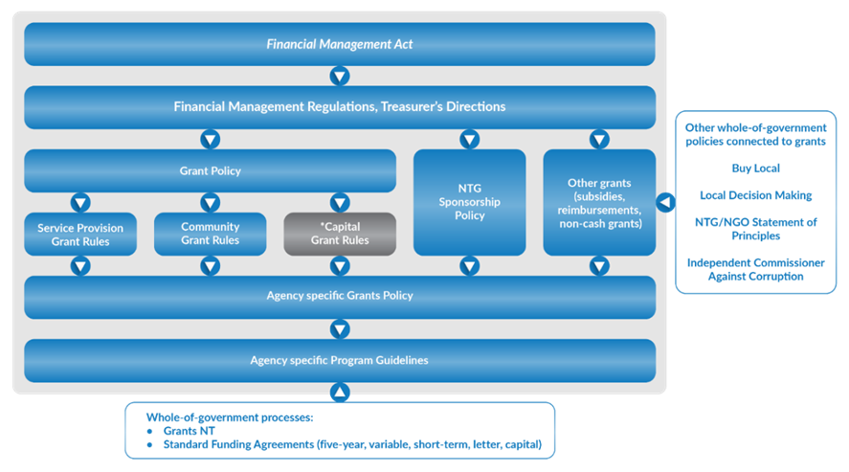
Source: Northern Territory Government Grant Policy, January 2021.
Under the Financial Management Act 1995, NTG agencies are mandated to comply with the Treasurer’s Directions. The Department of Treasury and Finance is responsible for the development and maintenance of these Directions. The Treasurer’s Direction specifically governing grants management was revoked in August 2021, and replaced by the Guidance document: Grants and subsidies expense. As a guidance document, compliance with its contents is not mandatory.
The NTG Grants Policy, developed by the Department of the Chief Minister and Cabinet (DCMC), establishes the overarching principles that are to be applied for three of the five types of grants provided by NTG, those three types being service provision, community and capital grants.
Compliance with the NTG Grants Policy is mandatory for all NTG agencies.
Agencies are individually responsible for the management of grants. This responsibility includes the development and implementation of policies, procedures and processes supporting business operations related to the payment and administration of grants as well as the development and implementation of supporting systems (both technology-based and ‘manual’ systems).

NTG Grant Management IT System
The NTG Grants Policy also mandates the use of GrantsNT (a technology-based information system) for all cash-based grants.
Grant Management cont…
GrantsNT was developed, and is currently managed, by the Department of Corporate and Digital Development (DCDD). GrantsNT can be used by NTG agencies and grant applicants/recipients for the management of grant funding activities. Client agencies are charged a fee to use the system under the current Shared Services arrangements with DCDD.
GrantsNT is designed to support an agency’s end-to-end grant management process via an online platform, enabling:
- publication of content in a grants directory;
- online application forms;
- configurable assessment steps;
- capture of awarded funding details and acceptance of agreements;
- payments through the Government Accounting System interface;
- online acquittals and progress and performance reporting; and
- records management capability, meaning grant related documents are no longer required to be saved in Territory Records Manager.
Additional resources are provided by DCDD to client agencies to assist users. These include:
- access to internal agency system administrators;
- training on GrantsNT system configuration and system management;
- the ability to provide feedback and insights to the GrantsNT User Group; and
- access to the NTG intranet page providing information on user roles, workflows, request forms and security structures.

Prior Grant Audits
In May 2018, the Northern Territory Auditor-General’s Office completed an audit on the performance management systems at the former Department of Corporate and Information Services (DCIS), now DCDD, on the processes and systems in place that enable it to manage the design and implementation of the across government GrantsNT system.
The May 2018 audit demonstrated that DCIS had developed a robust performance management system to enable it to manage the design and implementation of the across government GrantsNT system. The audit identified some opportunities to further enhance the performance management system.
The audit findings were reported in my August 2018 Report to the Legislative Assembly, together with the following recommendations:
- centralise grant management for all NTG agencies;
- develop clearly defined process and responsibilities to support the implementation of GrantsNT;
- establish processes that allow visibility of grants information between agencies;
- establish standard processes and controls to be used within each agency;
- ensure controls are in place to verify the completeness and accuracy of grants paid in the general ledger;
Grant Management cont…
- enhance monitoring and reporting;
- improve the strategic alignment of grant outputs with agency outcomes; and
- improve documentation.
The audit recognised that the financial value of the benefits of implementing the GrantsNT system was unable to be fully captured, instead benefits will be measured from a business perspective in terms of improving operational efficiency through automation of key processes and consolidation of grants within a single system.

Scope and Objectives
This audit concentrated on the performance management systems to manage grants issued by the NTG through assessing:
- whether the across government GrantsNT system managed by DCDD is being supplied and supported effectively in a way that will assist NTG agencies to achieve their stated outcomes; and
- the systems in place at Territory Families, Housing and Communities (TFHC) which enable management to assess whether grant funding provided to external parties is being applied effectively, with regard to efficiency and economy, and in a way that will assist the Agency to achieve its stated outcomes.
The audit reviewed processes in place during the period from 1 July 2020 to 30 September 2021.

Index
The report on this audit is structured as follows:
Audit Opinion | 37
Recommendations | 37
Audit Observations | 39
Whole of Government Framework | 39
Whole of Government IT System | 40
Update on GrantsNT Implementation | 40
Ongoing Management | 42
On-Charging for Shared Services | 44
Grant Management at THFC | 48
Grant Objectives | 48
Policy and Procedures | 51
Grants System | 52
Reporting and Reconciliation | 52
Testing | 53
Grant Management cont…

Audit Opinion
A considerable amount of work has been undertaken to implement the whole of government grants framework and a centralised grants management system. The central and operational agencies need to continue to work together to ensure all the benefits of a centralised system and framework are realised. The use of a single grants management system is intended to reduce the costs across government, improve oversight and enhance management of progress towards outcomes.
The audit identified that there are opportunities to enhance the processes and controls supporting the across government GrantsNT system to better assist NTG agencies to achieve their stated outcomes as they pertain to grant funded activities. As the central agency responsible for the across government system, the responsibility for considering and implementing such enhancements primarily rests with DCDD.
In relation to the assessment of the performance management systems in place at TFHC that enable management to assess whether grant funding provided to external parties is being applied effectively, with regard to efficiency and economy, and in a way that will assist the Agency to achieve its stated outcomes, the audit identified that the Agency could implement improvements to its existing processes and controls. I acknowledge the impacts of machinery of government changes in September 2020 that saw grant programs and associated personnel from three separate agencies brought into TFHC. Personnel at TFHC were being governed by three separate Accounting and Property Manuals and processes until August 2021, when the Agency released an Agency specific Handbook. At the time of the audit, TFHC was still implementing new processes.

Recommendations
Opportunities to improve the grants management system and processes are presented below.
In relation to the whole of Government Grants Framework and Systems:
- Ensure there is adequate and appropriate oversight of the strategic direction, development and broader across government adoption of GrantsNT.
- Improve communication of grants management information and feedback between central and operational agencies relating to grants management services provided.
- Ensure the Agency continues to seek information that enables assessment of the extent to which grants are not being managed and recorded in GrantsNT and identify the reasons agencies have for not using GrantsNT. Assess the advantages and disadvantages of expanding the functionality of GrantsNT with a view to enabling all grants to be recorded in and managed through GrantsNT.
- Ensure there is effective collaboration between those central agencies with responsibility for supporting grants management. Use the existing Steering Committee to identify and prioritise action necessary to ensure all central grant services, including the rules and templates, are finalised and implemented as soon as practicable. Introduce a process to review and update the NTG Grant Policy and supporting documents currently used by agencies in order to achieve more streamlined and transparent grants administration processes and in turn improved reporting and targeting of grant programs for government. Whilst the audit processes were undertaken at DCDD and TFHC, DCMC, as the owner of the NTG Grants Policy, has a central agency role.
- Perform a formal program evaluation of the implementation of GrantsNT to assess the extent to which the outcomes intended from developing and implementing GrantsNT were met.
Grant Management cont…
I made the following recommendations intended to enhance the provision and understanding of Shared Services:
- Improve the GrantsNT related Service Statement to provide users with a clear and concise understanding of the services that will be delivered. A robust Service Statement needs to adequately define the services to be provided and expected service levels (output and performance levels) and would ensure:
- Services are clearly and concisely defined with defined outputs.
- Key performance indicators and standards are attributed to each service.
- There is a clear link between the service and the cost charged.
I further recommended consideration be given to enabling clients to identify any listed services they do not require and will be unlikely to need in the future which may enable DCDD to identify and downsize service offerings accordingly.
- Identify the total cost of providing grant services as a shared service including the identification of indirect costs. Identifying the total cost of delivering a service enables assessment of the extent to which a service is being delivered economically and efficiently. Where a high level of resources is committed with limited achievement of outcomes, independent assessment may determine that the resources would have yielded greater benefit if invested elsewhere. I recognise the process of collating / determining and allocating costs will be refined over time and recommended the process be extended to include an assessment of actual costs against outcomes and outputs is performed as part of the program evaluation process.
- Perform a robust review of the on-charging methodology on an annual basis to ensure the actual costs incurred are recovered. The current misalignment between actual cost incurred and cost recovered is a result of the selected cost driver not directly influencing the cost. Regular analysis of actual costs will assist in determining how efficiencies could be obtained rather than simply recovering the actual cost on an annual basis. This might involve identification of services offered by DCDD that are not required by client agencies.
- Improve transparency in the Pricing Model by including sufficient detail for clients to understand and evaluate the charges and invoiced costs. In the absence of a clear nexus between the services provided and the costs charged, client agencies are unable to effectively monitor and control the costs they are invoiced. Regular review of the cost allocation method will help ensure the appropriateness of the assumptions and the cost drivers utilised.
- Review the Pricing Model annually and, if required, update the Pricing Model in a timeframe that is consistent with the NTG budget cycle to ensure agencies’ budgeted figures are current and accurate.
- Improve accessibility and information provided on invoices to client agencies to enable them to verify and validate the fees they are being charged and enable identification of areas where efficiencies could be gained.
Grant Management cont…
The following recommendations from the audit were directed at the systems and processes at the operational agency level:
- Improve clarity of requirements in the Corporate Services Handbook (equivalent to an Accounting and Property Manual) to ensure agency personnel adhere to the grant management procedures. Improvements could include: specifying regular review of the requirements within the Handbook; including supporting process flowcharts, checklists and templates; providing additional guidance on managing conflicts of interest and managing instances of non-conformance to the terms of grant agreements; and the establishment of quality assurance checks and reviews.
- Enhancements to the existing performance management systems could include identifying minimum skill requirements for employees tasked with grant management and the development of internal sharing knowledge platforms, employee training plans and training registers.
- Reconciliation of grant information between the GrantsNT system and the government accounting system to be performed on a regular basis to ensure the accuracy and completeness of grants recorded. This process could be supported by the development of work instructions and templates.
- Consider key areas where grant management could benefit from the implementation of quality assurance checks/reviews performed to ascertain a grant recipient’s compliance with key grant requirements.
- Ensure the processes for identifying and managing conflicts of interest are consistently applied across different sections of the agency. Management would then need to communicate to and educate agency employees on the agreed processes. Robust internal controls would also require regular review to ensure compliance with the processes.
- Undertake regular reviews of user access to GrantsNT to ensure that users have appropriate access privileges aligned to their roles.
- Ensure the NTG wide Program Evaluation Framework is consistently applied to grant funded activities and that the required resources are available to individuals tasked with managing grant funded programs.
- Management establish and communicate an expected time period to close off grants. Compliance with the target could then be monitored on a regular basis.
- Ensure grants are managed in the dedicated GrantsNT system and not in Microsoft Excel or other applications.

Audit Observations

Whole of Government Framework
Key recommendations from the audit of grants management conducted by my Office in May 2018 included the development of centralised policy, processes, systems and templates across all NTG agencies to assist in achieving a more streamlined and transparent grants administration processes resulting in improved reporting and targeting of grant programs for government.
The NTG Grant Policy was implemented in February 2019 by DCMC with mandatory applicability across government.
Grant Management cont…
The NTG Grant Policy includes additional guidelines for service provision (developed in January 2021) and community grants (developed in August 2021). At the time of this audit, the capital grant rules, referred to in Figure 1, were not developed.
The NTG Grant Policy requires a number of established rules and templates to be used by agencies in order to achieve more streamlined and transparent grants administration processes and in turn improved reporting and targeting of grant programs for government. Not all of the rules and templates had been developed at the time of this audit.
Testing identified that links to websites included in the NTG Grant Policy no longer worked at the time of this audit.
Without the required guidelines, rules, templates and websites being available to support personnel when applying the NTG Grant Policy, inconsistent practices will eventuate. Once inconsistent practices are established, it can be difficult to realign them in the future.
Interviews undertaken as part of the audit produced the following feedback in relation to the NTG Grants Policy:
- The information provided in the NTG Grants Policy does not contain enough detail to provide all procedures and templates for grants maintained by the agency.
- The NTG Grants Policy does not specify what the Agency should do in situations where a grant recipient becomes insolvent, or there has been mismanagement of funds.
- Several templates listed in the NTG Grants Policy have not yet been developed and personnel have experienced difficulty accessing the existing templates.
- Linkages to external documentation, such as the evaluation framework and toolkit, is located within footnotes and therefore it is not easy to navigate and some links do not work.
The NTG Grants Policy was updated in January 2022, however the updated document was not reviewed as part of this audit.

Whole of Government IT System
DCDD maintains a centralised corporate services delivery model to support the day-to-day operations of all government agencies. One of the functions of DCDD is the day-to-day administration and management of the GrantsNT system. This responsibility lies with a dedicated GrantsNT Support Team comprising four fulltime equivalent personnel within the Across Government Systems business unit. Assistance is also received from the Operations Centre (the DCDD central service that triages calls to the system analysts).

Update on GrantsNT Implementation
The GrantsNT development project (the Project) commenced in 2014. Under the Project, agencies were initially scheduled to migrate onto GrantsNT from September 2018 based on a staged approach. This transition commenced in November 2018 and was completed in July 2021.
Once an agency was provided access, it was that agency’s responsibility to transfer each grant into GrantsNT with the understanding that this would happen over a period of time rather than all at one point in time.
Grant Management cont…
At the time of the audit, alternative systems continued to be used by agencies who assert that GrantsNT does not have the functionality to record all grants issued across government or all grant transactions. As an example, one NTG agency currently uses both a licensed web-based software application called ‘Smarty Grants’ and GrantsNT for the administration of grant application, assessment and approval processes. The Smarty Grants application has been used by this agency since 2014 as it had third party grant functionality. Third party grant functionality is where the applicant for the grant is not the recipient of the grant funding.
The functionality of GrantsNT was enhanced during 2021 enabling sport voucher and third party grant functionality. Further enhancement to the system capability is continuing with the addition of the development of community benefit fund functionality.
At the time of this audit, TFHC was finalising the transfer of grants previously held in Grants Tracker (an ‘off the shelf’ grants management system) and Microsoft Excel to GrantsNT. In 2020/21, 93 of 213 grants had payments made outside of GrantsNT totalling $120,273,206. This included eight repayments of unspent grants ($432,495) and two recoveries of overpaid grants ($4,280).
DCDD staff advised ad-hoc reviews are performed to identify grants that are not being administered through GrantsNT with additional action taken in order to assist agencies to record the excluded grants within GrantsNT. At the time of this audit, sufficient documented information was not available to identify each grant not in GrantsNT by agency and the reason why.
The use of a single grants management system is intended to reduce the costs across government. Continued use of alternative systems will impede improved efficiency in grants management.
A key outcome intended from the implementation of GrantsNT was the capability for improved reporting, auditing and visibility of grants expenditure across government. A list of grants and related expenditure is able to be extracted from the system however, as not all grants released by the NTG have been recorded in GrantsNT, the list is not complete. Visibility of grants information across and between agencies will enable effective oversight of the grants released, increase the transparency and efficiency associated with processing grant programs and may reduce unintended duplicate funding. Visibility of outstanding acquittals in other business units will provide a control against funding non-compliant applicants.

Cost of Implementation
The estimated cost to implement GrantsNT was $3.16 million across the financial years 2015/16 to 2017/18. This included an overrun of $573 thousand, mainly related to an additional $433 thousand to implement third party funding capability. This project was one of two significant enhancements to GrantsNT undertaken after its implementation.
Table 1: GrantsNT Project Cost
Cost Type | Budget ($000) | Actual ($000) | Difference ($000)
Capital | 3,160 | 3,733 | 573
Source: DCDD agency documentation
Grant Management cont…
The original budgeted recurring cost for GrantsNT, as identified in the project plan, was $553,000 per annum. The actual annual recurring cost has exceeded this, reaching $1,225,315 in 2020/21. Recurring costs can total significantly more over the life of an asset than the initial outlay. Understanding whole of life costs and the reason/s for significant variations is critical when making key decisions. A program evaluation can assist in this regard.

Program Evaluation on Implementation of GrantsNT
The audit of grants management conducted by my Office in May 2018 resulted in a recommendation that project benefit realisation be quantified for all projects and included in proposals and business cases relevant to each project. The DCDD response advised that the benefits realised from the implementation of GrantsNT would be tracked during implementation of the system.
The DCIS Business Case - GrantsNT Project stipulated the GrantsNT Steering Committee was responsible for tracking benefit realisation. This included the requirement to produce a ‘detailed plan for ongoing measurement of benefits realisation including roles and responsibilities, data requirements to measure benefits, frequency of review and expected timeframes to achieve benefits’.
At the time of this audit, over 24 months since the rollout of GrantsNT commenced, no formal plan or measurement of the stated outcomes and benefits realisation had been undertaken. As a management tool, a program evaluation is a structured approach to determining whether project outcomes were achieved efficiently, effectively and with economy.

Ongoing Management

Oversight
With DCMC as the owner of the NTG Grant Policy and DCDD as the system provider, the improvement and maintenance of GrantsNT is considered a joint responsibility.
To assist with the joint responsibility, the GrantsNT Steering Committee (the Committee) was established. The Committee’s role is to provide strategic direction and oversight of the GrantsNT development project and related initiatives to ensure they align with the NTG’s objectives and NTG Grant Policy. The Committee is supported by the GrantsNT Enhancement Review Group and the GrantsNT Coordinators Forum.
The oversight committees were not active in 2021.
Figure 2: GrantsNT governance framework 2021
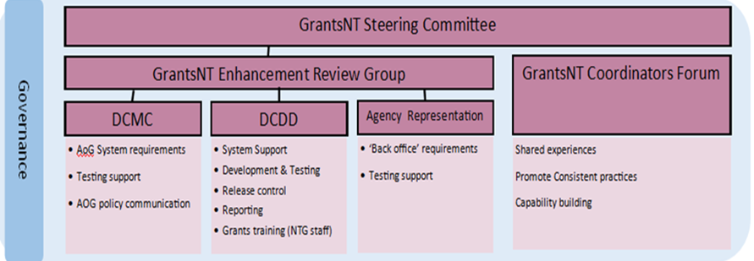
Source: GrantsNT Steering Committee Documentation
Grant Management cont…
The roles of the Committee and Enhancement Review Group were to commence at the beginning of 2021, upon the dissolution of the initial GrantsNT Implementation Steering Committee in December 2020. The Committee’s first meeting was held in October 2021 and the Enhancement Review Group had not met as the time of this audit (December 2021).
The GrantsNT Coordinators Forum was not active during 2021. At the time of this audit, the most recently held GrantsNT Coordinators Forum was in December 2020.
Client agency personnel advised that due to the working group (initially established with DCDD to provide timely feedback on issues with GrantsNT) being disbanded and the slow response times experienced with DCDD personnel responding to agency enquiries, there were limited opportunities to provide timely feedback in 2021. This audit did not examine the response times of DCDD when responding to agency enquiries.

Service Delivery
The delivery of shared services is defined by individual Service Statements prepared by DCDD and available to all client agencies. The Service Statements document roles and responsibilities, service standards and the dispute resolution processes that are expected to be followed by all parties. Service Statements are to be read in conjunction with the DCDD Enterprise Services Framework.
The GrantsNT system is included in the Across Government Systems Service Statement. No information technology system is specifically identified or referenced in the Service Statement. Some of the DCDD Service Responsibilities included in the Service Statement are:
- Providing advice on how systems can be better used to support agency business processes and decision making.
- Helping agencies define enhancements to NTG business application systems to improve administrative practices.
- Managing a program of system enhancements to increase automation, functionality and client self-service opportunities.
- Providing advice and support to client agencies for corporate business applications.
- Coordinating user group meetings and forums.
- Providing centralised service desk support, system administration and management of corporate business applications.
- Monitoring, escalating and mitigating corporate business application issues that impact on a client agency business operations.
- Providing system maintenance and enhancement and developing corporate business application systems.
The Service Statement includes five overall standards of performance that are used to measure all NTG IT systems overseen by DCDD.
The Service Statement could be enhanced to provide users with a clearer understanding of the services that will be delivered. A robust Service Statement needs to adequately define the services to be provided and expected service levels (output and performance levels). Examples of performance include tolerated error rate, response time and client satisfaction levels.
Grant Management cont…
A wiki is a web-based site that is designed for groups of people to share ideas through a number of linked webpages. A wiki was created in 2021 to provide grant information to agencies, including training opportunities and frequently asked questions. There is no established process to share the wiki site with client agencies.

On-Charging for Shared Services

Pricing Model
To fund the provision of shared services, DCDD receives an annual appropriation and generates revenue (classified as sales of Goods and Services) through on-charging the cost of delivering services to other NTG agencies. The cost of delivering shared services relating to grants management, including the provision of system support for GrantsNT, is intended to be recovered from agencies that enter into grant arrangements.
The on-charging model does not provide for a profit margin, meaning DCDD should recover the full cost of delivering the services from agencies. The effect of the cost allocation methodology on the consolidated financial position of the Northern Territory is zero, as the revenue to DCDD is offset with the expenditure at the client agencies.
Review of the on-charging model identified, at the time of the audit, DCDD were not recovering the full cost of providing grants management services due to three influencing factors:
- Indirect costs associated with GrantsNT and grants management shared services were not identified and recovered;
- The budgeted cost used as the basis for recovering costs from agencies (referred to as the ‘budgeted cost for recovery’) did not align with the actual cost of providing services; and
- The budgeted cost used for recovery did not align with the estimated cost of providing services as determined during DCDD’s annual budget process.
DCDD could identify the direct operational costs (including the contractor who holds the role of GrantsNT Administrator) and depreciation/amortisation of the system itself. Indirect costs associated with the provision of grants management services have not previously been recovered.
Table 2: GrantsNT Direct Costs
Cost Type | 2018/19 ($) | 2019/20 ($) | 2020/21 ($)
Operational | 556,030 | 920,302 | 973,900
Depreciation | 209,512 | 251,415 | 251,415
Direct Cost | 765,542 | 1,171,717 | 1,225,316
Source: DCDD Agency documentation
DCDD personnel advised a methodology for allocating corporate and accommodation overheads and indirect divisional personnel costs to service delivery areas has been developed and provided the estimated values below.
Table 3: GrantsNT Indirect Costs
Cost Type | 2018/19 ($) | 2019/20 ($) | 2020/21 ($)
Estimated Indirect Cost | - | 110,584 | 110,584
Source: DCDD Agency documentation
Grant Management cont…
Although the overheads were identified for the 2019/20 and 2020/21 financial years, they were not reflected in the monthly GrantsNT price on-charged to agencies. The pricing model was revised in 2021/22 at which time management determined the annual indirect cost applicable to GrantsNT was $108,951. The 2021/22 data was not examined as part of this audit.

Service Statements
The services provided by DCDD are outlined in Service Statements. On-charging information included in the Service Statements is not specific. There is only a generic reference to the Pricing Model applied by DCDD to recover the costs of providing services to client agencies.
The Pricing Model is published as an appendix to the DCDD annual report and on the NTG Central intranet. The Pricing Model lists each product name, cost drivers per billing period and the applicable rate applied as demonstrated below. The 2019/20 Pricing Model published in the DCDD 2019/20 Annual Report did not disclose a charge rate for Across Government Systems or a charge rate for GrantsNT. Audit testing found some information within the Pricing Model published in the Annual Report to be incorrect.
Table 4: Pricing Model for 2020/21 – GrantsNT Extract
Product Name | Cost Driver - Per Billing Period | Product Price
GrantsNT | % of $ value of grants processed | $544.91
Source: DCDD Agency documentation
Factor | Explanation
% of $ value of grants processed | The GrantsNT Support team allocate the budgeted cost used for recovery to client agencies on a monthly basis by calculating each client agency’s proportion of the total value of all grant payments across government (as a percentage).  Findings:  - The total value of grant payments and the agency’s proportion of that value includes grant payments transacted through GrantsNT and grant payments transacted outside the application therefore the charge to the client agency may not be representative of the amount of assistance provided by DCDD.
Product Price | Product Price = Budgeted Cost Used for Recovery / Budgeted Quantity  2019/20 & 2020/21 Calculated Product Price: $640,000 / 1200 = $533.33  2021/22 Calculated Product Price: $1,208,000 / 1200 = $1,006.66  Findings:  - The Product Price actually used for 2019/20 and 2020/21 was $544.91  - The Product Price actually used for 2021/22 was $1,008.43  - The actual costs recovered were less than the budgeted cost used for recovery. In 2020/21 a total of $622,039 was recovered, which is less than the maximum on-charge of $653,892 (being $544.91 * 1200).
Grant Management cont…
Factor | Explanation
Budgeted cost used for recovery | As the on-charge needs to be applied throughout the year (before the actual cost and actual quantity for the year are known), the product price in the Pricing Model is calculated based on budgeted cost used for recovery divided by budgeted quantity. In 2019/20 and 2020/21 the budgeted cost used for recovery was based on the actual GrantsNT cost for 2017/18 which was $640,000.  Findings:  - The budgeted cost used for recovery was far less than the actual cost of service delivery as shown below. Had DCDD’s indirect costs been fully allocated, the shortfall would have been higher again.  Budgeted cost used for recovery Actual direct costs  2019/20 $654,400 $1,171,717  2020/21 $654,320 $1,225,315  2021/22 $1,208,000 N/a at time of audit  - The budgeted cost used for recovery (which results in Sales of Goods and Services revenue) was not aligned with DCDD’s estimated costs of delivering grant management services. DCDD’s annual budget development cycle involves the estimation of annual agency costs to deliver services. These should align to the revenue associated with recovered cost. Because budgeted cost used for recovery was less than the expected cost to provide grant services, the on-charges applied would not have been sufficient to recover DCDD’s expected costs for the 2019/20 and 2020/21 financial years from the outset.  Budgeted cost used for recovery Estimated costs for DCDD budget purposes  2019/20 $654,400 $801,582  2020/21 $654,320 $798,615  2021/22 $1,208,000 $1,098,782

Grant Management cont…
Factor | Explanation
Budgeted Quantity | DCDD has specified that the budgeted quantity shall be represented by 100 units per month making a total of 1200 units for a full year. A client agency’s proportion of grant expenditure (as a percentage of total NTG grant expenditure) can then be translated to the quantity charged to the client agency. Therefore if a client’s grant expenditure for the month represents 34% of the total, the budgeted quantity attributed to that client is 34 units for the month.  The calculation to determine each client agencies proportion of grant expenditure includes grant payments transacted through GrantsNT and grant payments transacted outside the application (directly through the government accounting system or other applications). The use of the value of all grant payments does not provide a logical reference point for allocating the costs specific to the management of GrantsNT because it includes transactions processed outside GrantsNT.  Findings:  - The cost driver used to allocate the proportion of GrantsNT related costs to each client agency is derived from activity unrelated to GrantsNT.

The Pricing Model and Product Price for 2021/22 was updated and released on 26 October 2021, four months into the financial year in which the charges are being applied. Pricing Model changes did not align with the agencies’ budget development cycle. Consequently, the new prices are not reflected in DCDD’s or the client agencies’ budgets as released in May 2021.
Table 5: GrantsNT Budget, Actual and Recovered Cost
Financial Year | Budgeted Cost expected to be incurred for GrantsNT ($) | Actual Cost Incurred ($) | Recovered Cost  ($)
2018/19 | 729,582 | 765,542 | 0
2019/20 | 801,582 | 1,171,717 | 621,260
2020/21 | 798,615 | 1,225,315 | 622,039
2021/22 | 1,098,782 | n/a | n/a
Source: DCDD Agency documentation
Grant Management cont…

Invoicing
Monthly invoices are generated based on the GrantsNT data and uploaded to the Electronic Invoice Management System (EIMS) in order for the client agency to access the invoice and pay it.
Client agencies do not have access to the whole of government dataset so are unable to independently verify the charge or satisfy themselves as to the validity of the costs charged.
A review of six invoices identified minor rounding errors from the percentage apportionment.
Where the costs and cost allocation methods are not transparent and there is not a clear nexus between the services provided and the costs charged, clients are unable to effectively monitor and control the costs they are invoiced.
Without corrective action to align the budgeted cost to the actual costs associated, there is a risk that the costs associated with GrantsNT will be subsidised by other services. There is an equal risk that unless actual costs are calculated correctly and recovered proportionately, that there will be no impetus for agencies to seek efficiencies in grants management.

Grant Management at THFC

Grant Objectives
TFHC is a multi-functional human services and community-focused agency providing comprehensive community services covering four output areas:
- Strategic and Enabling Services,
- Families,
- Housing, and
- Regional Services and Communities.
The community services cover ‘a diverse range of government portfolios, including urban and remote housing; child protection; youth justice; family support service; domestic, family and sexual violence reduction; sport and recreation; heritage; arts; culture; disability services; indigenous essential services; multicultural affairs; seniors; youth; gender equity and diversity; and welfare group responsibilities under the Northern Territory Emergency Response Plan.’
In order to provide these services, a range of programs are implemented by TFHC that involve external parties being funded for the practical execution of the services. This funding may take the form of grants, sponsorships, subsidies or community service obligations.
Grant Management cont…
In 2020/21, TFHC provided grants totalling $334.66 million, with a further $102.7 million provided in the first quarter of the 2021/22 financial year.
The value of grants by output is presented in Table 6.
Table 6: TFHC Grants expenditure
Output area | Financial Year 2020/21 ($) | Quarter One 2021/22 ($)
Strategic Enabling Services | 19,693,417 | 4,315,311
Families | 17,060,742 | 6,299,834
Housing | 145,079,133 | 45,163,439
Regional Services and Communities | 152,824,345 | 46,938,139
TOTAL | 334,657,637 | 102,716,723
Source: TFHC Agency documentation
TFHC distributed one third of its budget to external entities through grant arrangements in the 2020/21 financial year. The figures include the National Disability Insurance Scheme (NDIS) that is required to be classified as a grant, however TFHC representatives are of the opinion the co-contribution is a subsidy in nature and therefore do not utilise GrantsNT for managing the arrangement and the payments. Whilst this opinion does not seem unreasonable, it should be noted that the cost recovery model applied by DCDD is applied using a calculation which involves all payments classified as grant payments irrespective of whether they are managed through GrantsNT.
Table 7: TFHC Grants expenditure – without NDIS
Output area | Financial Year 2020/21 ($) | Quarter One 2021/22 ($)
Strategic Enabling Services | 19,693,417 | 4,315,311
Families | 17,060,742 | 6,299,834
Housing | 145,079,133 | 45,163,439
Regional Services and Communities | 62,341,512 | 24,846,352
TOTAL | 244,174,804 | 80,624,311
Source: TFHC Agency documentation
Grant Management cont…
Each output area is responsible for the delivery of particular functions in order to ensure the services are delivered through the Agency’s 24 program areas presented in Figure 3.
Figure 3: 2020/21 Grant Value by TFHC Output and Program Areas
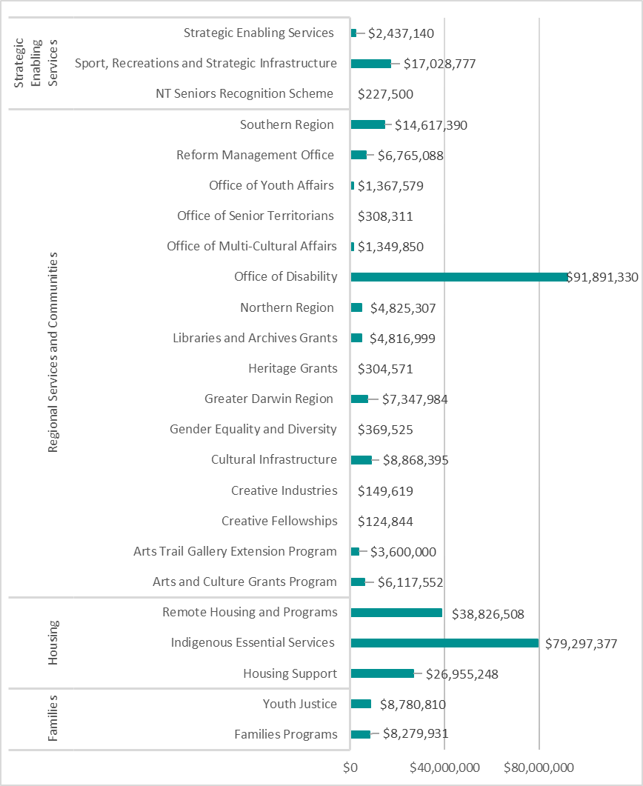
Source: TFHC Agency documentation
The grant programs provided by TFHC can consist of multiple individual grants, and each grant can have multiple rounds. It is not uncommon for grant programs to run over multiple years.
The NTG Grants Policy requires the objectives and outcomes of a grant program to be identified and clearly aligned to agency or NTG strategic objectives during the grant program’s planning stage.
Grant Management cont…
TFHC’s Corporate Services Handbook (the Handbook) has no further guidance or processes to ensure grant programs remain aligned with the agency’s objectives.
Agency personnel advised that, when a need is identified, a proposal is prepared and approved by the appropriate delegate, which then results in an allocation of funding to the grant program. The continued alignment of grant programs to strategic objectives is reviewed as part of the five year evaluation plan conducted by Strategic and Enabling Services.

Policy and Procedures
As provided in the background section of this report, the NTG Grant Policy and Framework were developed to provide consistent overarching principles for the management of grant programs by NTG agencies. The development of internal systems to support the management of grant payments is the responsibility of each agency.
The machinery of government changes on 8 September 2020 saw the grant programs of three separate agencies consolidated into a single agency. Prior to August 2021, TFHC was governed by three separate Accounting and Property Manuals.
TFHC released an agency-specific Handbook in August 2021 that details the grant management procedures to be adhered to by TFHC personnel.
The Handbook appears to adequately reflect the majority of the requirements detailed in the NTG Grants Policy including management principles and the funding cycle however information relating to the application of the across-government NTG Program Evaluation Framework and toolkit (introduced in May 2020) has not been included.
Review of the Handbook indicated additional guidance could be provided to enhance users’ compliance, including the development and implementation of:
- process flowcharts, checklists and templates;
- further guidance on identifying and managing conflicts of interest;
- guidance on non-conformance;
- quality assurance checks and review.

Conflict of Interest Processes
The Handbook contains conflict of interest requirements and refers to TFHC’s Conflict of Interest Policy.
Walkthroughs of grant management processes established that processes to identify and manage conflicts of interest were different in each of the three program areas.

Program Evaluation
The NTG Grants Policy outlines nine stages of a grant funding cycle with the final stage being program evaluation.
The NTG Program Evaluation Framework was developed in May 2020. Section 5 of the NTG Grants Policy requires agencies to use the NTG Program Evaluation Framework and associated toolkit to assist with the evaluation of grant programs.
Upon enquiry, several TFHC staff were unaware of the existence of the Framework and the resources available to support it. TFHC representatives could not provide evidence of any program evaluations having been undertaken.
Grant Management cont…

Grants System
The NTG Grants Policy mandates the use of GrantsNT for the management of grants, with effect from January 2019.
This concept is supported in the Handbook which states ‘all grants must be issued and managed through the GrantsNT system. No grant payments should be made outside the system. In the instance where a grant payment is required and the system cannot be used, the Chief Financial Officer should be contacted to arrange alternative payment arrangements.’
Through enquiry, it was established that TFHC also uses Grants Tracker (an ‘off the shelf’ grants management system) and Microsoft Excel to manage grant arrangements. TFHC were in the final stages of transferring all the grants into GrantsNT at the time of this audit.
As at 1 December 2021, 26 active grants remained within Grants Tracker that were considered finalised, however the completion and reporting processes had not been performed by the Agency. These grants dated back to the 2015-16 financial year. At the time of the audit, the completion dates of the grants were unable to be provided.
At the time of audit fieldwork, TFHC personnel advised there were also three grant programs that continue to be managed within Microsoft Excel spreadsheets. Managing grants in a non-specific application, such as Microsoft Excel, can have substantial limitations including lack of controls relating to access and file security.
As at 27 January 2022, TFHC had 325 GrantsNT users with different levels of access. The GrantsNT09 report identified 17 levels of access held across four inactive users. Agency staff advised that user access is audited biannually. Currently, there is no documented process in place to review grant system access.

Reporting and Reconciliation
As the grants management processes vary across the Agency’s 24 program areas, inconsistencies were identified with record keeping practices and the manner in which information is manually processed within GrantsNT.
Currently there is no consistent, holistic review performed to ascertain compliance with key grant requirements. Given the current objective to consolidate and implement consistent agency processes for the management of grants programs, quality assurance reviews could improve compliance with the agreed process and assist in educating those involved in grant management.
TFHC’s Corporate Service Handbook requires:
- the Grants Manager to oversee the management of the grant;
- a Grant Administrator to assist the Grant Manager;
- Central Grants Management Unit personnel to provide support with grant processes; and
- a Grant Management Plan to be prepared for grants valued at $15,000 or above with the plan to be endorsed by the Strategic Policy and Performance and Finance work units. No template was currently available.
There are no formal processes in place that require or support assessment of whether intended outcomes have been met.

Grant Management cont…
In response to an audit request for a transaction report detailing grants payments made during the 2020/21 financial year, it took three weeks for the listing to be provided indicating that no reconciliation of grant payments had been completed prior to the request.
The purpose of a reconciliation is to provide assurance on the completeness and accuracy of the grant payments and involves a comparison of the value of grant payments in the Government Accounting System to the grant payments recorded in separate systems. For 2020/21, TFHC managed grants using GrantsNT, Grants Tracker and Microsoft Excel. Payments of grant funding can occur through GrantsNT and directly from Government Accounting System. The reconciliation did not clearly identify that grants were managed in different systems or compare the grants payments from systems other than GrantsNT to the general ledger.
The reconciliation did not contain evidence of the identity of the preparer and reviewer of the reconciliation or the date the reconciliation was undertaken.
The NTG Grants Policy includes a requirement to report ‘all grant payments (amount, purpose and organisation) annually in their annual report’. Review of TFHC’s 2020/21 Annual Report found discrepancies between the Annual Report and the information provided for audit scrutiny with regard to ‘total funding’ and the ‘number of organisations’ funded.

Testing
Due to the wide range of services provided across the 24 program areas, each with its own unique internal processes, a walkthrough was conducted on the grants management procedures in three program areas. Comparison of the results of these walkthroughs to TFHC’s documented procedures and the minimum requirements of the Grants Policy identified two areas for improvement.
Detailed testing of the compliance of seven grant programs to TFHC’s documented procedures and the NTG Grants Policy identified the following deficiencies:
- Sufficient supporting documentation was unable to be provided to demonstrate that six of the programs had been subject to program evaluation.
- The grant agreement for one program had not been signed in accordance with the ‘Grants for Service Provision – Rules and Guidelines’.
- The grant template utilised by TFHC was not the template specified by the Grants Policy.
- Approval for the execution of one grant agreement could not be evidenced.
- Reports submitted by the recipient in October 2021 for one grant program were yet to be reviewed by the Agency. In addition, the reports submitted by the recipient were past their specified due dates. In one instance, the report was 18 months overdue.
- A record of a meeting held between the grant recipient and TFHC had not been documented.
- A grant agreement valued at $2.96 million was extended four times, resulting in the original agreement timeframe growing from 12 months to nearly five years. In addition, the scope of the agreement was expanded in August 2021 to include a grant (to the same recipient) which had previously ceased in May 2020.
- Supporting documentation could not be provided to evidence the approval of reopening a closed grant program and payment of an additional $5,000, which was in contradiction to the specified grant guideline for two grant recipients. Furthermore, the required conflict of interest forms had not been submitted by the assessor within TFHC.
Grant Management cont…
The Department of Corporate and Digital Development has commented:
The Department of Corporate and Digital Development reviews all Service Statements as part of an annual cycle, matters raised in the audit recommendations will be considered as part of this review. Similarly the DCDD Pricing Model has been reviewed and the description of service costings examined as part of this process.

NAB Transact Banking

Department of Corporate and Digital Development

Background
Transactions are received and processed from the Northern Territory Government (NTG) via National Australia Bank (NAB). NAB Transact is a Software as a Service (SaaS) application provided by NAB. NAB does not handle any data on behalf of the entity and provides only infrastructure services in a SaaS delivery model. Reporting is provided directly back to the NTG in a Payment Card Industry compliant format.
NAB Bank uses Australia Post’s SecurePay technology to power its NAB Transact platform. SecurePay (Australia Post) provides technical support services and the underlying infrastructure for the NAB Transact platform. The hosting environment and solution is Payment Card Industry Data Security Standard compliant and ISO 27001 Certified.
NAB Transact is accessed as a web application via the Internet. The application has a centralised technology interface for viewing a range of transactions such as payments and receivables (over the NAB banking system used by NTG).
The Department of Corporate and Digital Development (DCDD) uses NAB Transact mainly as a reporting tool, however, at times the application is used to process refunds and complete transactions as part of standard business processes. There are two types of access able to be assigned to DCDD users:
- ‘General / View’ access to the application where users can perform activities such as:
- Viewing other agencies’ transactions (if requested)
- Viewing refunds
- Reporting.
- ‘Payments / Refunds’ access to the application where users can perform activities such as:
- Completing existing transactions (if required)
- Accessing customer service functions
- Initiating or processing refunds (refunds may only go to the source account from where the payment originated).
The above actions are controlled through the use of privilege restrictions imposed by the NAB to prevent unauthorised usage of payment functionality within the system. As an example, a new payment cannot be initiated, only existing payments can be completed and refunds processed.

NAB Transact Banking cont…

Scope and Objective
The objective of this review was to review and test general information technology (IT) controls supporting access management for the NAB Transact application, including a review of sensitive privileges.
The review included gaining an overall understanding of the controls that were present in the IT environment surrounding the information systems in scope for the assessment. These included an understanding of the organisational and administrative structure of the IT function, the existence of policies and procedures for the day-to-day operations, availability of staff and their skills, and the overall control environment.
The scope of the review included review of the following areas of control relating to the management of NAB Transact within DCDD:
- Access provisioning and de-provisioning;
- Privileged access management;
- Logical access control;
- Segregation of duties; and
- Incident management.
Visibility regarding the specific operating system and databases hosting the solution was not possible and determined as not within the scope of this review. An overview of security requirements in place over the payment platform was undertaken as part of this review.

Review Opinion
Based on the scope of testing performed, except for the identification of some opportunities to enhance the design or implementation of controls, key information security controls tested in relation to access management and segregation of duties appeared to have been designed and implemented effectively during the review period.

Recommendations
The review identified a number of opportunities to enhance the design or implementation of controls relating to:
- Provisioning access for new users;
- De-provisioning of terminated users;
- The design and implementation of policies relating to password changes;
- Application of multi-factor authentication;
- The use of default accounts; and
- Establishment of audit/logging functionality for some accounts.

NAB Transact Banking cont…

Audit Observations

Overview of controls
- Access Management
Key attributes of access management process are defined where:
- The user requires approvals to gain access to the application.
- User access is reviewed monthly to ensure that all the users have appropriate access.
- Privileged access for the NAB Transact team is restricted to one administrator who manages access provisioning, modification and de-provisioning tasks.
- Role Management
The NAB Transact application supports role-based access. As the tasks performed by users are not complex, there are only two transactional roles together with an administrator role:
- General / View – View / Search transactions reports only. This is an enquiry only user account.
- Payments / Refunds – Customer service functions. This user account is able to refund transactions and complete new transactions.
- Administration – This account type has access to all functions within the application. Access cannot be modified as this role is configured and enabled by default.
Note: None of the above accounts have the ability to initiate a new transaction, not even the administrator role.
- Segregation of duties
- Segregation of duties between roles has been defined at the system implementation stage with assistance from NAB. All roles have been designed in a way to avoid segregation of duties conflicts. Administrative users are part of a small group, and this access is not provided to any end users of the application.
- Incident Management
Key attributes of the incident management process are defined where:
- Incidents are managed by NAB and reported to DCDD as required and are remediated in a timely manner.
- Incidents or issues relevant to the SecurePay platform are reported to and handled by the Australia Post SecurePay team.
- Change Management
- Change management activities in place for the NAB Transact application utilise existing DCDD change policies and standards. As this is a SaaS solution, DCDD do not have visibility over changes to the hosting environment managed by NAB / Australia Post.

NAB Transact Banking cont…
The Department of Corporate and Digital Development has commented:
The NAB Transact system and its functionality are not subject to control by DCDD. Auditing and logging functionality is available. DCDD will review and amend the new user application form and protocol documents. Processes are in place to mitigate the potential risk relating to de-provisioning of terminated users.
NAB Transact is being phased out and replaced with a more contemporary solution.

Operations and Service Management

Department of Corporate and Digital Development

Background
The Department of Corporate and Digital Development (DCDD) provides enterprise information and technology services and shared corporate services to support Northern Territory Government (NTG) agencies. Banned Drinker Register (BDR), Integrated Offender Management System (IOMS), NT Worksafe – Worksafe Information Management System (WIMS), InvoiceNTG, myPaysheet, and Pronto are six key corporate information systems utilised by government in the Northern Territory. DCDD, within the Across Government Services division, provide appropriately resourced teams to support these systems.

Scope and Objective
The objective of this review was to understand, risk assess and test the internal control structure across a number of systems in the DCDD / Data Centre Services IT environment, with particular focus on the monitoring of automated batch jobs relating to systems under their control with a scope emphasis on job management, monitoring and service level management.

Audit Opinion
Based on the scope of review and testing performed, except for the matters raised in this report, key general computer controls tested in relation to the review scope appeared to have operated effectively throughout the review period.

Recommendations
The review identified a number of opportunities to enhance the design or implementation of controls relating to:
- Regular testing of restoration of system backups across in-scope systems;
- Enabling business owners of in-scope systems with ready access to a system related Service Level Agreement;
- Ensuring WIMS incident management follows agreed protocols; and
- Monitoring of batch job execution across BDR relying on end user feedback.

Audit Observations
This review involved testing the controls, as defined in the scope, at the following selected information systems:
- Banned Drinker Register (BDR)
- Integrated Offender Management System (IOMS)
- NT Worksafe – Worksafe Information Management System (WIMS)
- InvoiceNTG
- myPaysheet
- Pronto.
Operations and Service Management cont…
The review assessed system controls in relation to the following key risk and control areas:
- System jobs, programs and processes do not support the intended function of the systems;
- System level access and permissions are not assigned and managed appropriately;
- System and file level backups are incomplete or not suitable as part of a disaster recovery plan;
- System and file level backups and data cannot be restored as required;
- IT system incidents force system downtime and halt business operations; and
- IT system incidents impact system performance and reliability.
The findings and recommendations were based upon review of documentation, limited testing and discussions with relevant personnel.

Operations and Service Management cont…
The Department of Corporate and Digital Development has commented:
The Audit opinion is noted. DCDD has a range of processes in place that will continue and be communicated to relevant teams.

Systems Change Control

Department of Corporate and Digital Development

Background
The Department of Corporate and Digital Development (DCDD) provide enterprise information and technology services and shared corporate services to support Northern Territory Government (NTG) agencies. Integrated Offender Management System (IOMS), NT Worksafe (WIMS), Tenancy Management System, myPaysheet, myResignation and SuperB are six key corporate information systems utilised by government in the Northern Territory. DCDD, within its Across Government Services division, provides appropriately resourced teams to support these systems.

Scope and Objective
The objective of this audit was to review and test the DCDD framework, policy, procedure and guidelines in relation to developing and changing software / applications including:
- Change control policies and procedures;
- Business change request process;
- Vendor initiated changes;
- Change approval;
- Testing of changes; and
- Change authorisation (to migrate to Production).

Review Opinion
Based on the scope of review and testing performed, except for the matters raised in this report, key general computer controls tested in relation to the review scope appeared to have operated effectively throughout the review period.

Recommendations
The review identified one opportunity to enhance the design or implementation of controls relating to sensitive information.

Audit Observations
This review involved testing the controls, as defined in the scope, at the following selected information systems:
- Integrated Offender Management System (IOMS)
- NT Worksafe (WIMS)
- Tenancy Management System
- myPaysheet
- myResignation
- SuperB
Systems Change Control cont…
The scope of this review included a review of the following key risks and their related controls:
- Unapproved changes to IT system programs are implemented into the production environment;
- Changes to IT system programs do not function as intended;
- Unapproved changes to IT system configurations are implemented into the production environment;
- Changes to IT system configurations do not function as intended; and
- Logical access to implement changes to IT system program or configurations into the production environment is unauthorised or not commensurate with job responsibilities.
The findings and recommendations were based upon review of documentation, limited testing and discussions with relevant personnel.
System Change Control cont…
The Department of Corporate and Digital Development has commented:
The Audit opinion is noted. DCDD will further strengthen controls through staff education and emphasise work instructions.

Agency Compliance Audit

Selected Agencies

Background
The use of delegated legislation, such as Treasurer’s Directions, devolves responsibility to Accountable Officers of agencies. That devolution has an accompanying requirement for accountability by Accountable Officers to their Ministers. Compliance audits are intended to assess how well that accountability is being discharged. The audits for this period concentrated on the extent to which agencies had complied with promulgated requirements with respect to:
- the maintenance of registers of financial interests, contingencies, guarantees and indemnities;
- validation of accounts payable and claims for payment, including funds availability;
- compliance with the Procurement Act 1995, Regulations made under that Act and Procurement Rules;
- the maintenance of registers of losses, and whether investigation, and reporting and recovery of losses accorded with the requirements of Treasurer’s Directions;
- ensuring that expenditure on official travel, telephones and hospitality was properly authorised, recorded and acquitted;
- the recording and accounting for trust monies;
- the legal and statutory arrangements governing the recovery of certain debts, the retention of financial management records, the granting of ex-gratia payments and the maintenance of Registers of Fees and Charges;
- the control of physical assets; and
- budget management, including financial and performance reporting.
Audits were performed in each of the following agencies during the five months covered by this report:
- Aboriginal Areas Protection Authority;
- Department of Corporate and Digital Development;
- Department of Education;
- Department of Environment, Parks and Water Security;
- Department of Health;
- Department of Industry, Tourism and Trade;
- Department of Infrastructure, Planning and Logistics;
- Department of Territory Families, Housing and Communities;
- Department of the Attorney-General and Justice;
- Department of the Chief Minister and Cabinet;
- Department of the Legislative Assembly;
- Department of Treasury and Finance;
Agency Compliance Audit cont…
- Northern Territory Electoral Commission;
- Northern Territory Police, Fire and Emergency Services;
- Office of the Independent Commissioner Against Corruption; and
- Ombudsman’s Office.

Scope and Objectives
Agency compliance audits are intended to ascertain the extent to which agencies’ Accountable Officers have implemented and maintained procedures that assist in ensuring that the requirements set out in Acts of Parliament, and subordinate and delegated legislation, are adhered to.

Audit Observations
Whilst none of the exceptions identified in the audits were indicative of pervasive across-government weaknesses leading to material misstatements of the Treasurer’s Annual Financial Statements, a number of controls weaknesses and issues were identified at many agencies during the agency compliance audits. These matters are presented below.
- ‘Deposits held’ and ‘Accountable Officers Trust Accounts’ at the Department of the Attorney-General and Justice had unreconciled differences. Matters related to these accounts, and the management of Prisoners’ Monies were previously reported to the Agency in management letters issued at the conclusion of agency compliance audits conducted since 2010.
- There has not been a formal review of one agency’s fraud-related policies, procedures and fraud control plans since August 2016. As a result, the policies, procedures and fraud control plans may not be appropriate for the agency’s current operations. Paragraph 19(a) of the Treasurer’s Direction requires regular reviews of agencies’ fraud control policies, procedures and fraud control plans.
- Paragraph 7(b) of the Treasurer’s Direction requires a fraud risk assessment be conducted at least once every two years:
  - One agency was unable to provide evidence as to when the latest fraud risk assessment was conducted.
  - At another agency, a fraud risk assessment was not performed following a significant restructure of the agency.
- Of the 25 procurement related transactions tested at one agency, the following instances of non-compliance with the Procurement Rules were identified:
  - Eight tier 1 transactions for which approval to invite quote was unable to be provided.
  - Four tier 1 transactions were identified where evidence of one quotation being obtained was unable to be provided.
  - The approval to accept a quotation was unable to be provided for two tier 1 transactions.
  - The approval provided for one tier 1 transaction did not state the total contract value being approved.
  - One tier 2 transaction was incorrectly classified as tier 1 based on the Goods and Services Tax exclusive amount. As a result, the transaction was approved by a delegate with insufficient authority and was also non-compliant with all tier 2 procurement requirements.
Agency Compliance Audit cont…
  - One tier 2 transaction was identified for which the notification of outcome was sent to suppliers prior to the approval of the ‘Recommendation to accept quote’.
  - One tier 2 transaction was identified where an addendum was issued, however this information was not updated in APRO nor in the ‘Recommendation to accept quote’.
  - One tier 2 transaction was identified where the following instances of non-compliance with procurement rules were observed:
    - Evidence that the agency sought a minimum of three quotes was unable to be provided;
    - The ‘Authority to invite quotation’ form was unable to be provided;
    - The conflict of interest declaration forms were not submitted by members of the assessment panel; and
    - The notification of outcome was not sent to the unsuccessful supplier.
  - The approval for one addendum issued was unable to be provided for a tier 3 transaction.
  - Two tier 3 transactions were identified where the delegate signing the Project Specific Procurement Plan (PSPP) did not expressly indicate that ‘approval’ of the PSPP and its attachments had been granted.
  - One tier 4 transaction was identified where the delegate signing the ‘Authority to purchase supplies’ form did not expressly indicate that approval had been granted. In addition, this transaction breached the following procurement rules:
    - APRO was not used; and
    - A procurement assessment was not performed.
- The following departures from another agency’s documented procedures and Treasurer’s Directions were identified:
  - Of the five hospitality expense transactions tested:
    - One transaction was approved by a delegate with insufficient delegated authority.
  - Of the five travel expense transactions tested:
    - One transaction was identified where the actual costs incurred were not updated in TRIPS on acquittal.
    - One travel event was not acquitted within the required period of 10 working days from the completion of the travel.
    - One instance of interstate travel was incorrectly classified as intrastate travel in the ledger.
  - A review of outstanding travel acquittals on 9 February 2022, identified a total of 162 outstanding acquittals (dating back to November 2020) which had not been finalised within the prescribed ten working days timeframe. There were 25 staff members with multiple outstanding acquittals.
Agency Compliance Audit cont…
  - Of five grant and subsidies expense transactions tested:
    - One transaction was identified where the performance report submitted by the recipient was not provided to the Grant Delegate (who approved the grant), as required by section 6.3.10.4 of the Corporate Services Handbook.
    - One transaction was identified where performance reports submitted by the grant recipient in October 2021 had not been reviewed and endorsed by the Agency.
  - Of 25 payment transactions tested:
    - One payment was approved by a staff member with no delegated authority.
    - One payment of over $22 million was made via direct payment, however evidence of notification to the Northern Territory Treasury Corporation prior to the payment being made was unable to be provided.
  - Of 25 procurement transactions tested:
    - There were four tier 1 transactions where the agency could not demonstrate approval was given to obtain a quote.
    - The evidence of one quote being obtained for one tier 1 transaction could not be provided.
    - Conflict of interest documentation for one tier 2 transaction was unable to be provided.
    - One tier 2 transaction was identified where the delegate signing the Project Specific Procurement Plan (PSPP) did not expressly indicate that approval of the authority to invite offer (as part of the PSPP) had been granted.
- NT Procurement Rules Section 13.2 states: ‘The agency must ensure that at least two Territory enterprises are invited to provide an offer for Tier 2 supplies.’ At one agency, three instances (from a sample of five Tier 2 procurements) were identified where the agency only invited one Territory enterprise to quote.
- NT Procurement Rules Section 19.7 states: ‘The assessment should identify, assess and document any risks in the offers.’ At one agency, two instances (from a sample of 25 procurement activities) were identified that did not have a documented Procurement Assessment Recommendation and thus could not demonstrate that the Section 19.7 requirement had been met.
- Several errors were identified in one agency’s accounting for fixed assets.
- At one agency, there were a number of assets comprising a significant value recorded as ‘not found’ during the stocktake of property, plant and equipment.
- At one agency, sections in the Accounting and Property Manual were still under review with the previous requirements accessible to staff on the intranet. At some other agencies, the Accounting and Property Manual required updating.
- One agency did not have a current internal audit plan linked to strategic risks. At another agency, deficiencies in the internal audit program present risks to that Agency.
- Instances of non-compliance with policy were observed in relation to corporate credit cards.
Agency Compliance Audit cont…
- Many agencies could not demonstrate adherence to the NTG policy requiring undisputed invoices to be processed within the required 20 day (under $1 million) and 30 day (over $1 million) periods.
Where an agency compliance audit identified that an agency had exceeded the specified payment days in 10% or more of the payments, the matter was reported to the Accountable Officer for their attention.
Whilst there are valid reasons why this measure cannot always be achieved, some agencies were reminded to revisit their internal payment processes in order to improve compliance levels. The percentage of payments processed outside of the Northern Territory Government’s Payment Policy for the period 1 July 2021 to 13 February 2022 is presented by Agency in the following chart.
Figure 1: % of Payments Outside of NTG Payment Policy
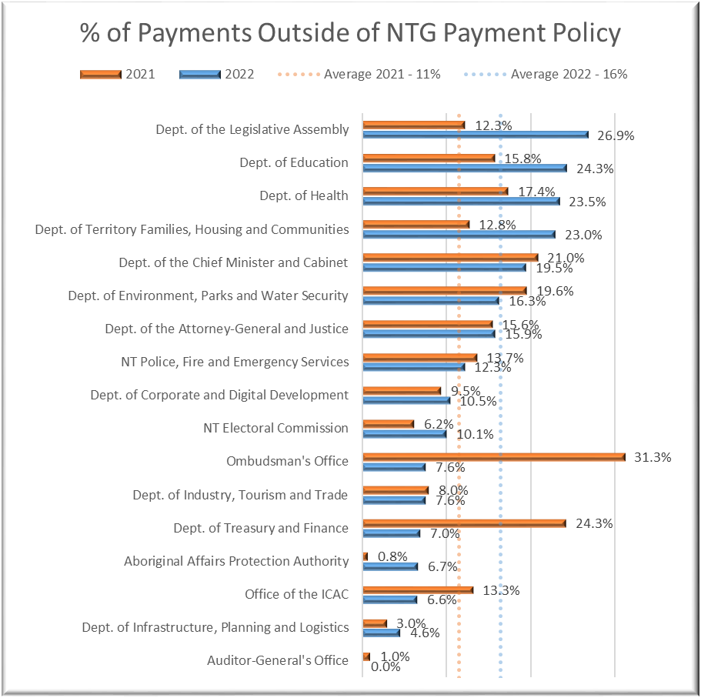
Source: Department of Corporate and Digital Development generated AP06 – Invoice Processing Report extracted on 14 February 2022
The percentage of payments made outside of NTG Payment Policy timeframes has increased significantly when compared to 2021 for the Department of Territory Families, Housing and Communities, the Department of Health, the Department of Education, and the Department of the Legislative Assembly.
Agency Compliance Audit cont…
The Department of Corporate and Digital Development has commented:
The Department of Corporate and Digital Development issues reminders periodically regarding meeting the 20 day and 30 day policy requirements for processing invoices for payments.

The Department of Education has commented:
As outlined in the Auditor-General’s report, the Department of Education noted that there were elements of the report used by the Auditor-General which impacted the correct calculation of the department’s level of compliance with the NTG payment policy. The Department of Education is committed to ensuring compliance with the relevant delegated legislation and has addressed recommendations to improve its processes, including a focus on improving its payment timeframes despite the department’s observations on the Auditor-General’s findings.

The Department of Environment, Parks and Water Security has commented:
The Department of Environment, Parks and Water Security notes compliance with the NTG payment policy has improved over the prior year. The agency will explore options to obtain detailed reporting to further improve compliance, which it hopes will assist in identifying process stages that can be strengthened.

The Department of Industry, Tourism and Trade has commented:
There were no matters arising from the audit that required attention however, we will continue to educate staff and review processes and procedures to ensure continual compliance.

The Department of the Chief Minister and Cabinet has commented:
The findings of the report are noted. The Department of the Chief Minister and Cabinet will continue efforts to meet the Northern Territory Government payment policy timeframes.

Agency Compliance Audit cont…
The Department of Treasury and Finance has commented:
The Department of Treasury and Finance continues to review Treasurer's Directions to bring them to contemporary standards and resolve known compliance deficiencies across government. Reviews of Treasurer's Directions are prioritised in terms of risk to the Treasurer's Annual Financial Report, and to address material issues across government agencies, new government policy requirements and changes to Australian accounting standards.
The audit findings from agency compliance audits included within this report provide valuable input into the Treasurer's Direction review project, and will be addressed as part of that process.

Northern Territory Police Fire and Emergency Services has commented:
NTPFES acknowledges the findings of the Annual Compliance Review and has taken necessary action to address those findings.

Compliance with Travel Policy

Selected Entities

Background
Travel undertaken by Northern Territory Government (NTG) employees is required to comply with the Travel Policy Framework and the supplementary Travel Policy Statements: overseas travel.
The Department of Corporate and Digital Development provides the TR10 Travel Policy Compliance Report (the TR10 Report) that details travel recorded in the Travel Request Information Processing System (TRIPS) and provides Accountable Officers and entity management with information on employees’ compliance with aspects of the Travel Policy Framework.
The TR10 Report highlights any travel incident where the approval date was after the first travel date, the travel was acquitted before departure, the travel allowance is inconsistent with the travel days, and travel was acquitted outside of policy.
The analysis is based on the report sourced from BOXI on 6 June 2022. The TR10 Report details all travel recorded in TRIPS with departure dates between 1 July 2021 and 31 May 2022 inclusive and the travel status (i.e. approved or acquitted) as at the date the TR10 Report was run. In this instance, the TR10 Report was run on 6 June 2022 thus effectively being for 6 June 2022. Any changes that occurred from 6 June 2022 onward are not reflected in this report.

Scope and Objectives
The objective of this assessment was to examine travel at selected entities during the period 1 July 2021 to 31 May 2022 inclusive (based on departure date) in order to identify requisitions that did not comply with the Travel Policy Framework (version 3.2 approved 5 June 2020) and its supplementary document Travel policy statements: overseas travel dated 17 December 2018. Information about those requisitions identified as non-compliant was provided to the selected entities to enable Accountable Officers to investigate the cause of the non-compliance and take any necessary corrective action.
This assessment identified anomalies at the following entities:
- Aboriginal Areas Protection Authority
- Batchelor Institute of Indigenous Tertiary Education
- Department of Corporate and Digital Development
- Department of Education
- Department of Environment, Parks and Water Security
- Department of Health
- Department of Industry, Tourism and Trade
- Department of Infrastructure, Planning and Logistics
- Department of Territory Families, Housing and Communities
- Department of the Attorney-General and Justice
Compliance with Travel Policy cont…
- Department of the Chief Minister and Cabinet
- Department of the Legislative Assembly
- Land Development Corporation
- Northern Territory Electoral Commission
- Northern Territory Police, Fire and Emergency Services

Scope Limitation
In responding to my correspondence about information within the TR10 report which appeared anomalous, a number of Accountable Officers responded advising of elements of the TR10 report which they consider factually inaccurate and have undertaken to bring these to the attention of the Department of Corporate and Digital Development to ensure the report, which is intended to be used to support internal controls relating to corporate travel, is fit for purpose. Further comment has been made in relation to this matter at the end of this report.

Overall Assessment
Review of the data related to travel policy compliance highlights the necessity for management to actively monitor travel requisitions and design and implement controls to ensure compliance with the Travel Policy Framework and the Authority’s internal policies and procedures.
The fact that the assessment has identified items as reported in the observations below does not mean that there are no other matters of which management should be aware in meeting their responsibilities, nor does this report absolve them from taking appropriate action to meet their responsibilities. It should be noted that this assessment did not constitute an audit.

Accountable Officer’s Responsibility
The Accountable Officer is responsible for:
- ensuring that official travel undertaken within their agency complies with the Travel Policy Framework;
- maintaining internal controls over the acquisition of services and expenditure of public monies, including official travel, to a standard that will satisfy accountability requirements and audit scrutiny;
- including audits for official travel in annual audit plans where risks have been identified. Such audits test compliance with the Travel Policy Framework. Agencies are to respond to findings;
- ensuring all officers and persons involved in undertaking, managing or processing official travel comply with the Travel Policy Framework and travel policy statements and adhere to related accountability frameworks;
- maintaining adequate accounting records;
- maintaining a system of internal controls to prevent or detect errors or irregularities;
- ensuring the adequacy of reporting and controls over accounting and financial transactions; and
- developing systems to achieve compliance with accountability and control requirements including the prescribed accountability requirements that are identified in the Financial Management Act 1995, Treasurer’s Directions, Procurement Act 1995, other specific legislation and in other whole of government service wide policies.
Compliance with Travel Policy cont…

Observations

Prior Approval Not Obtained
During the period under review, there were 37,087 travel requisitions. Of these, analysis of the data was undertaken to identify instances of travel where the requisition:
- was approved after departure date;
- was approved after arrival date;
- had not been approved at the time of the report;
- had not been acquitted within 10 working days;
- was acquitted before the departure date; and/or
- was acquitted before arrival date.
These instances constitute non-compliance with the Travel Policy Framework.
Figure 1: Number of non-compliance incidents
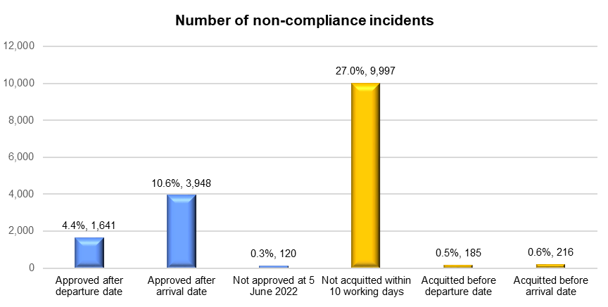
Source: Northern Territory Auditor-General’s Office derived from the TR10 Report
Section 5.2.1.3 of the Travel Policy Framework requires that the ‘traveller/travel booker must have an approved movement requisition before finalising travel bookings’. The TR10 Report identified a total of 5,709 requisitions where prior approval was not obtained.
Further analysis of the requisitions with no prior approval demonstrated that 69% of these requisitions were approved after the trip had been completed, 29% were approved after the departure date with 2% (120 requisitions) not approved as at 5 June 2022.
Compliance with Travel Policy cont…
Figure 2: Late approval by dates
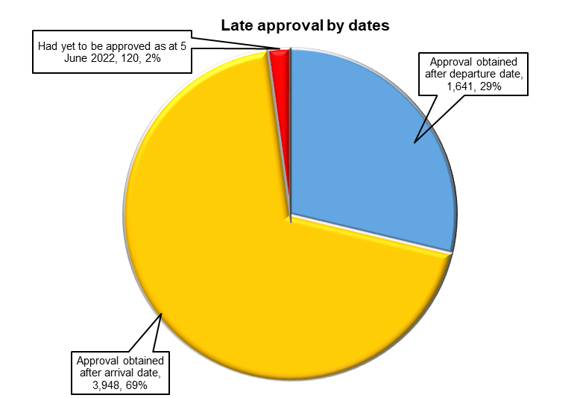
Source: Northern Territory Auditor-General’s Office derived from the TR10 Report
Of the 5,589 requisitions that received late approval:
- 3,655 were approved within 10 days of the departure date;
- 1,460 were approved between than 11 to 30 days after the departure date;
- 359 were approved between 31 and 60 days after the departure date; and
- 115 were approved more than 60 days after departure.
Figure 3: Late approval by departure date
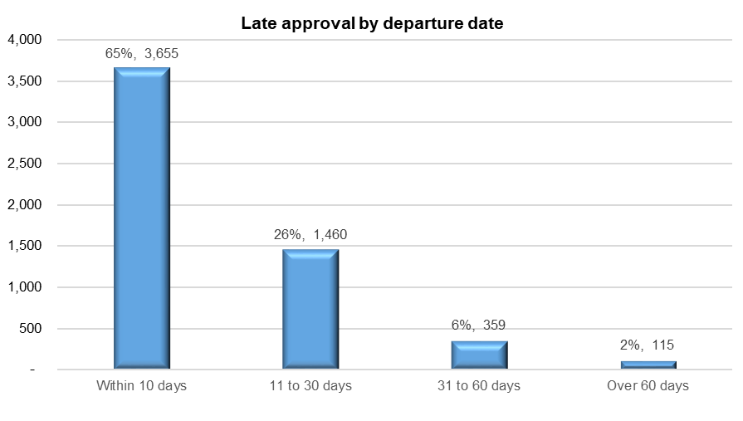
Source: Northern Territory Auditor-General’s Office derived from the TR10 Report
Compliance with Travel Policy cont…
1,127 employees had more than one incident where the approval of the travel (according to the TR10 Report) occurred after their departure date.
Figure 4: Number of employees - by late approval occurrence
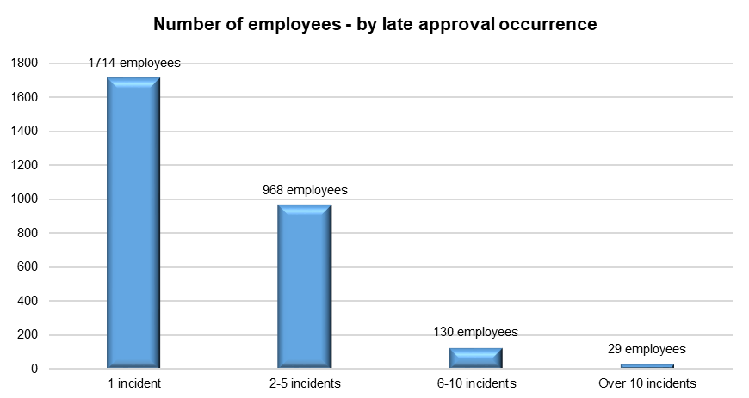
Source: Northern Territory Auditor-General’s Office derived from the TR10 Report
Compliance with Travel Policy cont…
Figure 5 presents the number of requisitions that did not (according to the TR10 Report) comply with approval procedures. The data presented in Figure 5 is limited to agencies where there were 1,000 or more travel requisitions between 1 July 2021 and 31 May 2022.
The TR10 Report identified that:
- 2,039 (50%) out of a total of 4,045 requisitions undertaken by employees of the Northern Territory Police, Fire and Emergency Services during the period were non-compliant.
- 308 (16%) out of 1,897 requisitions undertaken by employees of the Department of the Attorney-General and Justice were non-compliant.
- 575 (13%) out of 4,531 requisitions undertaken by employees of the Department of Education were non-compliant.
- 1,486 (12%) out of 12,610 requisitions undertaken by employees of the Department of Health were non-compliant.
- 194 (12%) out of 1,686 requisitions undertaken by employees of the Department of Industry, Tourism and Trade were non-compliant.
Figure 5: Non-compliant with approval procedures
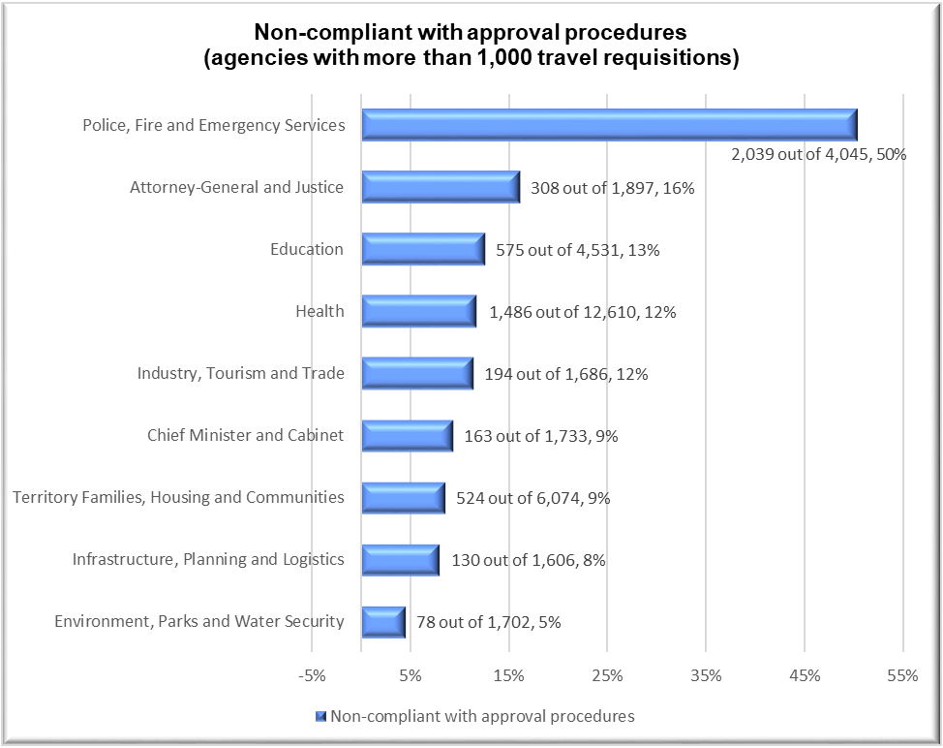
Source: Northern Territory Auditor-General’s Office derived from the TR10 Report

Compliance with Travel Policy cont…

Requisitions Not Acquitted Within Mandated Timeframes
The Travel Policy Framework requires that ‘all travellers must acquit official travel within ten working days of returning to the workplace’.
Of the 10,398 non-compliant requisitions, commencing during the period 1 July 2021 to 31 May 2022, 9,997 requisitions were reported as not having been acquitted within the 10 working day timeframe. 8,690 of these requisitions were acquitted more than 10 working days after arrival and 1,307 were not acquitted as at 5 June 2022.
Figure 6: Late acquittal after arrival date by working days
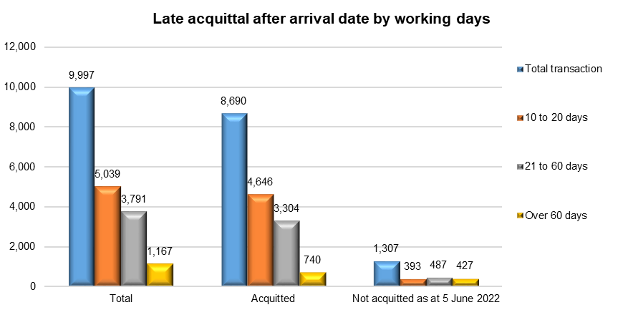
Source: Northern Territory Auditor-General’s Office derived from the TR10 Report
In addition to the 9,997 requisitions included in Figure 6, there were 185 requisitions that were reported as being acquitted before the departure date and 216 requisitions reported as being acquitted before the arrival date. That is to say, the travel was acquitted prior to the travel being undertaken.
The TR10 Report also identified 1,960 employees who had more than one incident where the travel was acquitted more than 10 working days after their arrival date.
Figure 7: Number of employees - by late acquittal occurrence
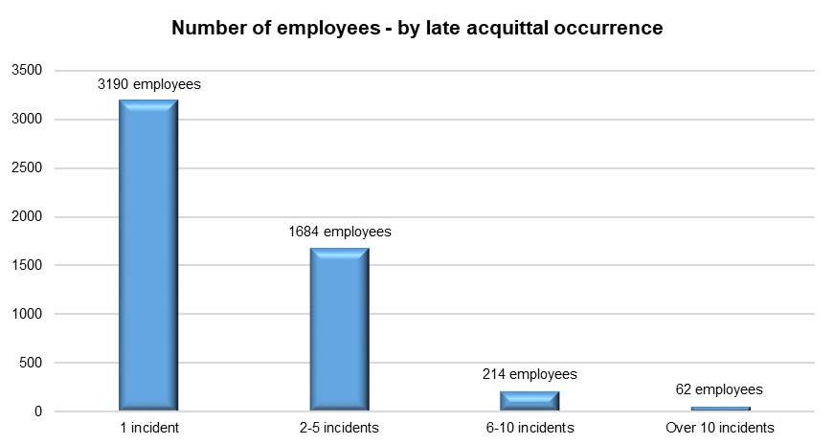
Source: Northern Territory Auditor-General’s Office derived from the TR10 Report
Compliance with Travel Policy cont…
Figure 8 details the number, and percentage, of requisitions that were non-compliant with the acquittal requirements. The information is presented for those agencies where there were 1,000 or more travel requisitions between 1 July 2021 and 31 May 2022.
Of the 10,398 requisitions that were identified by the TR10 Report as being non-compliant with the acquittal policy, the TR10 Report identified that:
- 747 (43%) out of a total of 1,733 requisitions undertaken by the Department of the Chief Minister and Cabinet were non-compliant.
- 2,510 (41%) out of a total of 6,074 requisitions undertaken by the Department of Territory Families, Housing and Communities were non-compliant.
- 1,501 (33%) out of a total of 4,531 requisitions undertaken by the Department of Education were non-compliant.
- 510 (30%) out of a total of 1,686 requisitions undertaken by the Department of Industry, Tourism and Trade were non-compliant.
- 1,213 (30%) out of a total of 4,045 requisitions undertaken by the Northern Territory Police, Fire and Emergency Services were non-compliant.
Figure 8: Non-compliant with acquittal procedures
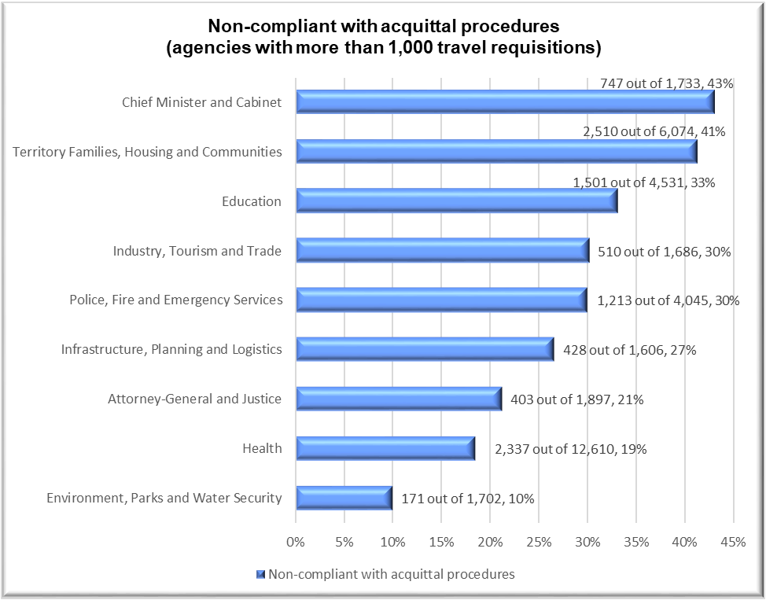
Source: Northern Territory Auditor-General’s Office derived from the TR10 Report
Compliance with Travel Policy cont…

Travel type not updated correctly in TRIPS
The travel undertaken is required to be classified into one or more travel types available in TRIPS. The travel classification options are: Regional centre, Remote area, Interstate or International. The analysis identified:
- 227 requisitions where interstate travel was incorrectly classified as travel to ‘Regional centre’;
- 4 instances where international travel was incorrectly classified as travel to regional centres; and
- 279 requisitions where information on the first and/or final destinations was not updated.

Recommendations

TR10 Report Accuracy
The accuracy of the TR10 Report has been called into question by some agencies, in particular where the acquittal date was erroneously recorded as being prior to the departure and/or arrival dates, where the acquittal dates were significantly longer than the 10 working day policy, and where approval was obtained after travel commenced.
Where the TR10 Report erroneously identifies a significant number of transactions as exceptions that are not genuine exceptions, the usefulness of the report is reduced and may result in actual non-compliance issues not being identified and addressed in a timely manner.
Where agencies have identified that reports include erroneous or inaccurate information, it would be appropriate for those agencies to liaise with the Department of Corporate and Digital Development who can refine the underlying system instructions to improve the accuracy of the TR10 Report.

User Error
Agencies subsequently identified some of the exceptions as being caused by user error, for example where employees entered an incorrect date within TRIPS.
In these instances, the TR10 Report had identified an exception that required action as it was not a deficiency in the TR10 Report itself.
These instances highlight the need for the agency to provide:
- training in the use of TRIPS to all travellers prior to their first travel event; and
- subsequent training where travellers are identified as having entered incorrect information in TRIPS.

Failure to Comply With Policy
Agencies also subsequently identified some of the exceptions as being due to failure by the employee to acquit the travel within the required time set by the travel policy.
In these instances, the TR10 Report had identified an exception that required action as it was not a deficiency in the TR10 Report.
Where exceptions are identified following the conclusion of the travel, agencies may need to provide further training and undertake remedial action to ensure the traveller is aware of the NTG Travel Policy Framework requirements prior to them undertaking further travel.

Compliance with Travel Policy cont…
The Department of Corporate and Digital Development has commented:
The Department of Corporate and Digital Development will place increased focus on ensuring that documented records of travel undertaken provide satisfactory evidence of adherence to the NT Government Travel Policy.
The issues identified on page 80 of 102 regarding the accuracy and utility of the TRIPS TR10 report are noted. This is a matter for DCDD to address and is currently the subject of technical investigations by DCDD systems teams.

The Department of Education has commented:
As outlined in the Auditor-General’s report, the Department of Education noted that there were elements of the report used by the Auditor-General’s, which formed the basis of the findings that were inaccurate, and this will be brought to the attention of the Department of Corporate and Digital Development. The Department of Education will continue reviewing its processes and will continue to raise awareness across the department on the need to comply with the Travel Policy Framework, including approval and acquittal procedures.

The Department of Environment, Parks and Water Security has commented:
The Department of Environment, Parks and Water Security had recently finalised its own internal audit on travel compliance against the Travel Policy Framework. A satisfactory outcome was achieved with higher compliance than that outlined in the NTAGO’s review. This is due to issues identified with the TR10 report (utilised by the NTAGO) resulting in non-genuine exceptions being reported.

The Department of Industry, Tourism and Trade has commented:
Due to the inaccurate data in the TR10 travel report, data relating to approval procedure non-compliance and acquittal non-compliance is significantly overstated.
The Department does acknowledge that ensuring travel is acquitted within 10 days is an area for improvement and has implemented new procedures to try and address this issue.

The Department of the Chief Minister and Cabinet has commented:
The Department of the Chief Minister and Cabinet will continue to educate and communicate the NTG Travel Policy Framework requirements to travellers. The issues identified regarding the TRIPS TR10 report are a matter for DCDD to address, which we understand are being progressed through technical investigations by DCDD systems teams.

Compliance with Travel Policy cont…
Northern Territory Police Fire and Emergency Services has commented:
NTPFES notes the findings which have been acted upon where necessary.

Matters Referred to the Auditor-General Pursuant to Section 6 of the Public Information Act 2010

Background
The Public Information Act 2010 (the Act), as in force at 10 April 2019, and the associated Regulations, provide for the review of public information produced by public authorities. A public authority is defined in Section 5 of the Act as:
- an Assembly member;
- the holder or occupier of any of the offices of a Minister, the Speaker, the Leader of the Opposition or any other office of the Legislative Assembly;
- the holder or occupier of an office established by or under a law of the Territory;
- a person appointed or engaged to perform work for a public authority;
- an Agency;
- a body (whether incorporated or not) established by or under a law of the Territory;
- a body corporate to which one or both of the following apply:
- the capital of the body corporate is owned by one or more public authorities;
- one or more public authorities have a total of more than one-half of the voting power in the management of the body corporate;
- a body corporate that is a subsidiary of a public authority (whether or not through any interposed entity).
Excluded from the definition are:
- holders or occupiers of:
- judicial office;
- an office as a member of a tribunal established under a law of the Territory;
- the office of the Auditor-General;
- a local government council;
- Jacana Energy;
- the Power and Water Corporation;
- Territory Generation; and
- a person or body prescribed by regulation.
Matters Referred to the Auditor-General Pursuant to Section 6 of the Public Information Act 2010 cont…
Section 4(1) of the Act defines public information as ‘information given by a public authority to the public by using money or other property of the Territory’. Exemptions from this definition are:
- information given to members of the electorate of an Assembly member if the preparation and giving of the information is funded by an allowance payable to the Member for the electorate under a law of the Territory; and
- a media release of a Member of the Legislative Assembly (whether or not in his or her capacity as an Assembly member); and
- information prescribed by regulation.
The Act does place a limit on the scope of what might be considered to be public information in that Section 4(2) provides that a ‘public authority gives information to the public when it makes the information available to the public generally (rather than any particular members of the public) through any medium’.
Section 6(1) of the Act provides that the Auditor-General must, upon the receipt of a written request of a Member of the Legislative Assembly, or may, on the initiative of the Auditor-General, conduct a review of that information to determine whether the provisions of the Act have been contravened, with regard to the Public Information Regulations.
The Auditor-General may determine that the Act is contravened in relation to particular public information if the Auditor-General is satisfied one or more of the following applies to the information:
- the information promotes particular party political interests;
- the information includes statements that are misleading;
- the information is an advertisement that includes an image of a minister or a minister's message;
- for public information that is not an advertisement – the information includes an image of a minister or a minister's message other than:
- the Chief Minister; or
- the relevant minister;
- the information includes facts (including comparisons), statistics or data that are not presented accurately; or
- the information fails to specify the source, or a means for identifying a source, of any facts (including comparisons), statistics or data.
The Auditor-General may also determine this Act is contravened in relation to particular public information if the Auditor-General is satisfied the content of the information is not for the purpose of the public interest.
There have been no matters referred since my March 2022 Report to the Legislative Assembly.

Appendices

Appendix 1: The Role and Responsibilities of the Auditor-General

Responsibilities of the Auditor-General
The Auditor-General’s powers and responsibilities are established in the Audit Act 1995 by the Northern Territory's Parliament, the Legislative Assembly. The Auditor-General is required to report to the Legislative Assembly at least once each year on any matters arising from the exercise of the auditing powers established in that Act. Each report may contain findings from financial statement audits, agency compliance audits, information technology audits, controls and compliance audits, performance management system audits and findings from any special reviews conducted. Results of any reviews of referred information under the Public Information Act 2010 are included when the reviews are concluded.
In reporting these results, the Auditor-General is providing information to the Parliament to assist its review of the performance of the Executive Government, particularly the Government’s responsibility for the actions of the public sector entities which administer its financial management and performance management directives. The Parliament has a responsibility to conduct this review as the representative of the people of the Northern Territory.
The Auditor-General is required to report to the Accountable Officer (or equivalent) of public sector entities on matters arising from the conduct of audits at the conclusion of the audit.
Reports provided to Parliament and public sector managers should be recognised as a useful source of independent analysis of government information, and of the systems and controls underpinning the delivery of that information.
The Auditor-General is assisted by personnel of the Northern Territory Auditor-General’s Office who plan audits and tasks conducted by private sector Authorised Auditors.
The requirements of the Audit Act 1995 in relation to auditing the Public Account and other accounts are found in:
- Section 13, which requires the Auditor-General to audit the Public Account and other accounts, with regard to:
- the character and effectiveness of internal control; and
- professional standards and practices.
- Section 25, which requires the Auditor-General to issue a report to the Treasurer on the Treasurer’s Annual Financial Statement.
Appendix 1: The Role and Responsibilities of the Auditor-General cont…

Audit of the Treasurer’s Annual Financial Statement
Using information about the effectiveness of internal controls identified in the overall control environment review, Agency Compliance Audits including End of Year Reviews and the results of financial statement audits, an audit approach is designed and implemented to obtain assurance that the balances disclosed in the Treasurer’s Annual Financial Statement are in accordance with the disclosure requirements adopted by the Treasurer, and are within acceptable materiality standards.
The audit report on the Treasurer’s Annual Financial Statement is issued to the Treasurer. The Treasurer then tables the audited Treasurer’s Annual Financial Statement to the Parliament as a key component of the accountability of the Government to the Parliament.
Statutory bodies, Government Owned Corporations and Government Business Divisions are required by various Acts of Parliament to prepare annual financial statements and to submit those statements to the Auditor-General for audit. Those statements are audited and audit opinions issued accordingly. The opinions are included in the various entities’ annual reports that are tabled in the Legislative Assembly. If matters of concern were observed during the course of an audit, specific comment may be included in a subsequent report to the Legislative Assembly.
In addition, the Northern Territory Government controls, either directly or indirectly, a small number of companies that have been incorporated pursuant to the Commonwealth Corporations Act 2001. Audits of these companies are performed subject to the provisions of the Commonwealth legislation, with the Auditor-General being deemed by the Corporations Act 2001 to be a Registered Company Auditor.
Audits conducted through the Northern Territory Auditor-General’s Office are conducted in accordance with Australian Auditing Standards. Those standards are issued by the Australian Auditing and Assurance Standards Board, a Commonwealth statutory body established under the Australian Securities and Investments Commission Act 2001. Auditing Standards issued by the Board have the force of law in respect of audits of corporations that fall within the ambit of the Corporations Act 2001, while the Audit Act 1995 also requires that the Auditor-General has regard to those standards.

The Public Account
The Public Account is defined in the Financial Management Act 1995 as:
- The Central Holding Authority; and
- Operating accounts of agencies and Government Business Divisions.
Appendix 1: The Role and Responsibilities of the Auditor-General cont…

Audits of Performance Management Systems

Legislative Framework
A Chief Executive Officer, as an Accountable Officer, is responsible to the appropriate Minister under section 23 of the Public Sector Employment and Management Act 1993 for the proper, efficient and economic administration of his or her agency. Under section 13 (2)(b) of the Financial Management Act 1995, an Accountable Officer shall ensure that procedures in the agency are such as will at all times afford a proper internal control’. Internal control is defined in section 3 of the Financial Management Act 1995 to include ‘the methods and procedures adopted within an agency to promote operational efficiency, effectiveness and economy’.
Section 15 of the Audit Act 1995 complements the legislative requirements imposed on Chief Executive Officers by providing the Auditor-General with the power to audit performance management systems of any agency or other organisation in respect of the accounts of which the Auditor-General is required or permitted by a law of the Territory to conduct an audit.
A performance management system is not defined in the legislation, but section 15 of the Audit Act 1995 identifies that: ‘the object of an audit conducted under this section includes determining whether the performance management systems of an agency or organisation in respect of which the audit is being conducted enable the Agency or organisation to assess whether its objectives are being achieved economically, efficiently and effectively.’ Performance management system audits can be conducted at a corporate level, a program level, or at a category of cost level, such as capital expenditure.

Operational Framework
The Northern Territory Auditor-General’s Office has developed a framework for its approach to the conduct of performance management system audits, which is based on the premise that an effective performance management system would contain the following elements:
- identification of the policy and corporate objectives of the entity;
- incorporation of those objectives in the entity’s corporate or strategic planning process and allocation of these to programs of the entity;
- identification of what successful achievement of those corporate objectives would look like, and recording of these as performance targets;
- development of strategies for achievement of the desired performance outcomes;
- monitoring of the progress toward that achievement;
- evaluation of the effectiveness of the final outcome against the intended objectives; and
- reporting on the outcomes, together with recommendations for subsequent improvement.

Appendix 2: Guide to Using this Report

Auditing
There are two general varieties of auditing undertaken in the Northern Territory Public Sector, independent auditing and internal auditing. Only independent audits are undertaken through the Northern Territory Auditor-General’s Office. The Auditor-General and personnel of the Office do attend meetings of agencies’ audit and risk committees where invited, but only in the role of observer.

Independent Audit (also known as External Audit)
Independent audits are generally undertaken in order for an entity to achieve compliance with statutory or legal arrangements. Independent audits may be mandated by legislation or be required by a contractual arrangement. The audit work and resultant opinion is undertaken by an individual or entity independent of the agency or entity subjected to audit. These audits can take the form of financial statements audits, compliance audits or performance management system audits.

Internal Audit
Treasurer’s Direction Part 3, Section 2 requires an Accountable Officer to ensure his/her Agency has an adequate internal audit capacity. Internal audit is a management tool designed to provide assurance to Accountable Officers that systems and internal controls operating within agencies are adequate and effective. Internal audit carries out its functions by undertaking audits, reviews and other related tasks for improving the performance of organisations. The Accountable Officer is ultimately responsible for selection of audit topics, risk management and audit frameworks and the delivery of internal audit services.

Types of Financial Reports
Financial reports submitted for independent audit are prepared under either a general purpose or special purpose framework.

General Purpose Financial Report
A general purpose financial report comprises a complete set of financial statements, including the related notes, and an assertion statement by those responsible for the financial report, prepared in accordance with a financial reporting framework designed to meet the common financial information needs of a wide range of users. The financial reporting framework may be a fair presentation framework or a compliance framework.

Special Purpose Financial Report
A special purpose financial report comprises a complete set of financial statements, including the related notes, and an assertion statement by those responsible for the financial report, prepared in accordance with a special purpose framework. The requirements of the applicable financial reporting framework determine the format and content of a financial report prepared in accordance with a special purpose framework.
Appendix 2: Guide to Using this Report cont…

Types of Assurance Engagements
The amount of audit work performed, and the resultant independent opinion, varies between an audit and a review. The level of assurance provided by the opinion is either reasonable or limited.

Reasonable Assurance
A reasonable assurance engagement is commonly referred to as an audit. A reasonable assurance engagement is an assurance engagement where the auditor is required to perform sufficient work to reduce the risk of misstatement to an acceptably low level in order to provide a positive form of conclusion.

Limited Assurance
A limited assurance engagement is commonly referred to as a review. A limited assurance engagement is an assurance engagement where the assurance practitioner’s objective is to perform sufficient audit procedures to reduce the risk of misstatement to a level that is acceptable in the circumstances but where the risk is not reduced to the level of a reasonable assurance engagement. A negative opinion is provided that states that nothing has come to the attention of the reviewer that indicates material misstatement or non-compliance with established criteria.

Audit Opinions
There are two overarching categories of audit opinion, an unmodified audit opinion (sometimes referred to as a ‘clean’ opinion) and a modified audit opinion.

Unmodified Audit Opinion
Unmodified opinions provide a reasonable level of assurance from the auditor that the financial statements present a true and fair reflection of an entity’s results for the period reported.
Notwithstanding an audit opinion may positively attest to the truth and fairness of the financial statements, additional paragraphs may be included in the audit opinion in relation to a matter the auditor believes requires emphasis.
An ‘Emphasis of Matter’ paragraph means a paragraph included in the auditor’s report that refers to a matter appropriately presented or disclosed in the financial report that, in the auditor’s judgement, is of such importance that it is fundamental to users’ understanding of the financial report. The inclusion of an emphasis of matter paragraph in the audit opinion is intended to draw the reader’s attention to the relevant disclosure in the financial report.
An ‘Other Matter’ paragraph means a paragraph included in the auditor’s report that refers to a matter other than those presented or disclosed in the financial report that, in the auditor’s judgement, is relevant to users’ understanding of the audit, the auditor’s responsibilities and/or the auditor’s report.
Australian Auditing Standard ASA 701 Communicating Key Audit Matters in the Independent Auditor’s Report deals with the auditor’s responsibility to communicate key audit matters in the auditor’s report. The purpose of communicating key audit matters is to enhance the communicative value of the auditor’s report by providing additional information to intended users of the financial report to assist them in understanding those matters that, in the auditor’s professional judgement, were of most significance in the audit of the financial report of the current period.
Appendix 2: Guide to Using this Report cont…

Modified Audit Opinion
Australian Auditing Standard ASA 705 Modifications to the Opinion in the Independent Auditor's Report, paragraph 2, establishes three types of modified opinions, namely, a qualified opinion, an adverse opinion and a disclaimer of opinion. The decision regarding which type of modified opinion is appropriate depends upon:
- the nature of the matter giving rise to the modification, that is, whether the financial report is materially misstated or, in the case of an inability to obtain sufficient appropriate audit evidence, may be materially misstated; and
- the auditor’s judgement about the pervasiveness of the effects or possible effects of the matter on the financial report.

Qualified Opinion
An auditor shall express a qualified opinion when:
- the auditor, having obtained sufficient appropriate audit evidence, concludes that misstatements, individually or in the aggregate, are material, but not pervasive, to the financial report; or
- the auditor is unable to obtain sufficient appropriate audit evidence on which to base the opinion, but the auditor concludes that the possible effects on the financial report of undetected misstatements, if any, could be material but not pervasive. [ASA 705, paragraph 7]

Adverse Opinion
An adverse opinion is expressed when the auditor, having obtained sufficient appropriate audit evidence, concludes that misstatements, individually or in the aggregate, are both material and pervasive to the financial report. [ASA 705, paragraph 8]

Disclaimer of Opinion
An auditor shall disclaim an opinion when the auditor is unable to obtain sufficient appropriate audit evidence on which to base the opinion, and the auditor concludes that the possible effects on the financial report of undetected misstatements, if any, could be both material and pervasive. [ASA 705, paragraph 9]
The auditor shall disclaim an opinion when, in extremely rare circumstances involving multiple uncertainties, the auditor concludes that, notwithstanding having obtained sufficient appropriate audit evidence regarding each of the individual uncertainties, it is not possible to form an opinion on the financial report due to the potential interaction of the uncertainties and their possible cumulative effect on the financial report. [ASA 705, paragraph 10]
Appendix 2: Guide to Using this Report cont…

Assurance Engagements Conducted by the Auditor-General
The types of assurance engagements conducted through the Northern Territory Auditor-General’s Office include:
- Statutory Audits of Financial Statements;
- End of Year Reviews;
- Information Technology Audits;
- Controls and Compliance Audits; and
- Performance Management System Audits.

Statutory Financial Statements Audits
Statutory audits of financial statements are conducted on the full financial reports of government business divisions, government owned corporations and other government controlled entities that prepare statutory financial statements.
Agencies are required, by Treasurer’s Directions issued pursuant to the Financial Management Act 1995, to prepare financial statements that comply with Australian Accounting Standards. Agencies are not, however, required to submit those statements to the Auditor-General unless directed to do so by the Treasurer pursuant to section 11(3) of the Financial Management Act 1995. As no such direction has been given, agencies’ financial statements are not audited separately, but are reviewed as part of the audit of the Treasurer’s Annual Financial Statement.
In the case of a financial statement audit, an ‘unqualified audit opinion’ means that the Auditor-General is satisfied that the agency or entity has prepared its financial statements in accordance with Australian Accounting Standards and other mandatory financial reporting requirements or, in the case of acquittal audits, the relevant legislation or the agreement under which funding was provided. It also means that the Auditor-General believes that the report is free of material error and that there was nothing that limited the scope of the audit. If any of these conditions should not be met, a ‘modified audit opinion’ is issued together with an explanation of why a modified audit opinion was issued.
Within this report, the audit opinions, key audit matters and summaries of audit observations represent the more important matters relating to each audit. By targeting these sections, readers can quickly understand the major issues faced by a particular agency or entity or by the public sector more broadly.

Information Technology Audits
Information technology audits are undertaken as stand-alone audits of key agency or across government systems. Systems selected for audit may directly have an important role in processing data and providing information for the purposes of financial management or may be non-financial systems that are of critical importance to the delivery of government services such as those related to health, justice and education.
A number of financial information technology systems are audited specifically to provide assurance to the Auditor-General and the Legislative Assembly on the completeness and accuracy of information used for the purposes of financial reporting and the preparation of the Treasurer’s Annual Financial Statement.
Appendix 2: Guide to Using this Report cont…

End of Year Reviews
End of Year Reviews provide an audit focus on year-end balances particularly within agencies. The nature of the review is determined annually whilst planning the audit of the Treasurer’s Annual Financial Statement and includes testing of transactions occurring around year-end to provide a degree of confidence about the data provided to Treasury and which will form part of the overall reporting on the Public Account.
Whilst these audits are primarily intended to inform the Auditor-General’s opinion on the Treasurer’s Annual Financial Statements, the results from these audits may also assist Accountable Officers by identifying departures from the requirements of Australian Accounting Standards and the Northern Territory Government’s Financial Management Framework and misstatements in recorded financial transactions and balances. Resulting reports to Accountable Officers contain recommendations to enhance the agencies’ financial management processes.

Controls and Compliance Audits
Controls and Compliance Audits are conducted of selected systems or accounting processes to determine whether the systems and processes achieve compliance with legislated or otherwise mandated requirements. These audits are primarily intended to assist in the audit of the Public Account as they provide the Auditor-General and the Legislative Assembly with assurance that adequate financial and governance controls are designed, implemented and operating effectively across government.
Controls and Compliance Audits can assist Accountable Officers by identifying weaknesses in financial and governance processes and controls that, if left unaddressed, may contribute to regulatory non-compliance, financial mismanagement or inefficient operations, or the realisation of other risks to the agency.

Performance Management System Audits
The audit process determines whether existing systems or practices, or management controls over systems, are adequate to provide relevant and reliable performance information that will assist intended users of the information make decisions relating to accountability and the achievement of results. These audits are also intended to provide the Legislative Assembly with assurance that audited agencies have appropriate systems and processes in place to effectively monitor and manage projects, programs and policy directions.
Performance management system audits are not directed at assessing the extent to which an agency has achieved a particular outcome however they can assist Accountable Officers by identifying opportunities to enhance their ability to effectively monitor and manage the implementation of projects, programs and policies to ensure the intended outcomes are achieved.

Public Information Act 2010 Referrals
The Public Information Act 2010 requires the Auditor-General, upon receipt of a written request of an Assembly member, or on the Auditor-General’s initiative, to conduct a review of particular public information to determine whether the Act is contravened in relation to the information. If review of the information suggests a contravention, a preliminary opinion is issued to the public authority that gave the relevant public information. When preparing the report about the review, any comments provided by the public authority following the preliminary opinion are taken into consideration. The associated reports are included in reports to the Legislative Assembly.

Appendix 3: Audit Opinions Issued

Issued between 1 March 2022 and 31 July 2022

Financial Statements for the year ended 30 June 2021
 | Date 2021  Financial Statements tabled to Legislative Assembly | Date of Audit report  year ended  30 June 2021 | Date of Audit report  year ended  30 June 2020
Cobourg Peninsula Sanctuary and Marine Park Board | 26 July 2022 | 30 May 2022 | 21 June 2021
Common Funds of the Public Trustee⁽¹⁾ | 26 July 2022 | 15 June 2022 | 26 February 2021
Nitmiluk (Katherine Gorge) National Park Board | 30 March 2022 | 23 March 2022 | 30 March 2021
Not yet tabled – as at 31 July 2022
⁽¹⁾ Not separately reported within this report

Financial Statements for the year ended 31 December 2021
 | Date 2021 Financial Statements tabled to Legislative Assembly | Date of Audit report  year ended 31 December 2021 | Date of Audit report  year ended 31 December 2020
Bridging the Gap Foundation Limited | Not required | 31 March 2022 | 19 April 2021
Charles Darwin University | Not yet tabled | 27 May 2022 | 17 June 2021
Charles Darwin University Foundation | Not required | 10 May 2022 | 29 March 2021
Charles Darwin University Foundation Trust | Not required | 10 May 2022 | 29 March 2021
Menzies School of Health Research | Not yet tabled | 19 May 2022 | 26 May 2021
Not yet tabled – as at 31 July 2022
Not required – Financial statements are not required to be tabled
⁽¹⁾ Not separately reported within this report
Appendix 3: Audit Opinions Issued

Acquittals or other returns for the year ended 31 December 2021
 | Deadline for submission of Audited Financial Statements | Date of Audit report year ended  31 December 2021 | Date of Audit report year ended  31 December 2020
Charles Darwin University Higher Education Research Data Collection⁽¹⁾ | 30 June 2022 | 30 June 2022 | 31 May 2021
⁽¹⁾ Not separately reported within this report

Appendix 4: Status of Audit Activity
Listed below is the status, as at 31 July 2022, of non-routine audits and reviews identified as not yet complete in Appendix 4 of my March 2022 Report to the Legislative Assembly:
Department of Corporate and Digital Development
Grant/Stimulus Management | Refer page 34
NAB Transact Banking | Refer page 55
Operations and Service Management | Refer page 59
Payment Gateway | Not yet completed
Department of Infrastructure, Planning and Logistics
Accounting for Assets on Leased Land | Not yet completed
Department of the Chief Minister and Cabinet
Darwin City Deal Management | Not yet completed
Implementation of the TERC Recommendations | Not yet completed
Local Jobs Fund | Not yet completed
Department of Territory Families, Housing and Communities
Grant/Stimulus Management | Refer page 34
Selected Agencies
Prefabricated Housing Project | Not yet completed
Youth Justice Facility | Not yet completed

Appendix 5: Proposed Audit Activity in the Six Months Ending 31 December 2022
In addition to the routine audits, primarily being agency compliance audits and audits of financial statements conducted at entities with a 31 December financial year end, the following audits have been scheduled for the period:
Department of Education
Program Evaluation Audit
Department of Health
Outsourcing – Achievement of Outcomes/Outputs
Department of the Attorney-General and Justice
Grants – Achievement of Outcomes/Outputs
Department of Infrastructure, Planning and Logistics
Infrastructure Program Development and Reporting
Selected Agencies
Wages Policy and Lump Sum Payment Implementation

Appendix 6: Abbreviations
APRO | Agencies Purchase Requisitions Online
ASA | Australian Auditing Standard
BDR | Banned Drinker Register
BOXI | BusinessObjects XI
CDU | Charles Darwin University
COVID-19 | Coronavirus Disease 2019 or SARS-CoV-2
DCDD | Department of Corporate and Digital Development
DCMC | Department of the Chief Minister and Cabinet
DCIS | Department of Corporate and Information Services
DIPL | Department of Infrastructure, Planning and Logistics
DITT | Department of Industry, Tourism and Trade
DoE | Department of Education
TFHC | Territory Families, Housing and Communities
EIMS | Electronic Invoice Management System
GST | Good and Services Tax
HECS | Higher Education Contribution Scheme
HELP | Higher Education Loan Program
IBIS | Internal Billing and Invoicing System
IOMS | Integrated Offender Management System
ISO | International Organization for Standardization
IT | Information Technology
NAB | National Australia Bank
NDIS | National Disability Insurance Scheme
NT | Northern Territory
NTG | Northern Territory Government
PSPP | Project Specific Procurement Plan
SaaS | Software as a Service
TRIPS | Travel Request Information Processing System
TR10 | Travel Policy Compliance Report
VET | Vocational Education and Training
WIMS | Worksafe Information Management System

Appendix 7: Agencies not subject to audit relating to the year ended 30 June 2022
Section 13(3) of the Audit Act 1995 permits the Auditor-General to dispense with an audit of an Agency.
For activities relating to the financial year ended 30 June 2022 audits were, or are intended to be, conducted at all agencies.
The annual financial statements of the Northern Territory Auditor-General’s Office are subject to independent audit in accordance with section 27 of the Audit Act 1995. The audit opinion on the financial statements was issued by the independent auditor on 18 August 2022.

Contents by Entity
 | Page
Aboriginal Areas Protection Authority
Agency Compliance Audit | 65
Compliance with Travel Policy | 72
Batchelor Institute of Indigenous Tertiary Education
Compliance with Travel Policy | 72
Bridging the Gap Foundation Limited
Audit Findings and Analysis of the Financial Statements for the Year Ended 31 December 2021 | 14
Charles Darwin University
Audit Findings and Analysis of the Financial Statements for the Year Ended 31 December 202 | 8
Charles Darwin University Foundation
Audit Findings and Analysis of the Financial Statements for the Year Ended 31 December 202 | 18
Cobourg Peninsula Sanctuary and Marine Park Board
Audit Findings and Analysis of the Financial Statements for the Year Ended 30 June 2021 | 22
Department of Corporate and Digital Development
Agency Compliance Audit | 65
Compliance with Travel Policy | 72
Grant Management | 34
NAB Transact Banking | 55
Operations and Service Management | 59
Systems Change Control | 62
Department of Education
Agency Compliance Audit | 65
Compliance with Travel Policy | 72
Department of Environment, Parks and Water Security
Agency Compliance Audit | 65
Compliance with Travel Policy | 72
Department of Health
Agency Compliance Audit | 65
Compliance with Travel Policy | 72
Department of Industry, Tourism and Trade
Agency Compliance Audit | 65
Compliance with Travel Policy | 72
Department of Infrastructure, Planning and Logistics
Agency Compliance Audit | 65
Compliance with Travel Policy | 72
Department of Territory Families, Housing and Communities
Agency Compliance Audit | 65
Compliance with Travel Policy | 72
Grant Management | 34
Department of the Attorney-General and Justice
Agency Compliance Audit | 65
Compliance with Travel Policy | 72
Department of the Chief Minister and Cabinet
Agency Compliance Audit | 65
Compliance with Travel Policy | 72
Department of the Legislative Assembly
Agency Compliance Audit | 65
Compliance with Travel Policy | 72
Department of Treasury and Finance
Agency Compliance Audit | 65
Land Development Corporation
Compliance with Travel Policy | 72
Menzies School of Health Research
Audit Findings and Analysis of the Financial Statements for the Year Ended 31 December 202 | 26
Nitmiluk (Katherine Gorge) National Park Board
Audit Findings and Analysis of the Financial Statements for the Year Ended 30 June 2021 | 30
Northern Territory Electoral Commission
Agency Compliance Audit | 65
Compliance with Travel Policy | 72
Northern Territory Police, Fire and Emergency Services
Agency Compliance Audit | 65
Compliance with Travel Policy | 72
Office of the Independent Commissioner Against Corruption
Agency Compliance Audit | 65
Ombudsman’s Office
Agency Compliance Audit | 65

All of Government, Policy Framework Policy Document, Travel Policy Framework, 1 July 2020, Version 3.2
Travel policy statement: overseas travel, 17 December 2018, Version 4.0

