Auditing for Parliament
Northern Territory
Auditor-General’s Office
Our Purpose – To assist Parliament in the oversight of the performance of the NT Government by providing independent analysis through the conduct of audits and reviews

March 2021

Report to the
Legislative Assembly
https://ago.nt.gov.au

Contact Details
Northern Territory Auditor-General’s Office
Level 9
22 Mitchell Street
Darwin, Northern Territory 0800
GPO Box 4594
Darwin, Northern Territory 0801
+61 8 8999 7155

ORDERED TO BE PRINTED BY THE
LEGISLATIVE ASSEMBLY
OF THE
NORTHERN TERRITORY
ISSN 1323-7128

March 2021 Report
to the Legislative Assembly

Contents
 | Page
Contents | 4
Transmittal letter to the Speaker | 5
Auditor-General’s Overview | 6
The Role and Responsibilities of the Auditor-General | 7
Guide to Using this Report | 10
Reports on the Results of Audits, Reviews and Assessments | 15
Appendix 1: Audit Opinions Issued | 58
Appendix 2: Status of Audit Activity | 59
Appendix 3: Proposed Audit Activity in the Six Months Ending 30 June 2021 | 60
Appendix 4: Abbreviations | 61
Index of Matters Reported | 62

The Honourable Speaker of the Legislative
Assembly of the Northern Territory
Parliament House
Darwin NT 0800

24 March 2021

Dear Madam Speaker,
Accompanying this letter is my report to the Legislative Assembly on matters arising from audits, reviews and analysis completed during the four months ended 28 February 2021 and I request that you table the report in the Legislative Assembly.
This report presents the results of performance management system audits designed to test the adequacy of performance management systems within agencies as they related to specific programs or projects.
The report presents the findings from an audit of information technology systems that was undertaken to assess whether controls pertaining to access to those systems and the data maintained within such systems were adequate.
The status of a project to develop and implement a replacement for the information system referred to as ‘PROMIS’ was subject to review, and the results of the review are contained within this report.
The results of an analysis of data relating to public sector employee leave balances are included in this report.
Yours sincerely,

Julie Crisp
Auditor-General for the Northern Territory

Auditor-General’s Overview

Audits Included in this Report
This report outlines the results of six separate audits and other tasks completed during the period 1 November 2020 to 28 February 2021. This report summarises the results of the following types of audits and legislated tasks conducted during the period:
- Information Technology System Audits;
- Performance Management System Audits; and
- Data Analysis.
This report presents the results of performance management system audits designed to test the adequacy of performance management systems within agencies as they related to specific programs or projects.
The report presents the findings from an audit of information technology systems that was undertaken to assess whether controls pertaining to access to those systems and the data maintained within such systems were adequate.
The status of a project to develop and implement a replacement for the information system referred to as ‘PROMIS’ was subject to review, and the results of the review are contained within this report.
The results of an analysis of data relating to public sector employee leave balances are included in this report.
Agencies and entities are provided with the opportunity to comment on any of the matters reported in relation to their audit results. Where they choose to do so, their responses are detailed at the end of the relevant section.
The Audit Act 1995 provides a legislative requirement for the Auditor-General to report to the Legislative Assembly on at least an annual basis. This is the second report provided for tabling within the Legislative Assembly for the year ending 30 June 2021, the last report was tabled during December 2020.
A number of audits scheduled to be commenced and completed by 31 December 2020 are still to be completed. The outcomes of these audits (listed in Appendix 2) will be presented in future reports to the Legislative Assembly.

The Role and Responsibilities of the Auditor-General

Responsibilities of the Auditor-General
The Auditor-General’s powers and responsibilities are established in the Audit Act 1995 by the Northern Territory's Parliament, the Legislative Assembly. The Auditor-General is required to report to the Legislative Assembly at least once each year on any matters arising from the exercise of the auditing powers established in that Act. Each report may contain findings from financial statement audits, agency compliance audits, information technology audits, controls and compliance audits, performance management system audits and findings from any special reviews conducted. Results of any reviews of referred information under the Public Information Act 2010 are included when the reviews are concluded.
In reporting these results, the Auditor-General is providing information to the Parliament to assist its review of the performance of the Executive Government, particularly the Government’s responsibility for the actions of the public sector entities which administer its financial management and performance management directives. The Parliament has a responsibility to conduct this review as the representative of the people of the Northern Territory.
The Auditor-General is also able to report to management of public sector entities on matters arising from the conduct of audits.
Reports provided to Parliament and public sector managers should be recognised as a useful source of independent analysis of government information, and of the systems and controls underpinning the delivery of that information.
The Auditor-General is assisted by personnel of the Northern Territory Auditor-General’s Office who plan audits and tasks conducted by private sector Authorised Auditors.
The requirements of the Audit Act 1995 in relation to auditing the Public Account and other accounts are found in:
- Section 13, which requires the Auditor-General to audit the Public Account and other accounts, with regard to:
- the character and effectiveness of internal control; and
- professional standards and practices.
- Section 25, which requires the Auditor-General to issue a report to the Treasurer on the Treasurer’s Annual Financial Statement.

The Role and Responsibilities of the Auditor-General cont…

Audit of the Treasurer’s Annual Financial Statement
Using information about the effectiveness of internal controls identified in the overall control environment review, Agency Compliance Audits, End of Year Reviews and the results of financial statement audits, an audit approach is designed and implemented to obtain assurance that the balances disclosed in the Treasurer’s Annual Financial Statement are in accordance with the disclosure requirements adopted by the Treasurer, and are within acceptable materiality standards.
The audit report on the Treasurer’s Annual Financial Statement is issued to the Treasurer. The Treasurer then tables the audited Treasurer’s Annual Financial Statement to the Parliament as a key component of the accountability of the Government to the Parliament.
Statutory bodies, Government Owned Corporations and Government Business Divisions are required by various Acts of Parliament to prepare annual financial statements and to submit those statements to the Auditor-General for audit. Those statements are audited and audit opinions issued accordingly. The opinions are included in the various entities’ annual reports that are tabled in the Legislative Assembly. If matters of concern were noted during the course of an audit, specific comment is included in my report to the Legislative Assembly.
In addition, the Northern Territory Government controls, either directly or indirectly, a small number of companies that have been incorporated pursuant to the Commonwealth Corporations Act 2001. These audits are performed subject to the provisions of the Commonwealth legislation, with the Auditor-General being deemed by the Corporations Act 2001 to be a Registered Company Auditor.
Audits by my Office are conducted in accordance with Australian Auditing Standards. Those standards are issued by the Australian Auditing and Assurance Standards Board, a Commonwealth statutory body established under the Australian Securities and Investments Commission Act 2001. Auditing Standards issued by the Board have the force of law in respect of audits of corporations that fall within the ambit of the Corporations Act 2001, while the Audit Act 1995 also requires that the Auditor-General has regard to those standards.

The Public Account
The Public Account is defined in the Financial Management Act 1995 as:
- The Central Holding Authority; and
- Operating accounts of Agencies and Government Business Divisions.

The Role and Responsibilities of the Auditor-General cont…

Audits of Performance Management Systems

Legislative Framework
A Chief Executive Officer, as an Accountable Officer, is responsible to the appropriate Minister under section 23 of the Public Sector Employment and Management Act 1993 for the proper, efficient and economic administration of his or her agency. Under section 13 (2)(b) of the Financial Management Act 1995, an Accountable Officer shall ensure that procedures “in the agency are such as will at all times afford a proper internal control”. Internal control is defined in section 3 of the Financial Management Act 1995 to include “the methods and procedures adopted within an agency to promote operational efficiency, effectiveness and economy”.
Section 15 of the Audit Act 1995 complements the legislative requirements imposed on Chief Executive Officers by providing the Auditor-General with the power to audit performance management systems of any agency or other organisation in respect of the accounts of which the Auditor-General is required or permitted by a law of the Territory to conduct an audit.
A performance management system is not defined in the legislation, but section 15 of the Audit Act 1995 identifies that: “the object of an audit conducted under this section includes determining whether the performance management systems of an agency or organisation in respect of which the audit is being conducted enable the Agency or organisation to assess whether its objectives are being achieved economically, efficiently and effectively.” Performance management system audits can be conducted at a corporate level, a program level, or at a category of cost level, such as capital expenditure.

Operational Framework
The Northern Territory Auditor-General’s Office has developed a framework for its approach to the conduct of performance management system audits, which is based on the premise that an effective performance management system would contain the following elements:
- identification of the policy and corporate objectives of the entity;
- incorporation of those objectives in the entity’s corporate or strategic planning process and allocation of these to programs of the entity;
- identification of what successful achievement of those corporate objectives would look like, and recording of these as performance targets;
- development of strategies for achievement of the desired performance outcomes;
- monitoring of the progress toward that achievement;
- evaluation of the effectiveness of the final outcome against the intended objectives; and
- reporting on the outcomes, together with recommendations for subsequent improvement.

Guide to Using this Report

Auditing
There are two general varieties of auditing undertaken in the Northern Territory Public Sector, independent auditing and internal auditing. Only independent audits are undertaken through the Office of the Auditor-General. I, and my Principal Auditors (as my representatives), do attend meetings of Agencies’ audit and risk committees where invited, but only in the role of observer.

Independent Audit (also known as External Audit)
Independent audits are generally undertaken in order for an entity to achieve compliance with statutory or legal arrangements. Independent audits may be mandated by legislation or be required by a contractual arrangement. The audit work and resultant opinion is undertaken by an individual or entity independent of the agency or entity subjected to audit. These audits can take the form of financial statements audits, compliance audits or performance management system audits.

Internal Audit
Treasurer’s Direction Part 3, Section 2 requires an Accountable Officer to ensure his/her Agency has an adequate internal audit capacity. Internal audit is a management tool designed to provide assurance to Accountable Officers that systems and internal controls operating within Agencies are adequate and effective. Internal audit carries out its functions by undertaking audits, reviews and other related tasks for improving the performance of organisations. The Accountable Officer is ultimately responsible for selection of audit topics, risk management and audit frameworks and the delivery of internal audit services.

Types of Financial Reports
Financial reports submitted for independent audit are prepared under either a general purpose or special purpose framework.

General Purpose Financial Report
A general purpose financial report comprises a complete set of financial statements, including the related notes, and an assertion statement by those responsible for the financial report, prepared in accordance with a financial reporting framework designed to meet the common financial information needs of a wide range of users. The financial reporting framework may be a fair presentation framework or a compliance framework.

Special Purpose Financial Report
A special purpose financial report comprises a complete set of financial statements, including the related notes, and an assertion statement by those responsible for the financial report, prepared in accordance with a special purpose framework. The requirements of the applicable financial reporting framework determine the format and content of a financial report prepared in accordance with a special purpose framework.

Guide to Using this Report cont…

Types of Assurance Engagements
The amount of audit work performed, and the resultant independent opinion, varies between an audit and a review. The level of assurance provided by the opinion is either reasonable or limited.

Reasonable Assurance
A reasonable assurance engagement is commonly referred to as an audit. A reasonable assurance engagement is an assurance engagement where the auditor is required to perform sufficient work to reduce the risk of misstatement to an acceptably low level in order to provide a positive form of conclusion.

Limited Assurance
A limited assurance engagement is commonly referred to as a review. A limited assurance engagement is an assurance engagement where the assurance practitioner’s objective is to perform sufficient audit procedures to reduce the risk of misstatement to a level that is acceptable in the circumstances but where the risk is not reduced to the level of a reasonable assurance engagement. A negative opinion is provided that states that nothing has come to the attention of the reviewer that indicates material misstatement or non-compliance with established criteria.

Audit Opinions
There are two overarching categories of audit opinion, an unmodified audit opinion (sometimes referred to as a “clean” opinion) and a modified audit opinion.

Unmodified Audit Opinion
Unmodified opinions provide a reasonable level of assurance from the auditor that the financial statements present a true and fair reflection of an entity’s results for the period reported.
Notwithstanding an audit opinion may positively attest to the truth and fairness of the financial statements, additional paragraphs may be included in the audit opinion in relation to a matter the auditor believes requires emphasis.
An “Emphasis of Matter” paragraph means a paragraph included in the auditor’s report that refers to a matter appropriately presented or disclosed in the financial report that, in the auditor’s judgement, is of such importance that it is fundamental to users’ understanding of the financial report. The inclusion of an emphasis of matter paragraph in the audit opinion is intended to draw the reader’s attention to the relevant disclosure in the financial report.
An “Other Matter” paragraph means a paragraph included in the auditor’s report that refers to a matter other than those presented or disclosed in the financial report that, in the auditor’s judgement, is relevant to users’ understanding of the audit, the auditor’s responsibilities and/or the auditor’s report.

Guide to Using this Report cont…
Australian Auditing Standard ASA 701 Communicating Key Audit Matters in the Independent Auditor’s Report deals with the auditor’s responsibility to communicate key audit matters in the auditor’s report. The purpose of communicating key audit matters is to enhance the communicative value of the auditor’s report by providing additional information to intended users of the financial report to assist them in understanding those matters that, in the auditor’s professional judgement, were of most significance in the audit of the financial report of the current period.

Modified Audit Opinion
Australian Auditing Standard ASA705 Modifications to the Opinion in the Independent Auditor's Report, paragraph 2, establishes three types of modified opinions, namely, a qualified opinion, an adverse opinion, and a disclaimer of opinion. The decision regarding which type of modified opinion is appropriate depends upon:
- the nature of the matter giving rise to the modification, that is, whether the financial report is materially misstated or, in the case of an inability to obtain sufficient appropriate audit evidence, may be materially misstated; and
- the auditor’s judgement about the pervasiveness of the effects or possible effects of the matter on the financial report.

Qualified Opinion
An auditor shall express a qualified opinion when:
- the auditor, having obtained sufficient appropriate audit evidence, concludes that misstatements, individually or in the aggregate, are material, but not pervasive, to the financial report; or
- the auditor is unable to obtain sufficient appropriate audit evidence on which to base the opinion, but the auditor concludes that the possible effects on the financial report of undetected misstatements, if any, could be material but not pervasive. [ASA705, paragraph 7]

Adverse Opinion
An adverse opinion is expressed when the auditor, having obtained sufficient appropriate audit evidence, concludes that misstatements, individually or in the aggregate, are both material and pervasive to the financial report. [ASA705, paragraph 8]

Disclaimer of Opinion
An auditor shall disclaim an opinion when the auditor is unable to obtain sufficient appropriate audit evidence on which to base the opinion, and the auditor concludes that the possible effects on the financial report of undetected misstatements, if any, could be both material and pervasive. [ASA705, paragraph 9]
The auditor shall disclaim an opinion when, in extremely rare circumstances involving multiple uncertainties, the auditor concludes that, notwithstanding having obtained sufficient appropriate audit evidence regarding each of the individual uncertainties, it is not possible to form an opinion on the financial report due to the potential interaction of the uncertainties and their possible cumulative effect on the financial report. [ASA705, paragraph 10]

Guide to Using this Report cont…

Assurance Engagements Conducted by the Auditor-General
The types of assurance engagements conducted through the Auditor-General’s Office include:
- Statutory Audits of Financial Statements;
- End of Year Reviews;
- Information Technology Audits;
- Controls and Compliance Audits; and
- Performance Management System Audits.

Statutory Financial Statements Audits
Statutory audits of financial statements are conducted on the full financial reports of government business divisions, government owned corporations and other government controlled entities that prepare statutory financial statements.
Agencies are required, by Treasurer’s Directions issued pursuant to the Financial Management Act 1995, to prepare financial statements that comply with Australian Accounting Standards. Agencies are not, however, required to submit those statements to the Auditor-General unless directed to do so by the Treasurer pursuant to section 11(3) of the Financial Management Act 1995. As no such direction has been given, Agencies’ financial statements are not audited separately, but are reviewed as part of the audit of the Public Account and of the Treasurer’s Annual Financial Statement.
In the case of a financial statement audit, an ‘unqualified audit opinion’ means that the Auditor-General is satisfied that the Agency or entity has prepared its financial statements in accordance with Australian Accounting Standards and other mandatory financial reporting requirements or, in the case of acquittal audits, the relevant legislation or the agreement under which funding was provided. It also means that the Auditor-General believes that the report is free of material error and that there was nothing that limited the scope of the audit. If any of these conditions should not be met, a ‘modified audit opinion’ is issued together with an explanation of why a modified audit opinion was issued.
Within this report, the audit opinions, key audit matters and summaries of audit observations represent the more important matters relating to each audit. By targeting these sections, readers can quickly understand the major issues faced by a particular agency or entity or by the public sector more broadly.

Information Technology Audits
Information technology audits are undertaken as stand-alone audits of key agency or across-government systems. Each of the systems selected for audit plays an important role in processing data and providing information for the purposes of financial management and, more particularly, for the purposes of financial reporting and the preparation of the Treasurer’s Annual Financial Statement.

Guide to Using this Report cont…

End of Year Reviews
The End of Year Review provides an audit focus on year end balances particularly within agencies. The nature of the review is determined annually whilst planning the audit of the Treasurer’s Annual Financial Statement, but includes testing of transactions occurring around year end to provide a degree of confidence about the data provided to Treasury and which will form part of the overall reporting on the Public Account.

Controls and Compliance Audits
Controls and Compliance Audits are conducted of selected systems or accounting processes to determine whether the systems and processes achieve compliance with legislated or otherwise mandated requirements. These audits are intended to assist in the audit of the Public Account.

Performance Management System Audits
The audit process determines whether existing systems or practices, or management controls over systems, are adequate to provide relevant and reliable performance information that will assist intended users of the information make decisions relating to accountability and the achievement of results. These audits are intended to assist in the audit of the Public Account.

Public Information Act 2010 Referrals
The Public Information Act 2010 requires the Auditor-General, upon receipt of a written request of an Assembly member, or on the Auditor-General’s initiative, to conduct a review of particular public information to determine whether the Act is contravened in relation to the information. If review of the information suggests a contravention, a preliminary opinion is issued to the public authority that gave the relevant public information. When preparing the report about the review, any comments provided by the public authority following the preliminary opinion are taken into consideration. The associated reports are included in my reports to the Legislative Assembly.

Reports on the Results of Audits, Reviews and Assessments

Department of the Chief Minister and Cabinet

Masterbrand and Population Growth Strategy

Background
The 2019-20 Budget Economy Book made reference to “Job Creation” for the first time which included the following content relating to a Population Growth Strategy:
“the Territory Government has developed a Population Growth Strategy and Action Plan that outlines various incentives aimed at attracting and retaining early career women, late career workers and migrant workers to high priority jobs. The goal of these incentives and other incentives designed for businesses to employ local Territorians over FIFO workers, is to increase the Territory’s population over the longer term, which has flow‑on effects to the local labour market. A long‑term goal for the Territory is to achieve a self‑sustaining population level, whereby the impacts on population and the economy from single projects are not so pronounced.”
The Masterbrand and Population Growth Strategy are intended to work together to help boost the population, drive economic growth and create jobs.

Masterbrand
On 20 August 2018, the Northern Territory Government (NTG) announced the implementation of the Territory Masterbrand (the Masterbrand). The purpose was to shift outside perceptions of the Northern Territory (NT) and to encourage people to invest, do business, live and work within the NT.
The Masterbrand was developed around the slogan “The Territory, Boundless Possible” and included a full narrative, logo, video and images.
Several advertising campaigns were run across the NT and Australia promoting the Masterbrand.
The Masterbrand website provides information for people moving to the NT. It presents the brand and provides access to the Boundless Possible logo and guidelines for public use, encouraging business to use the Masterbrand within their advertising.

Population Growth Strategy
On 22 August 2018, the NTG announced the 2018 – 2028 Northern Territory Population Growth Strategy (the Strategy) with a vision of a “sustainably growing population that supports a healthy economy and thriving communities”.
The Strategy was supported by a publicly released plan that identified a vision, goal, approach, objectives and supporting commentary.
The goal of the strategy is to return the Territory’s population growth rate to the historical long-term average of 1.4%, from the recent low growth path of 0.6%.

Scope and Objectives
The objective of this audit was to assess the performance management systems in place at the Department of the Chief Minister and Cabinet (the Agency) that enable the Agency to manage the Masterbrand and Population Growth Strategy initiatives and assess whether the objectives related to the initiatives are being achieved economically, efficiently and effectively.

Department of the Chief Minister and Cabinet cont…

Index
The report on this audit is structured as follows:
Conclusion | 17
Recommendations | 17
Audit Observations | 18
Research | 18
Planning | 19
Monitoring and Reporting | 21
Funding | 22

Conclusion
Except for the matters giving rise to the recommendations, the audit found the performance management systems in place at the Agency to manage the Masterbrand and Population Growth Strategy initiatives enable the Agency to assess whether its objectives are being achieved economically, efficiently and effectively.

Recommendations
Audit observations identified the following opportunities to enhance the performance management systems and processes related to the Masterbrand and Population Growth Strategy initiatives.
- Whilst some elements of an overarching governance framework were demonstrated in the Agency’s existing processes, such as standardised financial reporting and progress reports, the Agency may benefit from implementation of an overarching governance framework and a consistent process to implement and monitor all initiatives/programs within the Agency.
- I recommended the Agency develop an overarching plan for each initiative/program that enables responsibilities to be assigned and performance measures to be defined and supports regular reporting of the Agency’s progress toward achieving its identified objectives.
- The establishment of defined objectives/goals and supporting performance measures for each initiative/program would provide clarity and enable monitoring of the achievement of those objectives.
- Establishment of a formal process by which to perform regular program evaluations would determine whether required outcomes are being achieved in an economical, efficient and effective manner or whether remedial actions and improvement opportunities are required to be implemented.
- To enhance the usefulness of the monthly project reporting, I recommended the content and quality of existing reports be reviewed to ensure that sufficient, relevant and required information is being regularly and consistently reported.
- Long term goals could be refined by including a timeline demonstrating how the goal is expected to be achieved incrementally.

Department of the Chief Minister and Cabinet cont…

Audit Observations

Research
The Agency has engaged external consultants to conduct research to support the purpose of each initiative, provide direction in the delivery of each initiative and review the performance of the initiatives.
In 2017, an "Economic Development Framework was developed through an Economic Summits process in partnership with Deloitte and involving the private and not-for-profit sectors, land councils and Aboriginal representative groups, unions and the community. The summits discussed the most important directions and actions we need to do to accelerate the Territory’s economic development right now.”
The Economic Development Framework (the Framework) was intended to “inform the Northern Territory’s long-term decision making and will deliver policy and regulatory certainty for investors”.
The Framework included 106 high level actions with supporting measures and designated owners. One of the recommendations from the Framework was to:
"Co-develop and co-deliver an overarching Northern Territory branding and marketing strategy to promote the Territory – including regional destinations – as places to live, work, visit, study, invest, trade and do business."
The Framework recommended the measures for success be:
- strategy implemented; and
- population data.
Based on the Framework, the NTG commenced the Masterbrand and Population Growth Strategy initiatives. The 2019/20 Budget paper saw the NTG incorporating this focus into the budget stating “A key priority of the Territory Government is to help sustain long-term growth and employment opportunities in the Territory economy”.

Department of the Chief Minister and Cabinet cont…
To support the implementation of each initiative, the following research activities were conducted to enable the Agency to make informed decisions when implementing each initiative.
Table 1: Summary of Research
Date | Report | Entity
2017 | Synthesising Northern Territory Population Research: A report to the Northern Territory Department of the Chief Minister | CDU
2017 | Northern Territory Economic Development Framework | NTG  Deloitte
Mar-18 | Population Research Report Summary - Synthesising Northern Territory Population Research: A report to the Northern Territory | NTG  CDU
Apr-18 | NT Masterbrand - National Segmentation Focus Group Report | McGregor Tan
Apr-18 | NT Masterbrand - National Segmentation Report | McGregor Tan
May-18 | NT Masterbrand Summary Report - Stage 1 | McGregor Tan
Jul-18 | NT Masterbrand Summary Report - Stage 2 Concept Research | McGregor Tan
Aug-19 | NT Masterbrand Measure Executive Insight | McGregor Tan

Planning

Masterbrand
The intent of the Masterbrand initiative is to develop and deliver an overarching NT branding and marketing strategy to promote the Territory, including regional destinations, as places to live, work, visit, study, invest, trade and do business.
No specific measures were developed to monitor the progress and performance of the initiative.
The Masterbrand was implemented as a program of works. Multiple plans were developed to address the different program of works. Some of the activities overlapped in the different plans. The layout and content of each plan changed. Information relating to cost and governance arrangements were included in some plans but not others.

Department of the Chief Minister and Cabinet cont…

Population Growth Strategy
The Population Growth initiative was explained in a Strategy document which was supported by an Action Plan.
An overarching vision, approach and actions were documented in the Strategy. The document was made publicly available. The strategy included a clear vision and goal:
Vision | A sustainably growing population that supports a healthy economy and thriving communities
Goal | To return the population growth rate to the historical long-run average of 1.4 per cent, from the recent low growth path of 0.6 per cent
I acknowledge this is a long term goal relating to a ten-year plan.
In the Strategy, the NTG committed $50.4 million over two years to implement the targeted population growth initiatives, as presented in the table below.
Table 2: Action Plan Financial Commitments
Initiative | $ million
Telling the modern Territory story | 4.6
Attracting investment and creating jobs | 8.5
Attracting and retaining interstate and overseas migrants | 13.8
Enhancing liveability | 23.0
Understanding the drivers of population change | 0.5
To support the Strategy, an Action Plan was developed. The Action Plan listed out the commitments made in the strategy and key activities across the NTG that would support population growth. There were 222 activities in total. For each activity, the Action Plan identified the delivery status and investment owner.
The Action Plan was required to obtain three approvals in the following order:
- Agency Accountable Officer;
- the Chief Minister; and
- Cabinet.
Approval was obtained from the Accountable Officer on 30 April 2019. The Agency was then advised in May 2019 that the Action Plan was not to be progressed further.
As a consequence of the early closure of the initiative, no review was undertaken to determine to what extent the identified activities had been achieved.

Department of the Chief Minister and Cabinet cont…

Masterbrand and Population Growth Strategy
In 2019/20, as a result of funding constraints, the initiatives were combined. To support the new combined approach, two plans were developed, the Progress and forward work plan (Feb-19) and the Department of the Chief Minister Division Plan 2019/20 Business Plan for Masterbrand (2019).
The plans presented:
Vision | A better Territory for all Territorians.
Purpose | Establish a reputation of the NT as a place with attributes that make it the right place to live, study, invest, do business and visit.
Values | Agile, cohesive, responsive, collaborative, tenacious, innovative, transparent, resilient.
Review of the plans for both initiatives demonstrated the document format and content of each plan was different.

Monitoring and Reporting
Various forms of monitoring and performance reviews have been undertaken.
Monthly reporting was prepared in accordance with the Agency’s initiative reporting process which requires all initiatives to be reported upon monthly in a standard format. Each monthly report was completed to a different level of detail and the information contained within the reports was not consistent between initiatives. As an example, actual expenditure was not consistently included for all initiatives.
Five performance reviews were undertaken by external consultants between August 2019 and April 2020.
Table 3: External Performance Reviews
Date | Report | Entity
Jul-19 | Attracting ‘Committed Opportunists’ to the NT | Instinct and Reason
Aug-19 | NT Masterbrand Measure Executive Insight | McGregor Tan
Jan-20 | NT Masterbrand Measure Executive Insight | McGregor Tan
Feb-20 | The Territory and Me - snapshot of results | CDU
Apr-20 | NT Masterbrand Qualitative Report | McGregor Tan
The Agency advised that analysing results from independent research is the primary way to measure the success of initiatives as the research is intended to measure if the campaigns are effective in changing misconceptions of the Territory, while revealing further insights for optimising future campaigns.

Department of the Chief Minister and Cabinet cont…
An Agency update in March 2020 reported:

Masterbrand
“Over 1 in 10 recalled the campaign, and 19% saw a positive shift in their likelihood to move to the NT after seeing the campaign”

Population Growth Strategy
“Recent population data showed the Territory’s estimated resident population increased by 0.1 per cent in the March quarter 2020.
Our ‘Are you Being Counted’ competition encouraged Territorians to update their Medicare details – with a $5000 prize awarded each month until the end of May.
This is likely to have been a factor contributing to the decline in net interstate migration outflows reported in the quarter.”
Without clear and pre-determined performance measures and a documented evaluation and reporting process, the ability to determine the success of an initiative is impaired as is the ability to ensure consistent evaluation over an extended period of time.
Figure 1: Budgeted vs Actual Population Growth as contained within Budget Paper 3
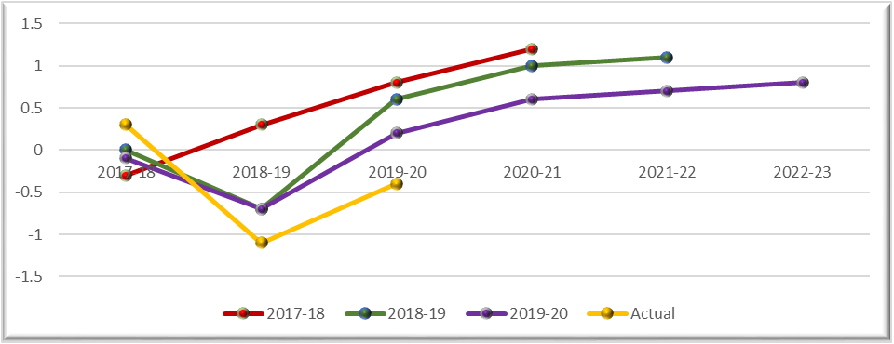
Source: NTG Budget Paper 3 2017/18, 2018/19 and 2019/20

Funding
A total of $6.9 million has been budgeted for delivery of the Masterbrand initiative over the last three years and $3.5 million budgeted over two years to implement the Population Growth Strategy.
Table 4: Budget/Estimates for Masterbrand and Population Growth Initiatives
Initiative | 2017/18 | 2018/19 | 2019/20
Masterbrand | $2.17 million | $2.97 million | $1.8 million
Population Growth | - | $1.78 million | $1.78 million
Source: Agency Internal Reporting

Department of the Chief Minister and Cabinet cont…
A sample of expenditure totalling approximately $3.5 million was reviewed across both initiatives in the following expenditure categories:
Brand Development | $1,193,077
Marketing and Promotion | $1,791,089
Research and Reviews | $487,610

Masterbrand
The budget for the Masterbrand initiative was not included in the 2017/18 Budget Paper 3 due to the commencement of the initiative being inconsistent with the budget timeframe. The budget for the Masterbrand was not included in the 2018/19 Budget Papers again due to timing around the decision to continue with the initiative.
Budgets were subsequently reported in the following year’s budget paper as a prior year estimate.
Figure 2: Masterbrand Budget vs Actual Spending
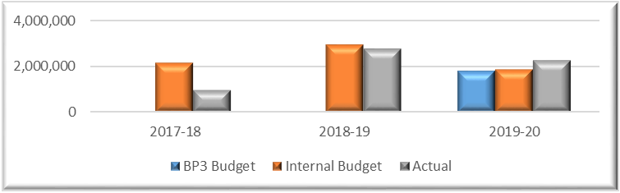
Source: NTG Budget Paper 3 2018/19 and 2019/20, Agency Internal Reporting
Total expenditure of $6.07 million is within the total budget of $6.9 million, with a 12% underspend.
Table 5: Masterbrand actual expenditure by category
Expense Category | 2017/18  ($) | 2018/19  ($) | 2019/20  ($)
Employee | 59,763 | 333,986 | 691,788
Grants | 0 | 0 | 41,350
Travel | 0 | 17,030 | 4,941
Consultant | 935,979 | 514,067 | 37,950
Marketing and Promotion | 0 | 1,865,373 | 1,395,549
Other | 843 | 54,377 | 114,831
Total | 996,585 | 2,784,833 | 2,286,409
Source: Agency Internal Reporting

Department of the Chief Minister and Cabinet cont…
‘Marketing and promotion’ expenditure was incurred promoting the Masterbrand through:

- Print Media
- Radio
- Outdoor signs
- Online News
- AFL Placement
- Television
- Cinema
- Social Media
- Magazine (Resident, Qantas, Virgin, Airnorth)

A campaign listing maintained by the Agency recorded 18 Masterbrand campaigns and two Population Growth campaigns.

Population Growth
Figure 3: Population Growth Budget vs Actual Spending
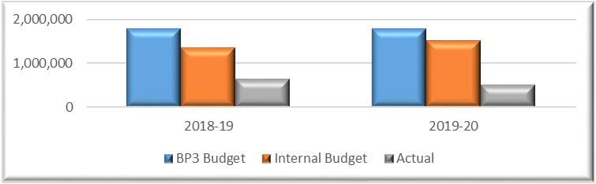
Source: NTG Budget Paper 3 2018/19 and 2019/20, DCMC Internal Reporting
Total expenditure of $1.12 million is within the total budget of $2.44 million, representing a 68% underspend. This underspend is consistent with the explanation provided regarding the Action Plan not being approved and the cessation of further action.
Table 6: Population Growth actual expenditure by category
Expense Category | 2018/19  ($) | 2019/20  ($)
Employee | 170,126 | 131,218
Grants | 74,375 | 13,273
Travel | 12,815 | 2,349
Consultant | 0 | 0
Marketing and Promotion | 360,137 | 304,682
Other | 4,942 | 47,961
Total | 622,394 | 499,482
Source: Agency Internal Reporting
Expenditure to deliver programs listed in the Action Plan including the “Welcome to the Territory Incentives” were not included in the above budget as these costs were not incurred by the Agency.

Department of the Chief Minister and Cabinet cont…
The Department of the Chief Minister and Cabinet has commented:
With the launch of the Population Growth Strategy 2018-2028, (the strategy) the Masterbrand program of work was included as a key focus area within the strategy. The Masterbrand and Population Growth Strategy programs of work aim to change misconceptions of the Northern Territory, position it is a destination of choice to live, visit, do business and invest, and attract key population demographics.
Specific metrics were identified for each of the marketing campaigns and periodic research was undertaken to ensure that cumulatively, the campaigns had achieved the overarching outcome of positively influencing negative views and opinions of the Territory with a view to encouraging people to see the Territory as a place to live, study, work and invest On each occasion, these metrics were achieved. This 10-year program of work has achieved positive results in a relatively short period, with independent research finding increased brand recall and 19% of the target audience expressing a positive shift in their likelihood to move to the NT after seeing the campaigns.
CM&C undertakes monthly performance reporting on priority projects to the Agency Executive Leadership team. The CM&C performance reporting process provides regular monitoring and reporting of our priority initiatives including the Population and Masterbrand program of work by the CM&C Executive Leadership Team. The CM&C monthly reporting process is continually reviewed and enhanced to ensure it is fit for purpose and an updated more contemporary format is currently being implemented.
The Population/Masterbrand Advisor/ committee (which included high level membership from the private sector, the social services sector, key Aboriginal organisations and government agencies) received regular progress reports relating to the work undertaken and the outcomes delivered, and reviewed and endorsed the proposed programs of work going forward.
The COVID-19 pandemic has had a significant impact on the continuation of the programs of work, with the delivery of the suite of initiatives disrupted due to lockdowns, economic impacts and travel restrictions.
Post COVID-19, we will seek policy advice as to the preferred approach relating to population growth within the Territory and develop an overarching plan based on this new advice.

Department of Corporate and Digital Development

E-Medication Management System Review

Background
The Department of Corporate and Digital Development (DCDD) provide enterprise information and technology services and shared corporate services to support Northern Territory (NT) Government agencies.
‘MedChart’ provides an electronic platform that streamlines medication prescribing, pharmacy reviews and nursing administration to reduce the likelihood of medication errors and improve coordination between clinical teams. The NT Government has two separate instances of the MedChart medication management system:
- The Acute Care Medication Management System (eMMA) solution is currently being used at Royal Darwin Hospital (RDH), Alice Springs Hospital, Katherine Hospital, Gove District Hospital and Tennant Creek Hospital.
- The Medication Management System (PCIS MedChart) is a different version of the electronic medication management system and has been implemented across Remote Health Centres, Terrace Gardens Aged Care Facility and NT correctional facilities in Darwin and Alice Springs.
The eMMA system was initially implemented between 2006 and 2010 across RDH, Katherine Hospital and Gove District Hospital.
Due to a range of issues related to inadequate infrastructure, insufficient systems support and resourcing and systems governance issues, the use of eMMA at RDH ceased in December 2010. In 2011, the Department of Health engaged the Department of Corporate and Information Services and iSoft to fix issues related to the eMMA infrastructure and application respectively. From 2011, the improved version of eMMA has been progressively implemented across Tennant Creek Hospital, RDH and Alice Springs Hospital.
The functionality in eMMA is continuing to be expanded and enhanced, with further rollout initiatives planned. Changes will continue to be made to the eMMA solution, including integration of new modules (e.g. infusions module), mobility and enhanced data integration to new health systems and platforms.
The functionality of eMMA has continued to expand however Agency representatives advised that, in the next 24 months, a new system is to be progressively implemented that will gradually phase out the eMMA and PCIS MedChart solutions. Currently, the systems are continuing to be updated where relevant to ensure effective operation until the new solution is finalised.

Department of Corporate and Digital Development cont…

Scope and Objectives
This review assessed aspects of general information technology controls in relation to two information systems managed for the Department of Health (DoH). The scope of this review addressed the following aspects as they relate to each system:

Acute Care Medication Management System (eMMA)
- Information security management
- User access management
- Systems change management
- Data interface controls
- Backup and recovery
- The status of action taken to address findings raised during the post implementation review conducted at DoH by my Office on the Acute Care Medication Management System in 2017 was evaluated.

Remote Healthcare Medication Management System PCIS MedChart (PCIS MedChart)
The review involved obtaining a high level understanding of information technology controls implemented in relation to PCIS MedChart.
The review evaluated the status of action taken to address recommendations arising from an earlier related review of PCIS MedChart conducted at DoH by my Office in 2017.
The findings are based upon review of documentation, limited testing and discussions with relevant personnel from DCDD personnel. Prior to machinery of government changes, DCDD was the Department of Corporate and Information Services (DCIS).

Limitation of Scope
My Authorised Auditors performed a limited evaluation and testing of general computer controls across the application, database and operating systems relating to eMMA and PCIS MedChart. Travel restrictions in response to COVID-19 in place at the time of testing required the review to be performed remotely using technology for undertaking interviews and evidence gathering.
Testing within this review was directed at only those items identified in the Scope section of this report. A number of information technology controls relating to network security controls, cryptography and data processing are managed by DCDD. These controls were not subject to testing during this review.
The ability to test and verify users who have access to the ‘sa’ account in the SQL database server was impaired as the evidence is stored in a server controlled by Data Centre Services.

Department of Corporate and Digital Development cont…

Conclusion
Based on the scope of review and testing performed, except for the matters raised in this report, key general computer controls tested in relation to the review scope appeared to have operated effectively throughout the review period. A number of technology issues previously raised in 2017 have not been fully remediated or the identified risk has been accepted by management with management not intending to undertake further mitigating actions.

Recommendations
Audit observations identified the following opportunities to enhance the controls tested during the review:
- continue to assess whether the Human Resources and Identity Access Management systems can be interfaced to ensure timely disablement, and whether changes to roles or temporary holds on access can be enforced digitally;
- ensure regular reviews and checks are performed on all users and ensure their access is terminated at both the network level and application level;
- review the file level access and update the permissions to ensure they are appropriate;
- update the eMMA password settings to align with established practice settings to increase account security;
- maintain auditable evidence on the outcome of the reviews of logs that are performed by the eMMA System Administrator;
- ensure user access forms are completed and approved prior to access to the system being changed;
- review the access of the identified users / accounts for appropriateness and determine if the access level is required to be updated to reflect the users’ current positions and business requirements;
- review the active guest accounts for both eMMA and PCIS MedChart and verify whether or not they are required to be enabled;
- consider upgrading the configuration where disaster recovery testing can be performed;
- ensure that the plans are tested and updated at least annually to reflect lessons learned;
- put in place monitoring controls for the duration that the PCIS MedChart remains in use;
- ensure the current database version remains secure and able to effectively interface with supporting systems;
- put in place processes and practices to identify and deactivate generic user accounts that have not been used for a period of time; and
- give consideration to implementing additional data protection measures in order to reduce the risk of data being lost or stolen.

Department of Corporate and Digital Development cont…

Audit Observations
Audit procedures confirmed that the majority of controls tested during this audit were working effectively.
A review of action taken by DCDD and/or DoH to address the findings raised in my audit undertaken at the Department of Health in 2017 found that three of the recommendations had been fully addressed through management action; five of the recommendations have been partially addressed through management action; and, in one instance, management had chosen to accept the associated risk rather than taking action to address the issue.
Deficiencies were identified in user access revocation and review processes where instances were identified where employment has terminated but access to eMMA has not been revoked.
Review of the file level access permissions to system, data and application files critical to eMMA identified that accessibility could be further restricted.
The password configuration within eMMA is not aligned with NT Government Password Policy.
The eMMA System Administrator is able to undertake logging and monitoring activities however there were limitations to obtaining evidence to verify that logging and monitoring activities were implemented and effective.
A sample of 25 new users was selected for testing to verify if the user access process was operating effectively. Two users did not have a formal user access request or clinical form completed to demonstrate approval for changes to their access permissions when their positions and roles were subsequently updated (as required to comply with the current user access process). These two users had their access originally created in 2015 and 2017 respectively under the procedures and processes that existed at the time.
User access is periodically reviewed in accordance with supporting policies and procedures using manual scripts that are run by the eMMA System Administrator however no auditable evidence or outcomes is retained to demonstrate the user activity reviews occurred.
Review of the accounts that have access to an owner role identified 13 accounts / users have access to this role. DCDD representatives stated that the accounts / users assigned are appropriate, however six of the 13 accounts do not have the correct access level assigned.
Eleven out of eighteen database accounts have the guest account as ‘enabled’ across their servers.
The DoH data centre has a disaster recovery plan that is updated annually to reflect major incidents throughout the day (if any). The disaster recovery plan has not been tested within the last 12 months. The current configuration for MedChart does not have disaster recovery, high availability or ability to failover incorporated due to the version of MedChart that is currently in use.
Review of the patch/security updates installed on the database servers identified that the latest version had not yet been installed. DCDD representatives advised that there are no plans to upgrade to a more current version as upgrading may result in integration and interface issues with MedChart and other applications and PCIS is due to be replaced by the new Acacia system in the next 12 to 18 months.

Department of Corporate and Digital Development cont…
Review of PCIS MedChart users demonstrated two generic/system test user accounts. These accounts were originally created to assist with production verification testing after upgrades into PCIS Production, as well as for investigating and resolving Production issues. The security groups assigned to these accounts allow functional access to a range of system functions and data. There is logging enabled to record when the accounts were used and the activity undertaken. These accounts are rarely used.
Limited control strategies exist to enforce consistent data protection across the environment. Control strategies may include practices such as information classification; restriction of communication of patient information via public email; and encryption of sensitive information on mobile storage devices.

Department of Corporate and Digital Development cont…
The Department of Corporate and Digital Development has commented:
The digital medications systems examined in this audit are legacy platforms completing their serviceable working life. A number of the audit issues identified are specific to the software and reasonably typical for such legacy systems.
The Department is working in partnership with NT Health to deliver a contemporary digital e-health platform through the Core Clinical Systems Renewal Program (CCSRP) which will see eMMA and eMMA MedChart replaced by the new fully integrated 'Acacia' solution.
In the interim, a range of measures are being implemented to strengthen controls, including a software version upgrade, transitioning user access provisioning and related support services to the NTG's ICT service centre and introduction of new service management support tools.
The Department is maintaining the reliability of the current e-medications systems while working in parallel to deliver the new Acacia solution.

Department of Corporate and Digital Development

SerPro (PROMIS Replacement Project) Review

Background

PROMIS
The Police Realtime Online Management Information System (PROMIS) is the primary information and case management system for the NT Police. PROMIS was introduced on 12 May 1999 and provides the NT Police with a single application in which all cases and incidents are managed or investigated on a Territory-wide basis.
PROMIS is supplied under license to the NT Police by the Australian Federal Police. PROMIS is hosted on a combination of windows and UNIX servers and has a three tier landscape with production, test and training instances. PROMIS was maintained in-house by the NT Police information technology team with support from contractors and is now maintained by the Department of Corporate and Digital Development (DCDD). The database that supports PROMIS is hosted and managed by Data Centre Services.

SerPro
The system intended to replace PROMIS is referred to as the Serve and Protect (SerPro) system.
Budget Paper No. 3 2017/18 (as it applied to DCDD’s antecedent agency, the Department of Corporate and Information Services [DCIS]) announced $45 million over four years for the replacement of PROMIS.
The Northern Territory Police, Fire and Emergency Services annual report for the year ended 30 June 2019 reported:
“Achievements in 2018–19 include the completion of the …. work to replace the PROMIS system”.
“The SerPro Steering Committee ensures the successful delivery of a contemporary, integrated solution that will support policing activity across the Northern Territory. SerPro effectively replaces the current core ICT System: the Police Real-time Online Management Information System (PROMIS).
A detailed program plan was achieved and approved, which has been divided into three phases known as functional blocks. The program is now in functional block 1 (phase 1) and is expected to be completed before the end of 2019.”

Department of Corporate and Digital Development cont…
The annual report for DCIS for the year ended 30 June 2019 reported the following status in relation to the program:
- Completed:
Completed the detailed program planning phase.
Developed a comprehensive design and implementation plan articulating the approach to roll-out SerPro.
Engaged over 300 Police Officers across the NT in planning the requirements for a new policing solution.
Developed and released an educational video showcasing SerPro to assist police officers get ready for the transition to a new policing solution.
Developed the champions’ network kit to support and guide SerPro champions.
- In progress:
Configuring of the system based on approved business requirements.
Completing the first SerPro survey to capture initial views of sworn officers’ requirements in terms of training, communication and engagement.
Bringing together governance of the SerPro and VERITAS programs to align delivery of these programs.
Completing design and development of training materials.
Implementing change management plans for policing functions impacted by the introduction of the new SerPro system.
Undertaking system testing to ensure readiness.
The annual report for DCIS for the year ended 30 June 2020 reported the following status in relation to the program:
“Major Digital Programs
SerPro case management system for Police – design and configuration of core functional components of the new policing system has progressed, with key components such as Entities and Occurrences, Custody and Warrants and other foundation functionality completed and tested. Detailed design analysis has been completed for the investigations function and technical planning for the complex series of integrations to other Territory and national public safety business systems undertaken. Strategy and approach for the migration of data from legacy systems is complete with work in progress to cleanse data to be migrated. Development of training materials in preparation for roll-out is well progressed and a network of ‘SerPro Champions’ made up of over 100 sworn officers is actively working to optimise engagement with frontline police in preparation for deployment of the new system in 2021.

Department of Corporate and Digital Development cont…
Future Priorities
Serpro – continue configuration and system integration activities to complete the initial release version of the new SerPro solution in readiness for user testing mid-2021. Align development with other digital reforms being progressed within the justice continuum related to firearms management and courts business processes.”

Scope and Objective
The objective of this review was to assess the following areas in relation to the SerPro system implementation that is intended to replace PROMIS:
- Progress of SerPro against the defined budget and stated objectives; and
- Risk and issue management.

Conclusion
Based on the procedures performed and evidence obtained during the course of this review, except for the delays to delivery attributed to resource constraints caused by the response to COVID-19, nothing has come to my attention that caused me to believe that DCDD had not progressed the project deliverables in accordance with the planned milestones and budget.
Notwithstanding the review did not identify any significant matters that require remediation, close monitoring and effective management will be required to ensure the deadlines are achieved within the approved budget of $45 million.

Audit Observations

Progress of SerPro against the defined budget and stated objectives

Business case
A Business Case was developed by NT Police in January 2017. The latest update to the Business Case (at the time of my review) was prepared by DCIS on behalf of NT Police in January 2020.
The primary driver for the project was that PROMIS was unreliable and nearing end-of-life. Consequently the essential outcomes were that the replacement system would be fit-for-purpose, reliable and contribute to improved operational efficiency. The Business Case included no cost/benefit analysis and quantified no return on investment however it did specify that the system being implemented needed to be fit-for-purpose and cost effective.
The Business Case contained a detailed description of the existing situation including system limitations and the business requirements to implement the SerPro solution. Various information system solutions were considered with SerPro being evaluated and determined as the best option.
Based on the understanding of the program scope; potential system costs; and the progress of the project at the date of preparation, Version 3 of the Business Case estimated the total cost and funding required to implement the program as $45 million over the period 2017 to 2021. This excludes costs associated with time spent on the project by sworn officers at an anticipated cost of $8.1 million. The Business Case identified annual recurrent costs of $5.3 million to maintain the system from 2022.

Department of Corporate and Digital Development cont…

Variance analysis and forecasting
A program cost model is maintained that focuses on the high level numbers when forecasting to budget. The model captures both non-resource and resource related costs. As human resources are a major contributor to the overall cost of the project, a full-time equivalent employee approach is applied for budgeting and forecasting purposes.
There is a cost monitoring process in place within DCDD which involves frequent financial reporting with the forecast being compared to the approved budget to ensure anticipated future spending remains within the budgeted allocation.
The Project Scope and Project Management Plan were approved by the project sponsor, NT Police. The project documentation includes a Program Scope section that summarises the scope defined by the Work Breakdown Structure. The Work Breakdown Structure defines specific work packages which are aligned to the Business Case. Both ‘in scope’ and ‘out of scope’ items were defined within the Project Management Plan.
The Project Management Plan contains a detailed Change Control Procedure to address scope and schedule changes. The Change Control Procedure specifies both identification and approval processes. Variation Management defines the mechanisms, standards and activities that must occur to manage changes to the program scope and all related activities and deliverables. The Variation Management process provides the mechanism for identifying, analysing, approving and monitoring changes to the program baselined configured items, including the addition of new configured items. The process involves documenting identified change requests, performing an analysis of the impacts of the requested change, submitting the change requests for disposition (approval, denial or deferral) and monitoring the progress of approved change requests.
There are two main reports that are being used to report on the progress against defined budget – the Program Highlight Report and the SerPro Finance Report.
The Program Highlight Report reports progress against the defined scope of the project at two different levels, the overall program level and the current phase level. The SerPro Finance Report supports the high level Program Highlight Report. Separate finance reports are presented to the governance groups containing financial information including the total budget allocated to a particular program phase and the actual amount utilised as well as the forecast for the next period. These reports indicated that actual expenditure was within the budgeted allocation at the time of my review.
The program schedule is approved and communicated to stakeholders with progress against the program schedule reported to the relevant committees on a monthly basis. The Program Management Plan contains a detailed program planning section which spans five years (from 2017 to 2021 inclusive) broken down into six phases from planning to closure. Key deliverables, and indicative milestone dates, are also included within the Program Management Plan.
The original timeframe for delivery of project stages was not on schedule at the time of my review with the current status being stated as “deviated, recoverable”. The predominant reason identified by DCDD for the deviation was that the impact of responding to COVID-19 restricted the availability of resources within both NT Police and the SerPro team (including the vendors).

Department of Corporate and Digital Development cont…

Critical success criteria
DCIS and NT Police considered the critical factors against which to assess the success of the program to be the quality and cost of the program.
The key constraints defined in the Project Management Plan are the timeline, resources, business processes and PROMIS major failure. Progress against scheduled cost, time, scope and resources is reported within the program status reports.

Program benefits
Because the Business Case was primarily focused on the cost of the replacement system and its fitness for purpose, whilst some other benefits were considered, no detailed benefits realisation plan was initially developed. There are mechanisms being developed as part of the Benefit Realisation Strategy to support the final decision and demonstrate further anticipated benefits to NT Police when the system goes live.
The Benefit Realisation Strategy was approved by the Program Steering Committee and lists the benefit realisation approach, delivery and benefit realisation planning. The purpose of the Benefits Realisation Strategy is to take the approach from the Business Case and apply findings from the initial states of the program and plan for their realisation in later states of the program and post-implementation.
A Benefits Realisation Plan (in draft form at the time of my review) is intended to be used to manage and report on the progress of the strategy both during and post-implementation of SerPro.

Risk and issue management
DCDD’s Enterprise Project Services (EPS) risk management framework is applied to all programs and projects that are run under EPS auspices.
As part of the overall Northern Territory Government ICT Governance Framework, the ICT Project Risk Management Guideline (the Guideline) was approved by the Chair, ICT Governance Board in August 2017 to provide a standard approach to manage risk within ICT projects in the NTG. The Guideline is based on PRINCE2 Project Management Methodology and can be applied across different project scales, project types, organisations, geography or culture. The Guideline defines the roles and responsibilities of different project stakeholders for risk management at multiple levels.
The program risk management process is based on a cycle of five stages; Identify, Assess, Plan, Implement and Communicate. A Risk Matrix has been developed to categorise the likelihood of a risk occurring and the consequence which that risk could present to the program. Multiple consequence ratings have been assigned to the risks ranging from Minor to Catastrophic. Risk treatment options have been defined as part of the risk management process.
The Risk Register maintained for SerPro documents the associated project risks categorised in line with the framework requirements. The risk action update history is maintained within the Risk Register to track any changes or updates to the risk mitigation strategies.
Current and prospective project risks are discussed and reviewed at regular intervals in working group meetings to assess any change in the likelihood and consequences of the documented risks and to identify any new project risks that might have emerged as a result of a change in project circumstances. Risks and issues are reported to the program governance committees.

Department of Corporate and Digital Development cont…
The Department of Corporate and Digital Development has commented:
The Department of Corporate and Digital Development appreciates the audit review and is pleased to note that, following a thorough examination of SerPro Program’s performance, no audit issues requiring action or remediation were identified.
The SerPro program is tracking to plan with the new solution to be delivered within the approved funding.

Selected Agencies

Annual Leave Entitlements

Background
The objective of this assessment was to examine leave accruals for Northern Territory Government employees recorded in the Personnel Information and Payroll System (PIPS) at 30 June 2020 in order to identify any employees that had accumulated annual recreation leave entitlements greater than 12 weeks (441 hours) and to provide information about those employees to the relevant entity’s management for review and follow-up.
The entities included within the analysis, as they existed at 30 June 2020, were:
- Aboriginal Areas Protection Authority  - Batchelor Institute of Indigenous Tertiary Education  - Board of the Museum and Art Gallery Northern Territory  - Central Australia Health Service  - Data Centre Services  - Department of Corporate and Information Services  - Department of Education  - Department of Environment and Natural Resources  - Department of Health  - Department of Local Government, Housing and Community Development  - Department of Infrastructure, Planning and Logistics  - Department of Primary Industry and Resources  - Department of the Attorney-General and Justice  - Department of the Chief Minister  - Department of the Legislative Assembly  - Department of Tourism, Sport and Culture | - Department of Trade, Business and Innovation  - Department of Treasury and Finance  - Land Development Corporation  - Northern Territory Auditor-General's Office  - Northern Territory Legal Aid Commission  - Northern Territory Police, Fire and Emergency Services  - NT Electoral Commission  - NT Fleet  - NT Home Ownership  - NT Treasury Corporation  - Office of the Commissioner for Public Employment  - Ombudsman's Office  - Power and Water Corporation  - Power Generation Corporation  - Power Retail Corporation  - Territory Families  - Territory Wildlife Parks  - Top End Health Services

Selected Agencies cont…

Overall Assessment
My review of the data related to leave highlights the necessity for entities to manage staff leave on a continual basis and ensure that staff take their leave entitlement in a timely manner.
The fact that the assessment has identified items as reported in the key findings below does not mean that there are not other matters of which management should be aware in meeting their responsibilities, nor does this report absolve them from taking appropriate action to meet their responsibilities. It should be noted that this assessment did not constitute an audit.

Key Findings
A similar analysis of employee leave data was undertaken by my office on the employee leave records as at 28 February 2017. Where relevant to the analysis, I have provided comparative figures from 28 February 2017.
PIPS had 23,836 unique employees recorded on the annual leave report as at 30 June 2020 (22,843 at 28 February 2017). I have recommended that the entities review the report to ensure the report is reflective of current staff status.

Over 12 weeks annual leave entitlement
No employees with an entitlement greater than 441 hours were identified at the following entities:
- Batchelor Institute of Indigenous Tertiary Education;
- Land Development Corporation;
- NT Home Ownership; and
- Northern Territory Legal Aid Commission.
2,732 employees (11.5%) were identified with annual leave entitlements greater than 441 hours as at 30 June 2020 (2017: 2,397 employees (10.1%)). Leave entitlements greater than 441 hours represent a liability (excluding on-costs) of approximately $101.5 million (2017: $80.5 million).
The highest annual leave balance for an individual employee was 2,918 hours (2017: 4,775 hours). This is approximately 397 days of annual leave representing a liability (excluding on costs) of approximately $246,142 (2017: 650 days, $396,658).
To put this particular employee’s entitlement into context (at the time of the analysis) and taking into account annual public holidays, if this employee commenced leave on 1 July 2020, received 30 days annual leave credit per annum, took all of their annual leave first, took five days per annum personal leave (with certificate – thus ‘crediting back’ five days annual leave), then took their long service leave, this employee could be on fully paid leave until February 2023.

Selected Agencies cont…
Graph 1 shows the total number of employees and the approximate dollar value of the liability within the specified entitlement range and shows that 15,105 employees (2017: 15,411) had a leave entitlement between zero and six weeks with a total value of $88.1 million payable to them (2017: $67.0 million), and 5,947 employees (2017: 4,971) had an annual leave entitlement between six and 12 weeks with a total entitlement value of $105.8 million (2017: $80.0 million).

Graph 1: Employee annual leave entitlements – by number of employees
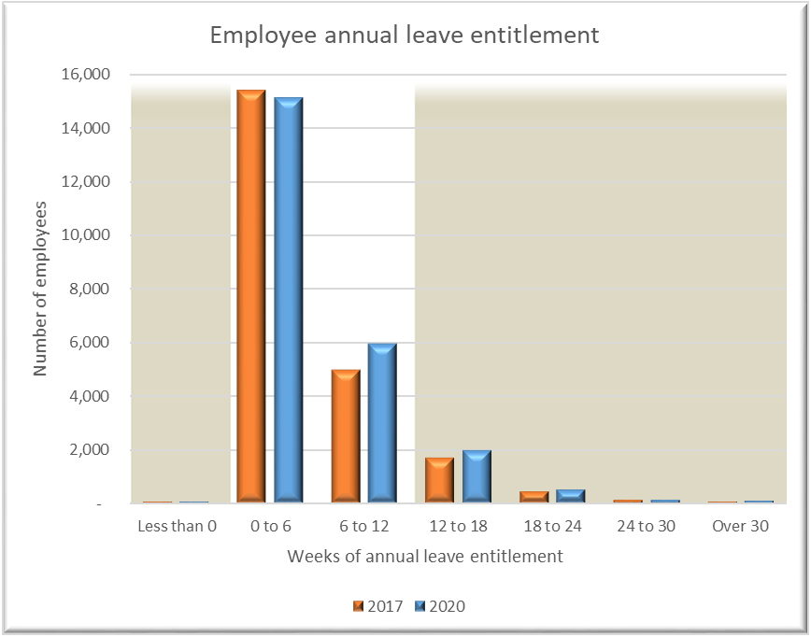

Selected Agencies cont…
Graph 2 presents the approximate dollar value of the liability within the specified entitlement range. This graph shows that 2,732 employees (2017: 2,397) have an annual leave entitlement of over 12 weeks, with an associated liability of over $101.5 million (2017: $80.5 million).

Graph 2: Employee annual leave entitlements – by approximate total dollar value.
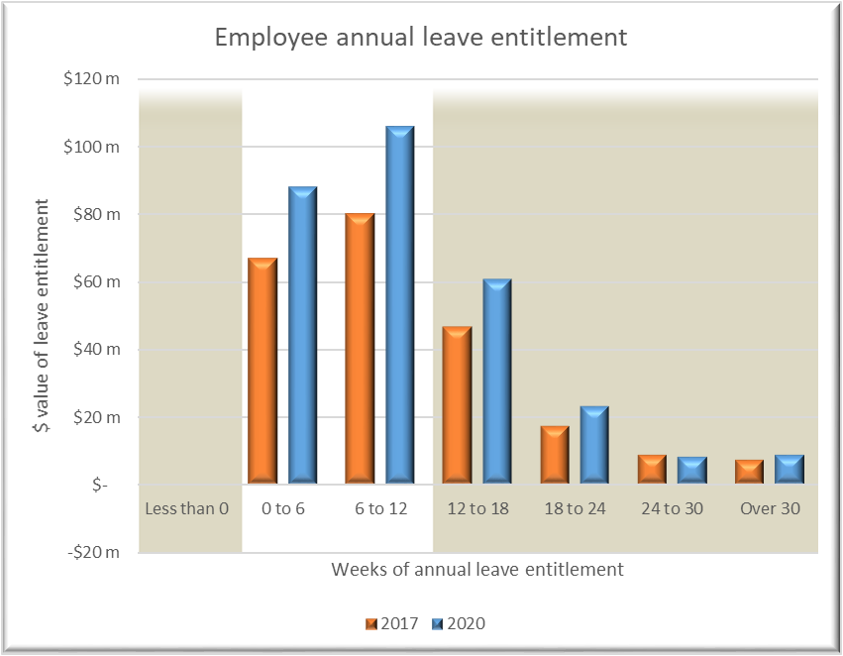

Selected Agencies cont…
Graph 3 identifies, by entity, the number of employees with an annual leave entitlement greater than 441 hours.
Graph 3: Employees with annual leave entitlements over 441 hours – by entity.
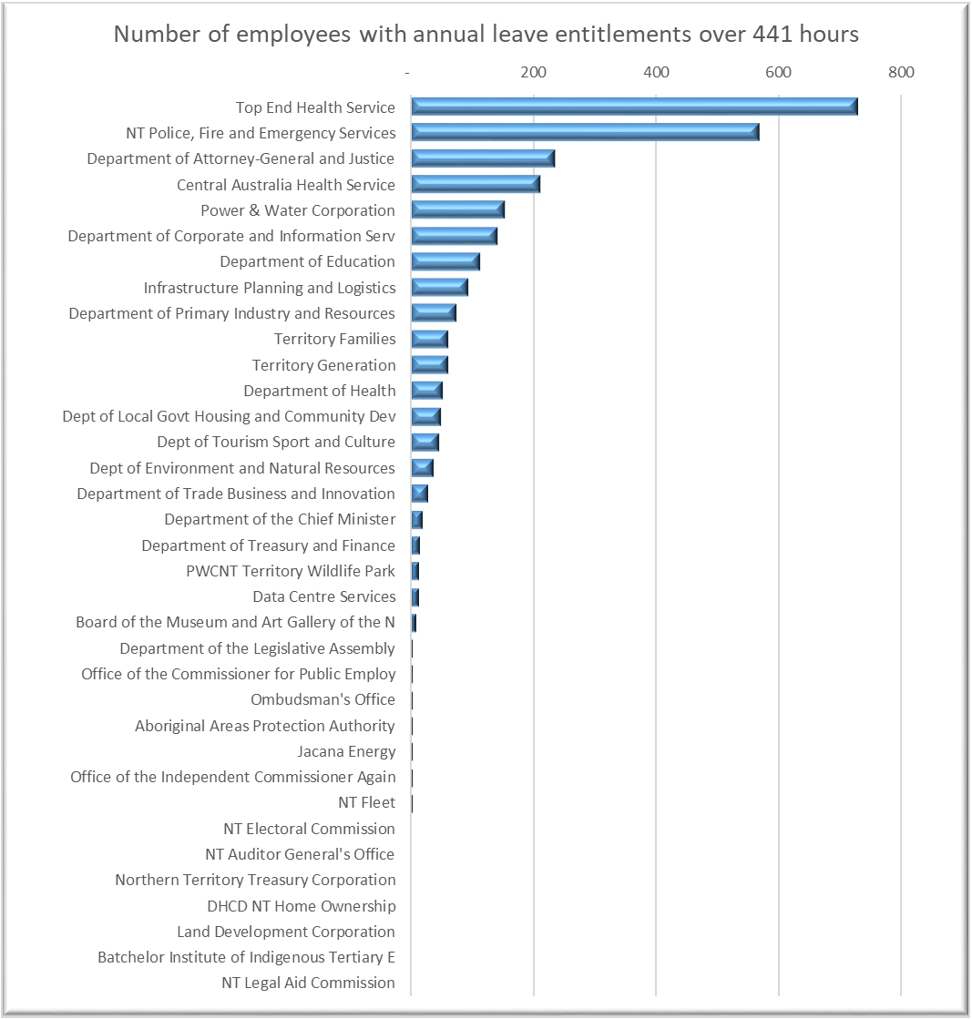

Selected Agencies cont…
Graph 4 shows the distribution of the 100 employees with the highest annual leave entitlements in the public sector, by entity.
Graph 4: Distribution of the 100 employees with the highest annual leave entitlements, by entity.
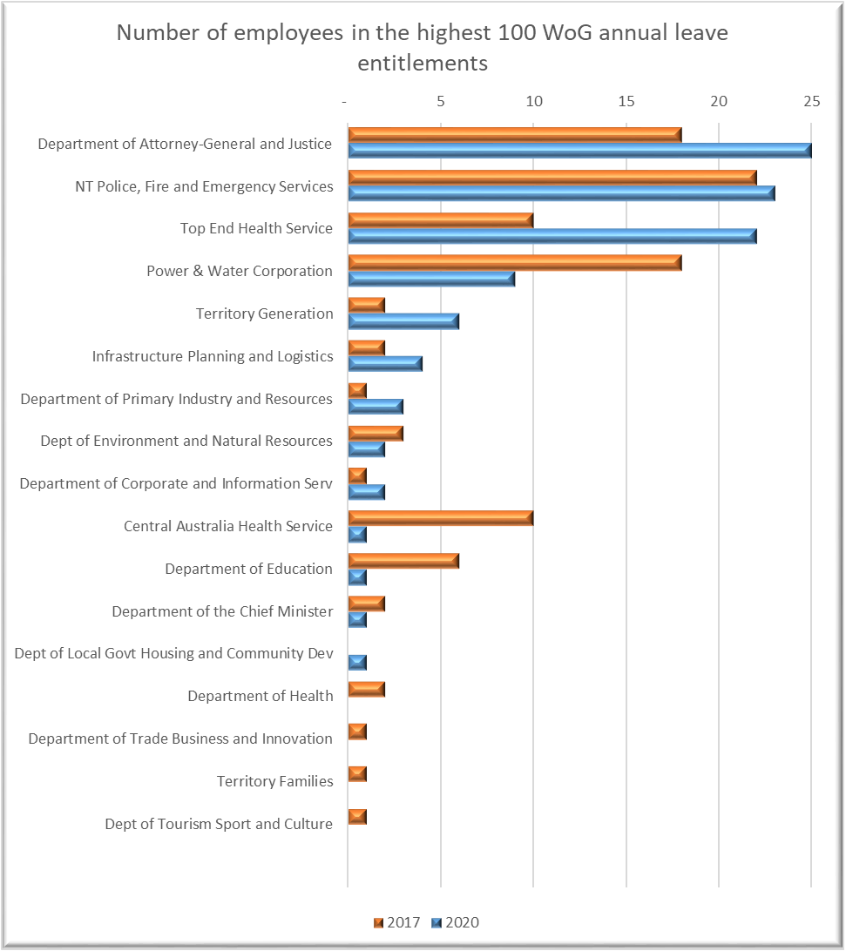

Selected Agencies cont…
Five entities have been highlighted in this report due to the significant numbers of employees with annual leave entitlements greater than 441 hours within these entities. A summary of the results from the analysis relating to these five entities as at 30 June 2020 is presented below.
- Top End Health Service
  - 5,364 employees (2017: 4,378)
  - 729 employees (14%) with more than 12 weeks leave entitlement (2017: 502 [11%])
  - $26.5 million of the total leave liability relates to leave greater than 441 hours (2017: $15.6 million)
  - The five employees with the highest annual leave entitlements have a collective annual leave entitlement of 228 weeks with an associated value of $1,382,999.
- Northern Territory Police Fire and Emergency Services
  - 2,263 employees (2017: 2,163)
  - 567 employees (25%) with more than 12 weeks leave entitlement (2017: 498 [23%])
  - $21.7 million of the total leave liability relates to leave greater than 441 hours (2017: $16.6 million)
  - The five employees with the highest annual leave entitlements have a collective annual leave entitlement of 212 weeks with an associated value of $450,784.
- Department of the Attorney-General and Justice
  - 1,524 employees (2017: 1,590)
  - 235 employees (15%) with more than 12 weeks leave entitlement (2017: 259 [16%])
  - $8.9 million of the total leave liability relates to leave greater than 441 hours (2017: $8.4 million)
  - The five employees with the highest annual leave entitlements have a collective annual leave entitlement of 255 weeks with an associated value of $517,813.
- Central Australia Health Service
  - 2,104 employees (2017: 1,863)
  - 211 employees (10%) with more than 12 weeks leave entitlement (2017: 234 [13%])
  - $7.2 million of the total leave liability relates to leave greater than 441 hours (2017: $7.3 million)
  - The five employees with the highest annual leave entitlements have a collective annual leave entitlement of 142 weeks with an associated value of $205,049.

Selected Agencies cont…
- Power and Water Corporation
  - 876 employees (2017: 989)
  - 152 employees (17%) with more than 12 weeks leave entitlement (2017:132 [13%] )
  - $7.3 million of the total leave liability relates to leave greater than 441 hours (2017: $6.9 million)
  - The five employees with the highest annual leave entitlements have a collective annual leave entitlement of 263 weeks with an associated value of $738,233.
The risk of allowing employees to accrue significant leave balances is that:
- Cash flows may be impacted if employees were to leave the entity unexpectedly.
- Not taking leave is detrimental to employees’ performance and wellbeing resulting in work, health and safety risks.
- Operational risks can arise associated with rosters, staff scheduling and service delivery.
- There is the potential that leave may have been taken by an employee but the leave application forms were not submitted and/or approved correctly.
- There is a financial risk associated with many staff taking their full leave entitlements at the same time.
- There is an increased risk that fraud may occur and not be detected.
- The carry forward of significant leave balances results in increased real cost to the Northern Territory as these leave balances will generally be paid out at a higher rate of salary than the level at which those leave balances were accrued.
The Public Sector Employment and Management By-Law 4.6, states that:
“Where an employee has accrued recreation leave entitlements in excess of two (2) years (or three (3) years in the case of a compulsory transferee), the CEO may, on giving a minimum of two (2) months’ notice, direct the employee to take recreation leave and the Employee must take that leave within a three (3) month period, or a period agreed between the parties, to reduce the accrued leave balance to the equivalent of two years (or three (3) years in the case of a compulsory transferee) of entitlements.”
Clause 42.7 of the Northern Territory Public Sector 2017-2021 Enterprise Agreement is similar to the by-law. Other Enterprise Agreements (for example the Northern Territory Police Force Consent Agreement 2019) have similar clauses. I acknowledge that, in some instances, the standard leave entitlements within some agreements provide for annual leave entitlements that exceed six weeks leave per annum for some categories of employees.
Although directing an employee to take recreation leave is left to the discretion of the Chief Executive Officer (CEO), I have recommended that CEOs implement a formally endorsed and documented procedure for monitoring employees’ recreation leave entitlements. This procedure should incorporate a reporting process to provide the CEO with sufficient information to decide whether or not it is appropriate for an employee to be directed to take leave should the circumstances allow (i.e., there would be no significant impact on operations/ongoing projects).

Selected Agencies cont…
I recommended that management actively monitor and manage employees with annual leave entitlements exceeding 441 hours to reduce the risk exposure. The entities may need to develop temporary succession arrangements to assist in this regard.

Negative annual leave entitlement
52 employees had negative leave entitlements at 30 June 2020 with overpaid entitlements of approximately $42,808 (2017: 64, $58,580).
The following negative annual leave entitlements in excess of 20 hours were identified within the report:
 |  | Hours | Equivalent Days | $
Employee A | Top End Health Service | (364)¹ | (50) | (12,609)
Employee B | Central Australia Health Service | (42) | (6) | (1,936)
Employee C | NT Police, Fire and Emergency Services | (39) | (5) | (2,364)
Employee D | Department of the Attorney-General and Justice | (35) | (5) | (1,659)
Employee E | Central Australia Health Service | (35) | (5) | (1,156)
Employee F | NT Police, Fire and Emergency Services | (32) | (4) | (1,311)
Employee G | Top End Health Service | (29) | (4) | (1,063)
Employee H | Central Australia Health Service | (29) | (4) | (1,160)
Employee I | Top End Health Service | (24) | (3) | (1,253)
Employee J | Department of Health | (22) | (3) | (1,094)
Employee K | Top End Health Service | (20) | (3) | (1,558)
1 This employee was also recorded as having a significant negative balance (336 hours) as at the year ended 30 June 2019.

Selected Agencies cont…
Central Australia Health Service has commented:
CAHS continues to monitor excess leave instances through regular management reporting and through CAHS financial management governance structures. The percentage of total employees with excess leave has decreased over the past four years, from 12% of 1893 employees in 2017 to 10% of 2104 employees in 2020.
CAHS regularly reviews negative leave instances with the majority relating to system timing issues. The materiality of the instances is low

The Department of Corporate and Digital Development, Data Centre Services and NT Fleet has commented:
Reports of excess leave for DCDD, NT Fleet and Data Centres Services staff are reviewed by senior leaders on a bi-annual basis. Staff with excess recreational leave, and their managers, are notified and arrangements made to reduce their leave balances having regard to operational and personal needs.

The Department of Education has commented:
The Department of Education notes the assessment and will be working with those staff with significant leave balances to ensure that they develop and implement a plan to use their leave within a reasonable period.

The Department of the Attorney-General and Justice has commented:
The Department has been actively addressing the accumulation of high leave balances by some employees. Divisional managers have been required to implement individual leave reduction plans and this has led to decreases in some divisions although too many accumulated entitlements remain excessive. Staffing shortages may result in some continued challenges.
The Department continues its efforts to reduce high leave balances and an independent internal audit of excessive accumulated leave has been programmed for the 2021/2022 year.

Northern Territory Police, Fire and Emergency Services has commented:
The Northern Territory Police, Fire and Emergency Services (NTPFES) has noted the findings of the Audit. The NTPFES acknowledges that while its COVID-19 response did not create the current leave holdings, it has exacerbated the issue and restricted the agency’s ability to actively reduce leave holdings. The NTPFES continues to monitor leave holdings and mitigate risk where identified.

Selected Agencies cont…
The Office of the Independent Commissioner Against Corruption has commented:
We support the Auditor-General's observations concerning the administrative, financial and performance risks associated with significant leave balances. Further, we confirm that excessive leave balances (specifically employees avoiding taking leave) is an identified enabler of improper conduct.
We confirm that two ICAC staff members captured within this audit are subject to mutually agreed upon corrective action, which is consistent with Northern Territory Public Sector 2017-2021 Enterprise Agreement. The Office of the Independent Commissioner Against Corruption has a process for monitoring employees' recreation leave entitlements, which includes active monitoring, quarterly reporting and corrective remedies.
We thank the Auditor-General for her ongoing oversight of the Office of the Independent Commissioner Against Corruption, which is complementary to our strategic aim of demonstrating public sector accountability and transparency.

Top End Health Service has commented:
The Annual Leave analytics review was undertaken on 30 June 2020 data, which was in the middle of the Northern Territory’s (NT) COVID-19 response. Clinical staff were requested not to take leave around that time, in case there was an outbreak of COVID-19 in the NT. Since March 2020, TEHS has been required to maintain surge workforce capacity to undertake pandemic work such as: provision of hotline services, COVID-19 clinics, preparation of COVID-19 documentation and communication material, assist with quarantine facility clinics, in addition to delivering business as usual health services. TEHS January 2021 excess leave report reported a total number of excess recreational leave hours as 151,220.83 equating to $11,920,911 and showing a significant reduction.
TEHS reviewed the original source data for the Annual Leave Analysis review and found, with assistance from the Department of Corporate and Digital Development that the negative leave balances listed were incorrect. The errors have been rectified and negative leave balances are no longer recorded against any of the 16 employees. In addition to regular excess leave reporting, TEHS has implemented leave reduction planning and tracking with a FAQ and messaging provided to support managers in the implementation of their leave reduction plans.

Selected Agencies

Job Creation

Background
“A key priority of the Territory Government is to help sustain long-term growth and employment opportunities in the Territory economy” (2019-20 Budget Paper 3). To support this priority, the Northern Territory Government (NTG) reports ‘jobs supported’ figures in relation to individual projects.
The NTG supports major projects undertaken by the private sector that are anticipated to positively impact the Territory economy through the creation of jobs and business opportunities. Such support is delivered through:
- Major Project Status projects;
- Government facilitated projects;
- Market-led Proposals Policy; and
- the Local Jobs Fund.
The former Department of Trade, Business and Innovation (DTBI) released an Investment Timeline presenting intended projects, investments and jobs supported from 2019 to 2024. Employment measures applicable to projects funded through the Local Jobs Fund have been communicated through media releases.
The Department of Infrastructure, Planning and Logistics (DIPL) is responsible for delivering the NTG’s infrastructure program. This includes “government’s capital works, minor new works, and repairs and maintenance programs in addition to delivering the 10-year Infrastructure Plan to ensure a continuous pipeline of work for industry and create sustainable jobs”. (2019-20 Budget Paper 3)
The annual report for DIPL for the year ended 30 June 2020 identified key projects and reports the ‘jobs supported’ for most of the identified projects.

Scope and Objectives
This audit concentrated on performance management systems and processes implemented to calculate the ‘jobs supported’ figures reported in reference to projects and investments managed or supported through the Department of the Chief Minister and Cabinet (DCMC) and DIPL.

Changes to Scope
A new Administrative Arrangements Order reflecting the NTG’s ministerial portfolios and changes to agencies was made on 8 September 2020. Changes to agencies are referred to as ‘machinery of government’ changes.
Following machinery of government changes in September 2020, the Major Projects function and administration of the Local Jobs Fund were transferred from DTBI to DCMC. The teams responsible for Major Projects and the Local Jobs Fund remained unchanged from before the machinery of government changes. The audit focus was on systems and processes in place at DTBI acknowledging that responsibility for addressing the recommendations will sit with DCMC.

Selected Agencies cont…

Index
The report on this audit is structured as follows:
Conclusion | 50
Recommendations | 50
Audit Observations | 51
What is a jobs measure? | 51
How is the measure calculated, monitored and reviewed? | 52
Testing results | 53

Conclusion
This audit concentrated on performance management systems and processes implemented to calculate the ‘jobs supported’ measure.
Whilst there are a number of processes in place at each agency to calculate or determine the reported ‘jobs supported’, these processes are not comprehensive nor consistent throughout either agency. As a result, at the time of my audit, neither agency was able to demonstrate that an adequate performance management system was in place to ensure that the NTG’s announced objectives, as they relate to supported jobs, are being achieved economically, efficiently and effectively.

Recommendations
As indicated by my conclusion, my audit identified the following opportunities to improve the performance management systems and processes as they relate to the calculation and reporting of supported jobs.
- Develop a consistent approach and process to calculate, report and monitor jobs measures. It would be prudent to ensure the calculation method is detailed and sufficiently specific to enable it to be consistently applied within each agency and across-government.
- As a central agency, DCMC is well-placed to initiate an across-government policy in relation to the calculation of jobs measures.
- Define key terms and, where appropriate, disclose limitations in relation to the accuracy of reported figures. The purpose of a definition is to explain the meaning of a term and provide clarity so as to identify what is included or excluded.
- Develop and implement a process to monitor actual performance against the estimated performance measure.
- When an estimate is published, ensure subsequent public reporting of the actual result to demonstrate transparency and accountability to users of the information.
- Provide additional information and clearer instructions in Requests for Tender to ensure those responding have sufficient information to calculate a consistent measure thus enabling effective comparison between tender responses. A robust process would include sufficiently specific criteria, adequate definitions and guidance for calculating estimates of jobs measures. Consider providing templates to contractors showing what to include when determining the number of jobs supported and how to report performance measures.

Selected Agencies cont…
- When data within a tender response is unclear, I recommended agencies seek clarification prior to finalising the tender process in a manner that complies with NTG procurement requirements. Appropriate documentation of the clarification process would need to be maintained.
- Ensure compliance with established processes. When an alternate process is used to calculate the jobs measure, it would be appropriate to develop and retain documentation explaining why the alternate approach was applied.
- Reference all externally sourced data, facts or information to the source.

Audit Observations

What is a jobs measure?
Across the NTG, jobs measures are used as indicators to demonstrate a project’s contribution to long-term growth and employment opportunities in the Territory economy. Most of the jobs measures reported related to ‘jobs supported’. A standard across-government definition and approach to determining ‘jobs supported’ has not been developed.
The terminology being used to calculate and report jobs measures is not consistent. The following terms were referred to when reporting jobs measures: "jobs supported", "local jobs", "direct jobs", "jobs during construction" and "created jobs". Below is a summary of terminology currently used when capturing data and reporting on jobs:
Table 1 – Job Terms used when reporting
Terminology | Definition
Employee | A person employed for wages or salary.
Contractor | A person or firm that undertakes a contract to provide materials or labour to perform a service or do a job.
Job | A paid position of regular employment.
Headcount | The number of people present.
Jobs Created | To bring a job into existence, usually though financial support.
Jobs Supported | To give assistance to existing jobs, usually though financial support.
Full-time equivalent (FTE) | The calculation of FTE is an employee's scheduled hours divided by the employer's hours for a full-time working week. A FTE is an employee that usually works, on average, 38 hours each week.
Direct employee | Employees that are directly employed as a result of the investment expenditure. Employment that flows on from an act or creates an output/outcome that can be directly traced to the project or activity.
Indirect employment | Employment generated in addition to direct employment as a result of flow-on effects from the project or activity.
Local employment | Jobs within the Northern Territory.

Selected Agencies cont…

How is the measure calculated, monitored and reviewed?
Findings from this audit identified inconsistencies between the jobs measures calculated and reported by agencies. The audit identified inconsistent methods being used within each agency to determine the estimated number of jobs supported by each project.
Audit testing demonstrated that the figures used are either determined in-house, estimated as part of cost/benefit analyses or sourced from information provided by proponents’ responses to tenders as submitted during the request for tender process.
One in-house methodology used within the NTG to derive the estimated number of jobs supported is through the application of what is known as the SPAR Note. The SPAR Note was prepared by the Strategic Planning and Reform (SPAR) unit of DTBI in 2016.
The SPAR Note provides a methodology to apply in the construction sector when estimates of direct jobs are not readily available. The methodology provides a formula that can be used to estimate the number of jobs supported by investment expenditure and is intended to be applied to investment expenditure attributable to a range of projects. The metric is the number of FTE supported per $1 million of expenditure.
The estimate includes both the direct and the flow-on (multiplier) employment attributable to the investment expenditure. The direct average employment supported per $1 million of investment is 1.9 FTE jobs and the flow-on (indirect) average employment is 3.6 FTE jobs.
The methodology was last reviewed in 2016. The input-output tables from which the employment multipliers are derived are updated in five year intervals to allow for structural changes occurring in the Territory economy. I acknowledge the calculation provided within the SPAR Note may not be appropriate for application in all circumstances (projects/programs) to determine the level of resultant employment.
Comparison of two approaches to estimating the number of jobs demonstrate the differing results.
Tenderer/ Proponents Response | SPAR Note
An estimate determined by the tenderer based on their knowledge and experience. It is developed in line with the specific scope of the individual project and supported with a project plan and budget.  From review of the information included in the Tender Response for a sample of selected projects, it was unclear if indirect labour or flow-on effects are consistently included. | A general approximation based on a mathematical calculation that does not take into account the specific project.  Includes direct jobs and flow-on effects.
Calculating an estimate of the number of jobs a project will contribute requires a significant number of assumptions to be considered. There is no process established to validate or review the accuracy of the estimate and the underlying assumptions.
When the jobs measures are reported, they are not accompanied by an explanation to clearly inform the user of the information used in the calculation, the method used by the agency to calculate the number of supported jobs or the different variables/limitations affecting the calculation.
In some instances, contractual requirements exist for a proponent or contractor to report actual jobs figures however there is no subsequent monitoring or reporting of actual to estimated jobs measures.

Selected Agencies cont…

Testing results
The audit approach resulted in ten projects with reported jobs measures selected for testing from the Selected Agencies. The testing identified inconsistencies in the supported job figures reported, including:
- different methods were applied to determine ‘jobs supported’ with no consistent process, definitions or guidance;
- reported figures were not supported;
- there was no clarification of the measures included or not included (e.g. direct or indirect jobs);
- deviations from the two processes above were identified when estimating the number of jobs;
- inconsistent job figures were reported within proponents’ responses to requests for tender; and
- in some instances, proponents not providing the requested estimate.
The individual results of the testing are outlined below:
- NT Airports Extension
Investment | Jobs measure | Actual Jobs Reported
$300 million | 1,500 supported | not available
The reported 1,500 jobs supported is based on a Federal Government media release.
The NT Airports Extension is not managed or financially supported by the NTG, it is a project funded and supported by the Northern Australia Infrastructure Facility (NAIF).
The NAIF website reports NT Airports Extension job figures as “980 jobs in construction and supporting 500 indirect jobs through supply chain with 142 new ongoing positions.”
This is not a NTG managed project, therefore no reporting on actual performance was available.
- Alice Springs Hospital Accommodation
Investment | Jobs measure | Actual Jobs Reported
$25 million | 575 supported | 154 employees
The reported 575 jobs supported is sourced from the Proponent’s Tender Response. The project was estimated to directly employ 110 people and indirectly employ 465 FTE.
- Asia Pacific Aircraft Solutions Ltd - Stage 2 development Infrastructure Grant
Investment | Jobs measure | Actual Jobs Reported
$1 million | 21 supported | not available
The job commitments were determined based on information provided through the application process and the use of a data model which considered the market, finances and employment outcomes.
As creating local jobs is a key objective of the Local Jobs Fund, this is emphasised throughout the application and monitoring process. Grant agreements require reporting against the FTE commitment and stipulate substantiation of reported figures through submission of the payroll summary. As the grant was issued in July 2020, no quarterly reporting had been received at the time of my audit.

Selected Agencies cont…
- Ship Lift
Investment | Jobs measure | Actual Jobs Reported
$400 million | 500 supported | not available
The reported 500 jobs was based on 100 construction jobs and an ongoing 359 FTE jobs. The Agency advised the total of 459 was then rounded by 41 to reach the announced figure of 500 jobs supported.
An initial cost/benefit analysis for the project identified 359 FTE jobs as the highest return of three possible project impact scenarios, however the report also identified limitations to the ability to accurately predict the parameters applied in the calculations. Evidence provided to me did not sufficiently support the 100 construction jobs.
The project had not commenced at the time of the audit, therefore no reporting on actual performance was available.
- Effusiontech Pty Ltd t/a SPEE3D - Business expansion Concessional Loan
Investment | Jobs measure | Actual Jobs Reported
$2.8 million | 24 supported | not available
The reported 24 jobs supported was not substantiated by any of the documentation provided for audit.
The assessment memorandum and loan agreement contained a FTE commitment of 12.
Creating local jobs is a key objective of the Local Jobs Fund and this measure is incorporated throughout the application and monitoring process.
The grant agreement includes reporting requirements against the FTE commitment and stipulates that substantiation of reported employment figures is to be provided through submission of the payroll summary. The agreement includes actions to be taken when requirements within the agreement are not met. As the grant was issued in July 2020, no quarterly reporting had been received at the time of my audit. Templates to be used for reporting were provided.
- Gunn Point Road Upgrade
Investment | Jobs measure | Actual Jobs Reported
$38 million | 160 supported | 133 employees
The reported 160 local jobs supported is based on the SPAR Note calculation using the tender award value (including GST) which totalled $32 million.
Jobs supported = investment value x 5.5%
177 jobs supported = $32 million x 5.5%
The 177 was rounded down to 160 however there was no evidence to support the downward adjustment. Agency representatives advised that “the calculation was rounded down to 160 given it was intended as an estimate”. The investment of $38 million as reported in the media release was not consistent with the value of the contract which was $32 million due to program changes.
Three contracts were awarded for this project. The Contractors’ Response Schedules identified inconsistent job figures within the same report. In some instances, the requested information was not provided. No further information was provided to clarify the job figures prior to contract completion.

Selected Agencies cont…
- Alice Springs Hospital
Investment | Jobs measure | Actual Jobs Reported
$29.6 million | 458 supported | not provided
The reported 458 jobs supported is the headcount reported within the contractor’s August 2018 Monthly Report.
The tender response to total number of employment was “TBA”, with no explanation provided. No further information was provided clarifying the job figures prior to the contract being finalised.
Actual local jobs figures for the project were not included in the monthly contractor’s report reviewed as part of my audit.
- Katherine Fire, Rescue and Emergency Services Complex
Investment | Jobs measure | Actual Jobs Reported
$8.5 million | 240 supported | 130
The tender response included inconsistent figures. The reported 240 jobs supported is the average of two figures provided in the Contractor’s Response Schedule. An explanation for the difference in the two reported figures was not recorded.
- State Square Underground Car Park
Investment | Jobs measure | Actual Jobs Reported
$19.4 million | 225 supported | not provided
The reported 225 jobs is sourced from the media release “Creating jobs: $32 million tender to revitalise and cool Darwin’s CBD” released on 24 January 2018.
The tender response included inconsistent figures in two places. There was no documented explanation for the difference in the two recorded figures.
Actual local jobs figures for the project were not included in the monthly contractor’s report reviewed as part of my audit.
- Garramilla Boulevard
Investment | Jobs measure | Actual Jobs Reported
$59.5 million | 540 supported | 239,327 hours
Agency representatives advised that, at the time of initially reporting the measure, the scope of the work was not finalised. As the jobs supported measure had not been a requirement in the past, the Agency developed the estimate based on assumptions premised on other projects of a similar nature.
The monthly contractor’s report reviewed as part of my audit showed the actual employment reported as total hours worked. It was unclear how this compared against the 540 estimated jobs.

Selected Agencies cont…
The Department of Infrastructure, Planning and Logistics has commented:
The Department of Infrastructure, Planning and Logistics recognises that calculation of jobs has evolved over time and that there are further improvements that can be made. As such, the Department will work together with other relevant agencies to review and provide better definitions of direct and indirect jobs as well as a consistent approach to calculation of jobs.
Through these definitions, the Department will also look at how to improve the consistency of contractors and consultants reporting their job numbers.

The Department of the Chief Minister and Cabinet has commented:
A whole of government approach to job measures will be developed in collaboration with agencies. The approach will be robust and flexible to accommodate the diversity of industries, projects and proponents involved (including the level to which the reporting agency controls the project outcome).
The 'Jobs Supported' reporting standard will extend to defining key terms, and prescribing the referencing of sources.
Consistent with the planned approach to job measures that will be developed, monitoring and reporting on job numbers (where appropriate) will be considered as a component of the overall approach.
The projects audited that were related to the Local Jobs Fund comprised recent transactions, and monitoring was yet to commence. Since the Audit has been undertaken this process has commenced for the projects in question.

Appendices

Appendix 1: Audit Opinions Issued

Issued between 1 November 2020 and 28 February 2021

Financial Statements for the year ended 30 June 2020
 | Date 2020 Financial Statements tabled to Legislative Assembly | Date of Audit opinion year ended 30 June 2020 | Date of Audit opinion year ended 30 June 2019
Common Funds of the Public Trustee⁽¹⁾ | Not yet tabled | 26 February 2021 | 18 December 2019
⁽¹⁾ Not separately reported within this report

Acquittals or other returns for the year ended 30 June 2020
 | Deadline for submission of Audited Financial Statements | Date of Audit opinion year ended 30 June 2020 | Date of Audit opinion year ended 30 June 2019
Disaster Recovery Funding Arrangements⁽²⁾ | 31 March 2021 | 18 November 2020 | 13 February 2020
National Land Transport Act 2014
Black Spot Program⁽²⁾ | 31 December 2020 | 27 November 2020 | 15 November 2019
Infrastructure Investment Program⁽²⁾ | 31 December 2020 | 23 December 2020 | 27 November 2019
⁽²⁾ Not separately reported within this report

Appendix 2: Status of Audit Activity
Listed below is the status of non-routine audits and reviews identified as not yet complete in Appendix 2 of my June 2020 Report to the Legislative Assembly:
Department Infrastructure, Planning and Logistics
Accounting for Assets on Leased Land | Not yet completed at 28 February 2021

In addition to the routine audits, primarily being compliance audits of agencies and audits of financial statements, the following audits and reviews were identified as not yet complete in Appendix 2 of my December 2020 Report to the Legislative Assembly:
Department of Corporate and Information Services
E-Medication Management System | Refer page 26
PROMIS Replacement Project (SerPro) | Refer page 32
Department of the Attorney-General and Justice
Stimulus Initiatives | Not yet completed at 28 February 2021
Department of Trade, Business and Innovation
Stimulus Initiatives | Not yet completed at 28 February 2021
Department of Treasury and Finance
Stimulus Initiatives | Not yet completed at 28 February 2021

Appendix 3: Proposed Audit Activity in the Six Months Ending 30 June 2021
In addition to the routine audits, primarily being end of financial year audits of Agencies and of financial statements, and follow-up of outstanding issues in previous audits the following audits have been scheduled for the period:
Department of Corporate and Digital Development
Incorrect Payment of Superannuation Follow-up
Shared Services
Identity and Access Management
Department of Treasury and Finance
Intra Solutions
Budget Repair

Appendix 4: Abbreviations
CEO | Chief Executive Officer
COVID-19 | A disease caused by a new form of coronavirus that causes respiratory infection
DCDD | Department of Corporate and Digital Development
DCIS | Former Department of Corporate and Information Services
eMMA | Acute Care Medication Management System
EPS | Enterprise Project Services
FTE | Full-time equivalent
ICT | Information and Communications Technology
NAIF | Northern Australia Infrastructure Facility
NT | Northern Territory
NTG | Northern Territory Government
PCIS MedChart | Remote Healthcare Medication Management System PCIS MedChart
PIPS | Personnel Information and Payroll System
PROMIS | Police Realtime Online Management Information System
RDH | Royal Darwin Hospital
SerPro | ‘Serve and Protect’ information system scheduled to replace PROMIS
SPAR | Strategic Planning and Reform
TBA | To be advised

Index of Matters Reported
 | Page
Aboriginal Areas Protection Authority
Annual Leave Entitlements | 38
Batchelor Institute of Indigenous Tertiary Education
Annual Leave Entitlements | 38
Board of the Museum and Art Gallery Northern Territory
Annual Leave Entitlements | 38
Central Australia Health Service
Annual Leave Entitlements | 38
Data Centre Services
Annual Leave Entitlements | 38
Department of Corporate and Digital Development
Annual Leave Entitlements | 38
E-Medication Management System Review | 26
SerPro (PROMIS Replacement Project) Review | 32
Department of Environment and Natural Resources
Annual Leave Entitlements | 38
Department of Health
Annual Leave Entitlements | 38
Department of Infrastructure, Planning and Logistics
Annual Leave Entitlements | 38
Job Creation | 49
Department of Local Government, Housing and Community Development
Annual Leave Entitlements | 38
Department of Primary Industry and Resources
Annual Leave Entitlements | 38
Department of the Attorney-General and Justice
Annual Leave Entitlements | 38
Department of the Chief Minister
Masterbrand and Population Growth Strategy | 16
Annual Leave Entitlements | 38
Job Creation | 49

Index of Matters Reported cont…
 | Page
Department of the Legislative Assembly
Annual Leave Entitlements | 38
Department of Tourism, Sport and Culture
Annual Leave Entitlements | 38
Department of Trade, Business and Innovation
Annual Leave Entitlements | 38
Department of Treasury and Finance
Annual Leave Entitlements | 38
Land Development Corporation
Annual Leave Entitlements | 38
Northern Territory Auditor-General's Office
Annual Leave Entitlements | 38
Northern Territory Legal Aid Commission
Annual Leave Entitlements | 38
Northern Territory Police, Fire and Emergency Services
Annual Leave Entitlements | 38
NT Electoral Commission
Annual Leave Entitlements | 38
NT Fleet
Annual Leave Entitlements | 38
NT Home Ownership
Annual Leave Entitlements | 38
NT Treasury Corporation
Annual Leave Entitlements | 38
Office of the Commissioner for Public Employment
Annual Leave Entitlements | 38
Office of the Independent Commissioner Against Corruption
Annual Leave Entitlements | 38
Ombudsman's Office
Annual Leave Entitlements | 38

Index of Matters Reported cont…
 | Page
Power and Water
Annual Leave Entitlements | 38
Power Generation Corporation
Annual Leave Entitlements | 38
Power Retail Corporation
Annual Leave Entitlements | 38
Territory Families
Annual Leave Entitlements | 38
Territory Wildlife Parks
Annual Leave Entitlements | 38
Top End Health Services
Annual Leave Entitlements | 38

Economic Development Framework, 2007
Economic Development Framework, 2007

