Northern Territory
Auditor-General’s Office
Auditing for Parliament
Our Purpose – To assist Parliament in the oversight of the performance of the NT Government by providing independent analysis through the conduct of audits and review.
August 2021
Report to the
Legislative Assembly
https://ago.nt.gov.au

Contact Details
Northern Territory Auditor-General’s Office
Level 9
22 Mitchell Street
Darwin, Northern Territory 0800
GPO Box 4594
Darwin, Northern Territory 0801
+61 8 8999 7155

We continually strive to improve our communication to our stakeholders and invite you to provide feedback on this report via our email address NT.Audit@nt.gov.au.
ORDERED TO BE PRINTED BY THE
LEGISLATIVE ASSEMBLY
OF THE
NORTHERN TERRITORY
ISSN 1323-7128

August 2021 Report
to the Legislative Assembly

Contents
 | Page
Financial Statement Audits
Charles Darwin University | 8
Bridging the Gap Foundation | 13
CDU Amenities Limited | 16
Charles Darwin University Foundation | 20
Cobourg Peninsula Sanctuary and Marine Park Board | 24
Jabiru Town Development Authority | 29
Menzies School of Health Research | 34
Nitmiluk (Katherine Gorge) National Park Board | 37
Northern Territory Police Supplementary Benefit Scheme | 41
IT Audits
Identity and Access Management System (IAMS) Review | 45
Integrated Revenue Application (INTRA) Review | 48
Compliance Audits
Agency Compliance Audit | 50
Data Analysis
Close-down leave | 59
Fuel Card Purchases | 80
Appendices
Appendix 1: The Role and Responsibilities of the Auditor-General | 90
Appendix 2: Guide to Using this Report | 93
Appendix 3: Audit Opinions Issued | 98
Appendix 4: Status of Audit Activity | 100
Appendix 5: Proposed Audit Activity in the Six Months Ending 31 December 2021 | 101
Appendix 6: Abbreviations | 102
Appendix 7: Agencies not subject to audit relating to the year ended 30 June 2021 | 104
Contents by Entity | 105

The Honourable Speaker of the Legislative
Assembly of the Northern Territory
Parliament House
Darwin NT 0800

17 August 2021

Dear Madam Speaker,
Accompanying this letter is my report to the Legislative Assembly on matters arising from audits, reviews and assessments completed during the period from 1 March 2021 to 2 July 2021 that have not been previously reported. I request that you table this report in the Legislative Assembly.
The findings from the three performance management system audits focussed on elements of the Northern Territory government’s COVID-19 response that were also completed during the period were communicated in an earlier report to Parliament tabled on 24 June 2021.
This report presents the results of financial statements audits completed during the period.
Audits designed to test agencies’ compliance with aspects of the Financial Management and Accountability Framework such as the Treasurer’s Directions and mandated procurement requirements were conducted at 16 agencies. The findings from those audits are presented within this report.
Data analytics exercises conducted on fuel card transactions and public sector leave over the 2020 Christmas close-down period were recently undertaken and the results are presented within this report.
The report also presents the findings from audits of information technology systems that were undertaken to assess whether access to those systems and controls over data maintained within such systems were adequate.
Yours sincerely,

Julie Crisp
Auditor-General for the Northern Territory

Auditor-General’s Overview

Audits Included in this Report
This report outlines the results of 29 separate audits and other tasks completed during the period 1 March 2021 to 2 July 2021. This report summarises the results of the following types of audits and legislated tasks conducted during the period:
- Statutory Audits of Financial Statements;
- Controls and Compliance Audits;
- Information Technology Audits; and
- Data analytics exercises.
The report presents the results of audits that were performed to assess the adequacy of selected aspects of controls over accounting and material financial transactions at 16 Northern Territory Government agencies. Findings arising from these audits have been reported to the affected agencies to enable them to address control weaknesses as required. Agency Compliance Audits are undertaken in accordance with Section 13 of the Audit Act 1995 and provide support to the audit of the Treasurer’s Annual Financial Statement.
Also included are the results of audits of financial statements for those entities with financial years ended 30 June 2020 and 31 December 2020 where the audits were completed during the period 1 March 2021 to 2 July 2021.
Data analytics exercises conducted on fuel card transactions and public sector leave over the 2020 Christmas close-down period were recently undertaken and the results are presented within this report.
Two audits of information technology systems, being the Identity and Access Management System and the Integrated Revenue Application were undertaken to assess whether access to those systems and controls over data maintained within such systems were adequate.
Agencies and entities are provided with the opportunity to comment on any of the matters reported in relation to their audit results. Where they choose to do so, their responses are detailed at the end of the relevant section.
The Audit Act 1995 provides a legislative requirement for the Auditor-General to report to the Legislative Assembly on at least an annual basis. This is the first report provided for tabling within the Legislative Assembly for the year ending 30 June 2022. The most recent report prior to this was tabled on 24 June 2021.
A number of audits scheduled to be commenced and completed by 2 July 2021 are still to be completed. The outcomes of these audits (listed in Appendix 4: Status of Audit Activity) will be presented in future reports to the Legislative Assembly.
There have been no matters referred to the Auditor-General under the Public Information Act 2010.

This page deliberately left blank.

Reports on the Results of Audits, Reviews and Assessments

Charles Darwin University

Audit Findings and Analysis of the Financial Statements for the Year Ended 31 December 2020

Background
Charles Darwin University (the University) is established under the Charles Darwin University Act 2003. The University controls the following entities:
- Menzies School of Health Research including the Bridging the Gap Trust;
- CDU Amenities Limited (a company limited by guarantee); and
- Charles Darwin University Foundation, a company limited by guarantee and which acts as trustee of the Charles Darwin University Foundation Trust.
The financial results of Menzies School of Health Research and the financial results of CDU Amenities Limited are consolidated within the financial statements of the University. The financial results of the Charles Darwin University Foundation Trust are also consolidated into the financial statements of the University.
The University provides both higher education and vocational education and training (VET). Higher education funding is provided to the University by the Commonwealth Government through direct grants and through the proceeds of student loans under the auspices of the HECS-HELP Scheme. VET funding is provided by the Northern Territory Government through monies appropriated by the Legislative Assembly through the Department of Industry, Tourism and Trade.
The University is required by its enabling Act to prepare financial statements as at 31 December each year and to submit those statements to the Auditor-General by 31 March each year.

Scope and Objectives
The objective of the audit was to complete sufficient audit procedures to enable an opinion to be expressed upon the financial statements of Charles Darwin University for the year ended 31 December 2020.

Audit Opinion
The audit of the Charles Darwin University for the year ended 31 December 2020 resulted in an unmodified independent audit opinion, which was issued on 17 June 2021.
Charles Darwin University cont…

Audit Observations
The audit did not identify any material weaknesses in internal controls.

Performance Overview
The University (parent entity only) generated a net surplus of $42.806 million (2019: net deficit of $8.762 million). The improved result was predominantly due to an increase in international student fee income, gifted land and a reduction in expenditure in response to COVID-19 as well as financial performance improvement initiatives.
- HELP Australian Government revenue increased by $8.6 million due to an increase in students deferring payment to HECS.
- Fees and charges increased by $11.3 million due to an increase in international students’ fee activities.
- Investment revenue increased by $2.1 million due to a larger dividend from Education Australia in 2020.
- Other revenue increased by $12.7 million including the receipt of gifted land valued at $14.3 million associated with the Darwin City Deal.
- Employee related expenses decreased by $1.4 million as a result of recruitment restrictions implemented with COVID-19 and reduced staff levels.
- Other expenses decreased by $9.7 million as a result of COVID-19 implications and expenditure reduction initiatives.
The University (parent entity only) had a net asset position of $549.4 million as at 31 December 2020 in comparison to a net asset position of $508.5 million as at 31 December 2019. The following significant movements were observed:
- Cash increased by $43.9 million.
- Property, plant and equipment increased by $14.5 million with the recognition of the gifted land associated with the Darwin City Deal.
- Provisions increased by $2.9 million due to employee redundancy provisioning.
- Other payables increased by $16.6 million reflecting the $15.0 million income received in advance associated with the City Deal Project, partially offset by a reduction in payables.
At a consolidated level, the Group generated a net surplus of $44.7 million (2019: deficit of $5.7 million) and recorded net assets of $582.6 million (2019: $551.7 million). The individual results of each of the entities consolidated within the Group are analysed within the entities’ individual financial statements.

Discontinued Businesses
On 23 March 2020, the Board of Directors of the Cairns Language Centre Pty Ltd (CLC) resolved to commence closure of the operations of CLC. The company was deregistered with the Australian Charities and Not-for-profits Commission on 31 October 2020.
On 29 April 2021, the CDU Council resolved to deregister CDU Amenities Limited.
Charles Darwin University cont…

Sale of subsidiaries
In December 2019, CDU Amenities Limited executed a share sale agreement to sell 100% ownership of shares in ICHM Pty Ltd to UP Education Australia Pty Ltd. Transfer of ownership occurred on 14 February 2020.
In July 2020, CDU Amenities Limited executed a share sale agreement to sell 100% ownership of shares in Cairns Business College Pty Ltd and Cairns Education Australia to Vitae Capital Pty Ltd. The sale occurred on 8 July 2020.
Audit evidence was obtained to support these disclosures.
Charles Darwin University cont…

Financial Performance for the year
 | 2020 | 2019
 | $’000 | $’000
Revenue from continuing operations
Financial assistance and grants from the Commonwealth | 125,718 | 117,292
Financial assistance from the Northern Territory Government | 19,492 | 20,751
Fees and charges | 103,642 | 92,300
Other revenue (HECS, fees, interest) | 59,453 | 40,506
Total revenue from continuing operations | 308,305 | 270,849
Less expenses from continuing operations
Employee expenses | (160,916) | (162,732)
Administration, operational and other expenses | (104,583) | (116,879)
Total expenses from continuing operations | (265,499) | (279,611)
Surplus/(deficit) before income tax | 42,806 | (8,762)
Income tax expense | - | -
Surplus/(deficit) after income tax | 42,806 | (8,762)

Charles Darwin University cont…

Financial Position at year end
 | 2020 | 2019
 | $’000 | $’000
Cash and cash equivalents | 116,011 | 72,027
Receivables and other current assets | 15,108 | 15,645
Less current liabilities | (97,079) | (77,545)
Working capital | 34,040 | 10,127
Add non-current assets | 520,742 | 504,900
Less non-current liabilities | (5,335) | (6,523)
Net assets | 549,447 | 508,504
Represented by:
Restricted and accumulated funds | 295,477 | 255,296
Reserves | 253,970 | 253,208
Equity | 549,447 | 508,504

Bridging the Gap Foundation Limited

Audit Findings and Analysis of the Financial Statements for the Year Ended 31 December 2020

Background
Bridging the Gap Foundation Limited (the Foundation) is a company limited by guarantee that acted as trustee of the Bridging the Gap Foundation Trust until the Trust’s closure on 29 December 2020. Since 29 December 2020 the Foundation has acted as a charity in its own right.
The Foundation is a fundraising arm of the Menzies School of Health Research and is a controlled entity of the University within the meaning of section 41 of the Charles Darwin University Act 2003.
The Foundation’s purpose is to support and assist Menzies School of Health Research, Charles Darwin University and other such organisations in the health, research and education sectors and to encourage and foster the interest and financial support of those persons and organisations interested in assisting and promoting these entities.

Scope and Objectives
The objective of the audit was to complete sufficient audit procedures to enable an opinion to be expressed upon the financial statements of the Foundation for the year ended 31 December 2020.

Audit Opinion
The audit of the Foundation for the year ended 31 December 2020 resulted in an unmodified independent audit opinion which was issued on 19 April 2021.

Audit Observations
The audit did not identify any material weaknesses in internal controls.

Performance Overview

Financial Analysis
The Foundation has two grant agreements with the Commonwealth Department of Health in the current year. The Foundation’s total income was $1,558,901 (2019: $1,857,368) derived from grant funding, donations and interest received during the period.
The disbursement of grant payments was $1,407,283 (2019: $1,857,283).
The Foundation recorded a surplus of $151,618 (2019: $85).
The Foundation’s cash balance at 31 December 2020 was $151,703 (2019: $128,510) and Trade Payables associated with grant expenditure was nil.

Cash donations
The Bridging the Gap Foundation Trust closed on 29 December 2020 and the cash balance of the Trust was transferred on 29 December 2020 to the Foundation and recorded as a donation.
Bridging the Gap Foundation cont…

Financial Performance for the year
 | 2020 | 2019
 | $’000 | $’000
Grant income | 1,407 | 1,857
Donations and Interest | 152 | -
Grant expense | (1,407) | (1,857)
Surplus | 152 | -

Bridging the Gap Foundation cont…

Financial Position at year end
 | 2020 | 2019
 | $’000 | $’000
Cash and cash equivalents | 152 | 129
Receivables and other current assets | - | -
Less current liabilities | - | (129)
Working capital | 152 | -
Add non-current assets | - | -
Net assets | - | -
Represented by:
Retained earnings | 152 | -
Contributed sum | - | -
Equity | 152 | -

CDU Amenities Limited

Audit Findings and Analysis of the Financial Statements for the Year Ended 31 December 2020

Background
CDU Amenities Limited (the Company) is a company limited by guarantee with the liability of each member being limited to an amount of $20. The sole member of the company is Charles Darwin University.
The Company was formed in March 2007 to coordinate support activities for students and student organisations.

Scope and Objectives
The objective of the audit was to complete sufficient audit procedures to enable an opinion to be expressed upon the financial statements of CDU Amenities Limited for the year ended 31 December 2020.

Audit Opinion
The audit of CDU Amenities Limited for the year ended 31 December 2020 resulted in an unmodified independent audit opinion, which was issued on 7 April 2021.

Audit Observations
The audit did not identify any material weaknesses in internal controls.

Performance Overview
The Company reported a deficit of $107,673 for the year ended 31 December 2020 compared to a deficit of $64,278 for the previous year. The Company reported income of $115,371, this was offset by impairment losses of $223,044 for the year ended 31 December 2020.
The Company has a net asset position of $0 as at 31 December 2020, compared with a net asset position of $107,673 disclosed as at 31 December 2019. The reduction in net assets to nil reflects the winding back of the Company’s operations and the sale of its related entities. On 19 November 2020, the Directors classified the Company as a non-trading entity.
The most significant movement between balance dates is a reduction in ‘assets classified as held for sale’ from $1,270,925 to nil, and a reduction in related party payables from $1,149,252 to nil. The sale proceeds from disposal of the assets held for sale were used to fund the repayment of related party payables.
A related party transaction to the value of $49,500 was identified in association with the sale of subsidiaries. At the time of transaction, the supplier was managed by a council member of the Company’s ultimate parent entity, Charles Darwin University. This transaction is adequately disclosed in the 2020 financial statements.
CDU Amenities Limited cont…

Disposal of controlled entities
During the year ended 31 December 2020, the Company disposed of its four controlled entities, those being:
- International College of Hotel Management Pty Ltd (ICHM)
- Cairns Education Australia Pty Ltd (CEA)
- Cairns Business College Pty Ltd (CBC)
- Cairns Language Centre Pty Ltd (CLC)
As at 31 December 2019, ICHM was considered an ‘asset held for sale’ with a carrying amount of $1,270,925. On 14 February 2020, the Company finalised a Share Sale agreement with a buyer for the purchase of ICHM for $3,000,000. Prior to finalisation of completion accounts, the Company subscribed to an additional 400,000 shares at a purchase price of $400,000 resulting in a carrying value of $1,670,925 prior to year-end. An initial adjustment amount of $1,075,873 was calculated and applied and transaction costs of $220,000 were incurred. Review of the completion accounts resulted in the parties agreeing a further payment of $63,083 to the Company, resulting in a fair value less cost to sell of $1,767,210. Ultimately a gain on disposal of $96,285 was recognised.
On 1 July 2020, the Company completed a Share Sale Agreement with a buyer for the purchase of CEA and CBC for a purchase price of $50,000. As at 30 December 2019, CEA and CBC had a combined carrying value of $30,914. A $19,086 gain on disposal was recognised.
On 23 March 2020, the Directors passed a resolution to commence the closure of CLC. Loan balances receivable from CLC were written off and CLC was wound up on 31 October 2020.
The Company is considered a non-trading entity and had no liabilities as at the balance date 31 December 2020. The ultimate parent entity, Charles Darwin University, has provided the entity with a Deed of Guarantee agreeing to provide the Company with financial support for the operations to enable the payment of debts as and when they fall due and to continue to trade. The ultimate parent has the capacity to provide the aforementioned financial support for a period of at least twelve months from the date that the financial statements were signed. The nature and extent of financial support that can be provided is outlined in the executed Deed of Guarantee. Notably, the guarantee provided by the Deed is unconditional (limited only by the liability of the Company) and is not limited in time, such that the Deed may only be terminated with the written agreement of the ultimate parent and Company. As a result the financial statements have been prepared on a going concern basis.

CDU Amenities Limited cont…

Financial Performance for the year
 | 2020 | 2019
 | $’000 | $’000
Revenue
Gain on disposal of investments in subsidiaries | 115 | -
Other revenue | - | -
Total revenue | 115 | -
Less expenses
Employee related costs | - | (2)
Impairment losses | (223) | -
Administration, operational and other expenses | - | (62)
Total expenses | (108) | (64)
Deficit before income tax expense | (108) | (64)
Income tax expense | - | -
Deficit after income tax expense | (108) | (64)

CDU Amenities Limited cont…

Financial Position at year end
 | 2020 | 2019
 | $’000 | $’000
Cash and cash equivalents | - | -
Receivables and other current assets | - | 1,271
Less current liabilities | - | (1,163)
Working capital | - | 108
Add non-current assets | - | -
Less non-current liabilities | - | -
Net assets | - | 108
Represented by:
Accumulated funds | - | 108
Equity | - | 108

Charles Darwin University Foundation

Audit Findings and Analysis of the Financial Statements for the Year Ended 31 December 2020

Background
The Charles Darwin University Foundation (the Foundation) is a company limited by guarantee that acts as trustee of the Charles Darwin University Foundation Trust (the Trust). The Foundation incurs liabilities on behalf of the Trust and discharges those liabilities out of the assets of the Trust.
The Foundation and the Trust were established as the fundraising arm of Charles Darwin University (the University) and both are controlled entities of the University within the meaning of section 41 of the Charles Darwin University Act 2003.
The purpose of the Foundation is to enhance the relationship between the University and the wider Northern Territory community, and to raise funds for the University. In pursuit of this objective, the Foundation seeks donations and other contributions while also providing assurance to donors that bequests and donations will be applied in accordance with the wishes of the testator or donor.

Scope and Objectives
The objective of the audit was to complete sufficient audit procedures to enable an opinion to be expressed upon the financial statements of the Foundation and the Trust for the year ended 31 December 2020.

Audit Opinion
The audits of the Foundation and Trust for the year ended 31 December 2020 resulted in unmodified independent audit opinions for both entities, which were issued on 29 March 2021.

Audit Observations

Attendance at Directors’ meetings
Corporate records show that one Director did not attend any of the three Directors’ meetings held during the financial year. Clause 13 (d) of the Constitution requires a “special leave of absence” to be granted in such circumstances to ensure fiduciary obligations are met.

Research Fellowship
The Foundation was unable to provide documentary evidence that a donor agreed to the application of their donation for a specific purpose. As some ongoing bequests and scholarships can extend beyond a decade, I recommended the Foundation review its record-keeping practices to ensure evidence is retained of longer term arrangements notwithstanding any minimum record retention requirements.

Performance Overview

Financial Analysis
The Trust recorded a deficit of $815,086 in 2020 (2019: $53,758 surplus). Total income decreased from $1,056,206 in 2019 to $904,708 in 2020 as both donation and investment income decreased.
Total expenses of the Trust increased from $1,002,448 in 2019 to $1,719,794 in 2020 mainly due to payments of Special Project “Emerging Needs” disbursements to Charles Darwin University for tuition scholarships and COVID-19 student support.
Charles Darwin University Foundation cont…

Cash donations
The Trust has determined that it is impractical to establish control over the collection of cash donations received ‘over the counter’ prior to entry of the donation onto its financial records. My understanding is that the only control regarding cash donations received is that donors generally request a receipt for tax purposes, however, this is not always the case.
As the evidence available to me regarding revenue from this source was limited, my audit procedures with respect to over the counter cash donations had to be restricted to the amounts recorded in the financial records. As the number of individual cash donations made to the Trust is not significant, I determined that it was not necessary to issue a modified audit opinion in relation to completeness of revenue.
Charles Darwin University Foundation cont…

Financial Performance for the year
 | 2020 | 2019
 | $’000 | $’000
Revenue | 905 | 1,056
Trust donations disbursed | (1,664) | (870)
Decrease in market value of investment property | (35) | (95)
Donations in kind – operational | (20) | (36)
Other | (1) | (1)
Surplus/(deficit) before income tax expense | (815) | 54
Income tax expense | - | -
Surplus/(deficit) after income tax expense | (815) | 54

Charles Darwin University Foundation cont…

Financial Position at year end
 | 2020 | 2019
 | $’000 | $’000
Cash and cash equivalents | 696 | 1,402
Receivables and other current assets | 4,106 | 4,180
Less current liabilities | - | -
Working capital | 4,802 | 5,582
Add non-current assets | 443 | 471
Net assets | 5,245 | 6,053
Represented by:
Accumulated funds | 174 | 167
Capital | 5,071 | 5,886
Equity | 5,245 | 6,053

Cobourg Peninsula Sanctuary and Marine Park Board

Audit Findings and Analysis of the Financial Statements for the Year Ended 30 June 2020

Background
The Cobourg Peninsula Sanctuary and Marine Park Board (the Board) was formed in 1981 under the Cobourg Peninsula Aboriginal Land, Sanctuary and Marine Park Act 1981 to acknowledge and secure the right of Aboriginals to occupy and use certain land on the Cobourg Peninsula, to vest that land in trust for Aboriginals, to declare that land to be a national park, to make provisions relating to the management of adjacent marine areas and related purposes.

Scope and Objectives
The objective of the audit was to complete sufficient audit procedures to enable an opinion to be expressed upon the financial statements of the Cobourg Peninsula Sanctuary and Marine Park Board for the year ended 30 June 2020.

Audit Opinion
The audit of the Cobourg Peninsula Sanctuary and Marine Park Board for the year ended 30 June 2020 resulted in an unmodified independent audit opinion, which was issued on 21 June 2021.

Audit Observations

Key Findings

Governance practices within the Board require improvement.
There were no Board meetings held during the financial year ended 30 June 2020, related party disclosure declarations were not received from three of the nine Board members and the information presented for audit demonstrated that a conflict of interest, relating to a waiver of a debt, was not appropriately mitigated.
There was a large discrepancy between the amount receivable subsequently waived as recorded (and agreed to) in the minutes of the Board Meeting held subsequent to year-end (22 November 2021) and the financial statements. Personnel at the Department of Environment, Parks and Water Security (who provide financial and governance services to the Board) stated, “The information they [the Directors] are using as receivable balance in the meeting is incorrect and includes invoices from FY17 – we have informed our Board liaison officer about the error in the numbers used in the minutes and they are aware of the actual $69,600 receivable balance that is being waived.” The Board were not provided with accurate financial information as a basis for decision making relating to related party waivers which impaired the ability of the Board to make effective decisions.
Cobourg Peninsula Sanctuary and Marine Park Board cont…

Receivable impairment
During the November 2020 Board meeting, it was agreed that the Board would waive banteng bull animal fees totalling $87,000, $69,600 of which relates to the year ended 30 June 2020.
The impaired receivables (relating to 30 June 2020) included $29,100 from an entity entirely owned by a Board member.

Processes to ensure the completeness of income could be enhanced
As reported in my management letters to the Board relating to the years ending June 2017, 2018 and 2019, the Board’s processes to ensure the completeness of income are insufficient.
The Board relies on the tour operators to provide concessionaire returns outlining the royalties they owe to the Board. There were no internal audits undertaken by the Board on these returns, and the tour operators do not provide audited concessionaire returns to provide assurance that the figures provided are accurate and complete.
This matter was raised in my management letters to the Board dated:
- 19 December 2017 – relating to the 30 June 2017 financial year – to which the Board responded “The recommendation is noted”.
- 8 February 2019 – relating to the 30 June 2018 financial year – to which the Board responded “The Board notes the audit matter”.
- 20 May 2020 – relating to the 30 June 2019 financial year – to which the Board responded “The Board notes the audit matter”.

Delays in preparation of financial statements
The Cobourg Peninsula Aboriginal Land, Sanctuary and Marine Park Act 1981 states:
“(1) The Board shall, within the period of 6 months immediately following the end of the financial year or such other period as the Minister determines, prepare a report on its operations during the financial year and forward it to the Minister.
(2) The Minister shall table the report under subsection (1), together with the financial statement and report of the Auditor-General on the financial statement required pursuant to subsection (3), in the Legislative Assembly within 6 sitting days of the Assembly after the delivery of the later of the reports to the Minister.
(3) Subject to subsection (2), section 10 of the Financial Management Act 1995 applies to and in relation to the Board as if its activities were a Government Business Division within the meaning of that Act.”
Section 10 of the Financial Management Act 1995 states:
- The Accountable Officer of an Agency responsible for a Government Business Division must, within the period of 2 months immediately following the end of the financial year or such other period as the Treasurer in a particular case determines, prepare a financial statement in respect of the Government Business Division.
Cobourg Peninsula Sanctuary and Marine Park Board cont…
(2) A financial statement under subsection (1) must be prepared in such form as the Treasurer directs and, unless the Treasurer directs otherwise, be prepared on commercial accounting principles.
(3) The Accountable Officer must forward the financial statement to the Auditor General who must audit the statement and report on the statement to the Minister and forward a copy of the report to the Accountable Officer.
(4) The Minister must table the financial statement and the Auditor-General's report in the Legislative Assembly within: (a) 4 months after the end of the financial year; or (b) if the Treasurer determines another period – the other period.”
Initial information was not received for audit until January 2021, over six months after the end of the financial year. Following further queries relating to the provision for the write-off of a debt receivable from a related party, updated financial statements were provided in May 2021 with the signed financial statements being provided on 21 June 2021.

Performance Overview
The Board reported a deficit of $42 thousand compared to prior year’s surplus of $37 thousand. The movement of $79 thousand is attributed to:
- Total income of $461 thousand (2019: $480 thousand) which decreased from the prior year by $19 thousand. This was largely attributed to a decrease of $76 thousand in Park Income and a decrease of $38 thousand in Goods and Services Received Free of Charge, partially offset by an increase of $97 thousand in Other Income. The decrease in Goods and Services income was fully offset by the associated expenditure.
- Total expenses of $503 thousand (2019: $443 thousand) increased by $60 thousand. The increase in expenditure of $60 thousand is largely due to the increase of $37 thousand in Payments to Traditional Owners and increase in Other Expenses of $61 thousand, offset by the reduction in Goods and Services received free of charges of $38 thousand.
Cobourg Peninsula Sanctuary and Marine Park Board cont…

Financial Performance for the year
 | 2020 | 2019
 | $’000 | $’000
Income
Park income | 266 | 342
Payments to Traditional Owners | (333) | (296)
Other revenue | 195 | 138
Total income | 128 | 184
Expenditure
Operational costs | (170) | (147)
Total expenditure | (170) | (147)
Surplus/(deficit) | (42) | 37

Cobourg Peninsula Sanctuary and Marine Park Board cont…

Financial Position at year end
 | 2020 | 2019
 | $’000 | $’000
Cash and cash equivalents | 335 | 303
Receivables and other current assets | 45 | 187
Less current liabilities | (110) | (178)
Working Capital | 270 | 312
Add non-current assets | - | -
Less non-current liabilities | - | -
Net Assets | 270 | 312
Represented by:
Accumulated funds | 270 | 312
Equity | 270 | 312

Jabiru Town Development Authority

Audit Findings and Analysis of the Financial Statements for the Year Ended 30 June 2020

Background
The Jabiru Town Development Authority (the Authority) has overall responsibility under the Jabiru Town Development Act 1978 for maintenance and development of the town of Jabiru, the issue of sub-leases of land, and for administration, management and control of the town. A head lease agreement between the Authority and the Commonwealth over the town expired in June 2021.
A 1985 cost sharing agreement set out the principles for the allocation between participating parties of expenditure required for the town development. The participating parties were principally the Commonwealth Government, the Northern Territory Government, Energy Resources Australia Limited and the Authority.
The Authority is indebted to the Northern Territory Government as a result of loans provided to the Authority for the construction of infrastructure. The initial value of loans provided was $8.40 million, but by 1986, the amount outstanding had increased to $8.80 million due to the capitalisation of net unpaid interest. In August 1986, the Northern Territory Government granted the Authority a moratorium on interest payments and principal repayments on existing loans. That moratorium continued to apply at 30 June 2020.

Scope and Objectives
The objective of the audit was to complete sufficient audit procedures to enable an opinion to be expressed upon the financial statements of the Jabiru Town Development Authority for the year ended 30 June 2020.

Audit Opinion
The audit of the Jabiru Town Development Authority for the year ended 30 June 2020 resulted in an unqualified independent audit opinion, which was issued on 4 March 2021.
The audit opinion, while unqualified, did include the following emphasis of matter paragraphs:
“Loan payable to Northern Territory Government
The Authority has a loan payable to the Northern Territory Government amounting to $8,804,916. The loan has been subject to a moratorium on future interest and principal repayments, since 1 July 1986 and as at the date of this report, remained in place. The Authority expects that the Northern Territory Government will provide it with a waiver such that a solvent winding up process can occur.
Jabiru Town Development Authority cont…
Cessation of head lease and expected wind up of affairs
On 28 June 2013, the Aboriginal Land Rights and Other Legislation Amendment Act 2013 was passed by the Australian Government. An impact of this legislative change is that the lease over the township of Jabiru currently held by the Authority will cease on 30 June 2021. Once the Head lease expires on 30 June 2021, the entity will commence the procedure to complete an orderly winding up of its affairs.”

Audit Observations

Performance Overview

Financial Analysis
The Authority incurred a deficit for the year of $95,991 (2019: loss of $113,011) due to the following:
- Total revenue of $102,604 (2019: $114,089). Total revenue decreased by $11,485 due to less interest income being received during the year.
- Total expenditure of $198,595 (2019: $227,100). Total expenditure reduced due to a decrease of $49,884 in management fees charged. This decrease was partially offset by an impairment charge of $21,608 recognised during the year.
The Authority had a net liability position at 30 June 2020 of $7,334,631 (2019: $7,238,640). The net liability comprised:
- cash and cash equivalents of $1,494,382;
- accounts and other payables of $24,097; and
- loan payable to the Northern Territory Government of $8,804,916.

Going Concern
The Authority has prepared its annual financial statements using an alternative basis of accounting as the Authority intends to liquidate the Authority and to cease operations in less than 12 months from the date of signing the financial report.

Loan payable to Northern Territory Government
The Authority has a loan payable to the Northern Territory Government amounting to $8,804,916. The loan has been subject to a moratorium on future interest and principal repayments since 1 July 1986 and as at the date of this report, the moratorium remained in place. The Authority expects that the Northern Territory Government will provide it with a waiver such that a solvent winding up process can occur.

Cessation of head lease and expected wind up of affairs
On 28 June 2013, the Aboriginal Land Rights and Other Legislation Amendment Act 2013 was passed by the Australian Government. An impact of this legislative change is that the lease over the township of Jabiru currently held by the Authority ceased on 30 June 2021. Once the Head lease expired on 30 June 2021, the entity commenced the procedure to complete an orderly winding up of its affairs.
Jabiru Town Development Authority cont…

Grant Agreement
A Grant Agreement with the Northern Territory Government has a range of requirements that include submission of an acquittal and audited financial statements which were due by 3 February 2021. The Grant Agreement appears incomplete as evidenced by the document not being dated on the cover page and ‘missing field’ errors are reported on page 1 (the Table of Contents).
The grant acquittal was not provided to the Northern Territory Government by 3 February 2021. An extension to the deadline was requested on 18 February 2021.

Failure to comply with the Jabiru Town Development Act 1978
Section 28 of the Jabiru Town Development Act 1978 (the Act) requires the Authority to prepare a report on its operations during the financial year and forward it to the Minister. The report is to be tabled together with the financial statements and the audit opinion. The report was not provided to the Minister within the required six months and an extension had not been obtained at the conclusion of the audit.
The Act also specifies that section 10 of the Financial Management Act 1995 applies to the Authority as if its activities were a Government Business Division within the meaning of the Financial Management Act 1995. Section 10 of the Financial Management Act 1995 requires financial statements of Government Business Divisions to be prepared within two months of the end of the financial year (or such other period as the Treasurer determines). The audited financial statements must be tabled within four months of the end of the financial year (or such other period as the Treasurer determines). The financial statements were not provided to me within the required two months and the resultant financial statements and audit opinion were not provided to the Minister and tabled within the required four months. No extension to the legislated timeframe had been obtained at the conclusion of the audit.

Jabiru Town Development Authority cont…

Financial Performance for the year
 | 2020 | 2019
 | $’000 | $’000
Income
Grants | 90 | 90
Interest | 13 | 24
Total income | 103 | 114
Expenditure
Administration expenses | (136) | (165)
Amortisation of town infrastructure | (63) | (62)
Total expenditure | (199) | (227)
Deficit | (96) | (113)

Jabiru Town Development Authority cont…

Financial Position at year end
 | 2020 | 2019
 | $’000 | $’000
Cash and cash equivalents | 1,494 | 1,532
Receivables and other current assets | - | 4
Less current liabilities | - | (54)
Working Capital | 1,494 | 1,482
Add non-current assets | - | 84
Less non-current liabilities | (8,829) | (8,805)
Net Assets | (7,335) | (7,239)
Represented by:
Accumulated deficit | (7,335) | (7,239)
Equity | (7,335) | (7,239)

Menzies School of Health Research

Audit Findings and Analysis of the Financial Statements for the Year Ended 31 December 2020

Background
The Menzies School of Health Research (the School) was established under the Menzies School of Health Research Act 1985 and operates as a medical research institute within the Northern Territory. The School is deemed to be controlled by Charles Darwin University by virtue of section 11(1) of the Menzies School of Health Research Act 1985 which, at the time of the audit, specified that the Vice-Chancellor of the University will be a member of the School’s Board, and that five Board members, but no more than nine Board members, will be appointed by the Council of the Charles Darwin University.

Scope and Objectives
The objective of the audit was to complete sufficient audit procedures to enable an opinion to be expressed upon the financial statements of the Menzies School of Health Research for the year ended 31 December 2020.

Audit Opinion
The audit of the Menzies School of Health Research for the year ended 31 December 2020 resulted in an unmodified independent audit opinion, which was issued on 26 May 2021.

Audit Observations
The audit did not identify any material weaknesses in internal controls.

Performance Overview
The School reported an operating result attributable to members of $1.0 million for the year ended 31 December 2020 compared to an operating result of $3.9 million for the comparative year ended 31 December 2019. This decrease of approximately $2.9 million is attributable to a decrease in total income of $2.5 million from the prior year and an increase in total expenditure of $0.4 million. The decrease in revenue resulted from:
- a decrease of $5.4 million in Australian Government financial assistance; and
- a decrease of $1.9 million in Northern Territory Government funding; partially offset by
- total increases in total non-government revenue of approximately $4.8 million.
The revenue movements are mainly a result of the School applying the new Australian Accounting Standards applicable to research revenue. On transition to AASB 15 Revenue from Contracts with Customers and AASB 1058 Income of Not-for-Profit Entities, the School had a transitional adjustment of $12.5 million to recognise a Contract Liability for research contracts (adjusted to opening retained earnings). Application of the new accounting standards has resulted in revenue being deferred to a later accounting period. The previous accounting treatment required revenue to be recognised upon receipt of the funds.
The net increase in total expenditure of $0.4 million was primarily influenced by an increase of approximately $1.0 million in direct research costs.
The financial results were impacted by government COVID-19 stimulus funding and reduced travel.
Menzies School of Health Research cont…

Financial Performance for the year
 | 2020 | 2019
 | $’000 | $’000
Income
Financial assistance from the Commonwealth | 15,433 | 20,805
Financial assistance from the Northern Territory Government | 5,563 | 7,435
Other revenue | 24,725 | 19,934
Gain on disposal of assets | - | 5
Total Income | 45,721 | 48,179
Less expenditure
Employee expenses | (28,415) | (27,985)
Administration, operational and other expenses | (16,292) | (16,276)
Total expenditure | (44,707) | (44,261)
Surplus before income tax | 1,014 | 3,918
Income tax expense | - | -
Surplus after income tax expense | 1,014 | 3,918

Menzies School of Health Research cont…

Financial Position at year end
 | 2020 | 2019
 | $’000 | $’000
Cash and cash equivalents | 16,670 | 9,153
Receivables and other current assets | 44,944 | 35,878
Less current liabilities | (34,953) | (6,811)
Working capital | 26,661 | 38,220
Add non-current assets | 1,948 | 2,063
Less non-current liabilities | (867) | (1,089)
Net assets | 27,742 | 39,194
Represented by:
Reserves | 779 | 9,124
Retained earnings | 26,963 | 30,070
Equity | 27,742 | 39,194

Nitmiluk (Katherine Gorge) National Park Board

Audit Findings and Analysis of the Financial Statements for the Year Ended 30 June 2020

Background
The Nitmiluk (Katherine Gorge) National Park Board (the Board) was formed in 1989 under the Nitmiluk (Katherine Gorge) National Park Act 1989 to acknowledge and secure the rights of those Aboriginals who are the traditional owners of certain land in the Northern Territory of Australia, and certain other Aboriginals, to occupy and use that land, to establish a National Park comprising that land [to be known as the Nitmiluk (Katherine Gorge) National Park] and to provide for the management and control of that Park and certain other land and for related purposes.

Scope and Objectives
The objective of the audit was to complete sufficient audit procedures to enable an opinion to be expressed upon the financial statements of Nitmiluk (Katherine Gorge) National Park Board for the year ended 30 June 2020.

Audit Opinion
The audit of the Nitmiluk (Katherine Gorge) National Park Board for the year ended 30 June 2020 resulted in an unmodified independent audit opinion, which was issued on 30 March 2021.

Audit Observations

Key Findings

Processes to ensure the completeness of income could be enhanced.
The Board relies on the tour operators to provide concessionaire returns outlining the royalties they owe the Board. There were no internal audits undertaken by the Board on these returns, and the tour operators do not provide audited concessionaire returns to provide assurance that the figures provided are accurate and complete.
This matter was raised in my previous management letters to the Board dated:
- 19 December 2017 – relating to the 30 June 2017 financial year – to which the Board responded “The recommendation is noted”.
- 9 January 2019 – relating to the 30 June 2018 financial year – to which the Board responded “The Board notes the audit issue”.
- 17 December 2019 – relating to the 30 June 2019 financial year – to which the Board responded “Operational agreements are being amended to require verified financial statements be provided with returns”.
Nitmiluk (Katherine Gorge) National Park Board cont…

There was no review of the allocation of revenue across the various categories and no analysis undertaken of significant variations in revenue categories.
During the year the Department of Environment, Parks and Water Security, who provide financial and governance services to the Board, provided no financial information to the Board. The Board is presented with the financial statements on an annual basis only. This may have impeded the Board’s decision making ability.
The absence of alternative procedures designed to confirm the completeness of revenue (as reported above) exacerbates the risk that the financial statements could be materially misstated.
I recommend that the Department of Environment, Parks and Water Security and the Board review the classification of transactions and undertake an analysis of any significant variances so as to ensure the Board members are appropriately informed of the reasons for any variation in revenues and expenses during regular Board meetings.

Performance Overview
Total income of $924 thousand (2019: $1,170 thousand) decreased from the prior year by $246 thousand. This decline was largely due to the impacts of COVID-19 on tourism in the final quarter of the financial year. The impact of COVID-19 was most significant in Boat Tour income which declined by $204 thousand during the year. The decrease in total expenses of $246 thousand is due to the reduction in payments to Traditional Owners and the former Department of Tourism, Sport and Culture and is equivalent to the movement in revenue, as all revenue is either paid to the Department to cover operational expenditure or distributed to the Traditional Owners.
Total receivables of $18 thousand (2019: $242 thousand) decreased from the prior year by $224 thousand. The decrease in receivables is due to the decrease in accrued revenue from the impact of COVID-19. The decrease in total payables is equivalent to the movement in receivables.
Nitmiluk (Katherine Gorge) National Park Board cont…

Financial Performance for the year
 | 2020 | 2019
 | $’000 | $’000
Income
Park income | 751 | 1,006
Less payments to Traditional Owners | (466) | (626)
Less payments to the former Department of Tourism, Sport and Culture | (285) | (380)
Other revenue (goods and services received free of charge) | 173 | 164
Total income | 173 | 164
Expenditure
Operational costs (goods and services received free of charge) | (173) | (164)
Total expenditure | (173) | (164)
Surplus | - | -

Nitmiluk (Katherine Gorge) National Park Board cont…

Financial Position at year end
 | 2020 | 2019
 | $’000 | $’000
Cash and cash equivalents | - | -
Receivables and other current assets | 18 | 242
Less current liabilities | (18) | (242)
Working Capital | - | -
Add non-current assets | - | -
Less non-current liabilities | - | -
Net Assets | - | -
Represented by:
Accumulated funds | - | -
Capital | - | -
Equity | - | -

Northern Territory Police Supplementary Benefit Scheme

Audit Findings and Analysis of the Financial Statements for the Year Ended 30 June 2020

Background
The Northern Territory Police Supplementary Benefit Scheme was established under a Trust Deed rather than by legislation and is intended to supplement pensions payable from the Commonwealth Superannuation Scheme (CSS) for members of the Northern Territory Police.
Eligibility for membership of the CSS ceased from 1 January 1988 and membership of the scheme is declining steadily. At 30 June 2020 there were 19 members (24 in 2019) and 211 pensioners (204 in 2019).
Members finance a share of scheme benefits by contributing one per cent of their salary to the fund, which is managed by the Trustee, the Superannuation Trustee Board. Each member has an accumulation account in the fund representing the member’s contributions and earnings.
A member qualifies for a supplementary benefit if:
- the member is at least 50 years of age or has at least 25 years CSS contributory service when ceasing to be a member of the scheme; and
- the member becomes entitled to a CSS age retirement pension, early retirement pension, deferred pension or postponed pension on or after ceasing to be a member of the scheme.
The supplementary benefit is based on the amount of the member’s CSS employer-financed pension and the member’s age when ceasing to be a member of the Northern Territory Police Force or a CSS contributor, whichever occurs later. Upon qualification for a supplementary benefit, the member’s accumulated contributions and earnings are paid to the Northern Territory, which is responsible for the payment of the supplementary benefit.
The supplementary benefit is paid as a lifetime indexed pension, which commences when the CSS employer-financed pension commences. Alternatively, a pension may be commuted to a lump sum equal to ten times the annual amount of a pension. Where a person ceases membership and is not entitled to a supplementary benefit, an amount equal to the member’s contributions plus earnings is paid.

Scope and Objectives
The objective of the audit was to complete sufficient audit procedures to enable an opinion to be expressed upon the financial statements of the Northern Territory Police Supplementary Benefit Scheme for the year ended 30 June 2020.

Audit Opinion
The audit of the Northern Territory Police Supplementary Benefit Scheme for the year ended 30 June 2020 resulted in an unmodified independent audit opinion, which was issued on 7 April 2021.
Northern Territory Police Supplementary Benefit Scheme cont…

Audit Observations
The audit did not identify any material weaknesses in controls.

Performance Overview
Net assets of the Scheme decreased by $1,563,493 to $13,113 (2019: $1,576,606) primarily due to the correction of a prior period error which resulted in $1,574,862 being reclassified from unallocated surplus to benefits payable.
Income decreased by $166,147 to $5,955 (2019: $172,102) largely due to a decrease in distributions from investments of $35,669, a decrease in the ‘net change in fair value of investments’ of $117,890 reflecting the investment environment during the year, and a decrease in member contributions of $7,927 reflecting the lower number of members as several members exited the fund.
Benefits expense decreased by $195,090 to ($2,140) in comparison to $192,950 in 2019. The benefits expense includes an adjustment relating to the prior period so as to include the expense relating to member’s benefits which were previously not accounted for in liabilities (as reported above). This expense now includes payments made to the Territory when members leave the scheme and the movement in the overall payables ultimately due to members at year-end.
Northern Territory Police Supplementary Benefit Scheme cont…

Abridged Income Statement for the year
 | 2020 | 2019
 | $’000 | $’000
Income
Interest | - | 1
Distribution from investments | 84 | 119
Movement in net market value of investments | (114) | 4
Member revenue | 36 | 48
Total income | 6 | 172
Expenditure
Benefits
Decrease in member liabilities | 368 | 249
Payment of accumulated contributions to the Territory | (366) | (442)
Other expenses | (5) | (7)
Total expenditure | (3) | (200)
Revenue less expenses before income tax expense | 3 | (28)
Income tax benefit/(expense) | 8 | (3)
Change in net assets | 11 | (31)

Northern Territory Police Supplementary Benefit Scheme cont…

Financial Position at year end
 | 2020 | 2019
 | $’000 | $’000
Cash and cash equivalents | 39 | 19
Investments and other current assets | 1,645 | 1,954
Total assets | 1,684 | 1,973
Less liabilities | (1,671) | (396)
Net assets | 13 | 1,577
Vested benefits
Member financed | 1,207 | 1,575
Employer financed | 84,900 | 87,400
Total vested benefits | 86,107 | 88,975
Net assets as a percentage of vested benefits | 0.02% | 1.77%

Department of Corporate and Digital Development

Identity and Access Management System (IAMS) Review

Background
The Department of Corporate and Digital Development (DCDD) provides enterprise information and technology services and shared corporate services to support Northern Territory (NT) Government agencies.
The ePASS system is the primary identity management solution used to manage the unique identity of computer users that access and use any system, application, or information that is the property of the Northern Territory Government. DCDD staff follow a prescribed set of processes to ensure that access and termination requests initiated within ePASS are appropriately actioned over in-scope systems.

Scope and Objective
The objective of this review was to assess the effectiveness of information technology general computer (ITGC) controls in relation to the across-government Identity and Access Management System (IAMS) solution.
The scope of this review included a review of the following:
ITGC Review Area | Scope
Access management | Access provisioning and termination of Government information technology users via IAMS
 | Monitoring and review of active users
Privileged access management | Access provisioning
 | Management of assigned delegations
 | Review and assessment of privileged user membership
Solution management roles and responsibilities | Role and responsibility documentation  Segregation of duties
IAMS logging and monitoring | Logging and monitoring of IAMS user changes (IT users)
 | Logging and monitoring of IAMS use and activities
 | Monitoring of logging outputs
 | Escalation, ownership, and resolution of alert items
The findings are based on a review of documentation, limited testing and discussions with relevant DCDD personnel.
Department of Corporate and Digital Development cont…

Limitation of Scope
The review involved limited evaluation and testing of general computer controls across the application, database and operating systems relating to the IAMS solution, particularly ePass.
Testing within this review was directed at only those items identified in the Scope and Objective section. A number of information technology controls relating to network security controls, cryptography and data processing are managed by DCDD. Those controls were not subject to testing within this review.

Opinion
Based on the scope of review and testing performed, except for the matters raised in this report, key general computer controls tested in relation to the review scope appeared to have operated effectively throughout the review period.

Audit Observations

ePASS scope is inconsistently described.
The ePASS user guide states that the ePASS IAMS is “used to manage the unique identity of computer users that access and use any system, application, or information that is the property of the Northern Territory Government” however user management for some Northern Territory Government information technology systems is not managed through ePASS.
Where the understanding of user management processes differ between systems and environments, there is a risk that parties responsible for the management of user access across Northern Territory Government information technology systems may not understand the extent of their responsibilities and / or the controls may differ in strength and effectiveness. There is a risk that inconsistent approaches to review and audit of system access across Northern Territory Government information technology systems may result in reliance on incorrect or incomplete data sets, leading to poorly informed management decisions/actions.

Separations do not automatically trigger a user termination process across all Northern Territory Government systems.
Staff separations do not automatically trigger a user termination process across all Northern Territory Government systems (via the creation of an ePASS termination request). Notification of user terminations is a manual process initiated by individual agencies and departments.
DCDD support have implemented a compensating control (a trigger to initiate an ePASS termination request upon identification of LAN account inactivity of seven months), however:
- there are scenarios whereby this control may not trigger;
- this compensating control would not trigger user terminations within any systems that are managed outside of ePASS; and
- the time threshold introduces an extended period of time for redundant user accounts to remain active post separation.
There is a risk that user accounts may remain active across Northern Territory Government information technology systems after the separation of a staff member from the Northern Territory Government, creating a vector for the separated staff member, or another person, to access Northern Territory Government systems and data in a manner inconsistent with the Northern Territory Government’s Access Policy.
Department of Corporate and Digital Development cont…
The Department of Corporate and Digital Development has commented:
The department notes the findings and advises that wording in the system user guide has been reframed with more precision. In relation to user termination, DCDD will investigate workable options to further enhance controls related to user permissions upon extended absence or termination having regard to the practical requirements of agencies.

Department of Corporate and Digital Development

Integrated Revenue Application (INTRA) Review

Background
“Integrated Revenue Application” (INTRA) is the public interface for lodgement of returns and payments for payroll tax and stamp duties and associated penalties and interest.
The Department of Treasury and Finance’s website (last updated 15 April 2020, referenced 10 December 2020) states:
“INTRA allows you to:
- calculate your monthly and annual liability using data entered by you
- lodge nil returns
- pay the amount payable by electronic transfer
- view a history of returns
- edit your returns (limitations apply depending on the tax type – contact the TRO for further information)”.
The Territory Revenue Office (TRO), which includes the Office of the Commissioner of Taxes, is responsible for the collection of taxes and any associated fees and fines within the Department of Treasury and Finance. The TRO is the primary user of INTRA.

Scope and Objective
The objectives of this review were to assess the following areas of control in relation to INTRA managed by the DCDD on behalf of the Department of Treasury and Finance:
- IT general computer controls including change control, information security, resilience and operations.
- Key application controls, including restriction of access to sensitive function; key workflow controls; data input controls and adequacy of reporting.
- Interface controls between source systems and the Government Accounting System (GAS).
The findings are based on a review of documentation, limited testing and discussions with relevant DCDD personnel.

Opinion
Based on the scope of review and testing performed of key general computer controls, key application controls and interface controls with source systems and GAS appeared to have operated effectively throughout the review period.

Department of Corporate and Digital Development cont…
The Department of Corporate and Digital Development has commented:
The Department notes the audit finding that controls related to the INTRA System in regard to system access, data security, general computer controls and interfaces to source systems operated effectively during the review period with no issues identified for remediation.

Selected Agencies – Agency Compliance Audit

Background
The use of delegated legislation, such as Treasurer’s Directions, devolves responsibility to Accountable Officers of agencies. That devolution has an accompanying requirement for accountability by Accountable Officers to their Ministers. Compliance audits are intended to assess how well that accountability is being discharged. The audits for this period concentrated on the extent to which agencies had complied with promulgated requirements with respect to:
- the maintenance of registers of financial interests, contingencies, guarantees and indemnities;
- validation of accounts payable and claims for payment, including funds availability;
- compliance with the Procurement Act 1995, Regulations made under that Act and Procurement Rules;
- the maintenance of registers of losses, and whether investigation, and reporting and recovery of losses accorded with the requirements of Treasurer’s Directions;
- ensuring that expenditure on official travel, telephones and hospitality was properly authorised, recorded and acquitted;
- the recording and accounting for trust monies;
- the legal and statutory arrangements governing the recovery of certain debts, the retention of financial management records, the granting of ex-gratia payments and the maintenance of Registers of Fees and Charges;
- the control of physical assets; and
- budget management, including financial and performance reporting.
Audits were performed in each of the following agencies during the six months covered by this report:
- Aboriginal Areas Protection Authority;
- Department of Corporate and Digital Development;
- Department of Education;
- Department of Environment, Parks and Water Security;
- Department of Health;
- Department of Industry, Tourism and Trade;
- Department of Infrastructure, Planning and Logistics;
- Department of Territory Families, Housing and Communities;
- Department of the Attorney-General and Justice;
- Department of the Chief Minister and Cabinet;
- Department of the Legislative Assembly;
- Department of Treasury and Finance;
Selected Agencies – Agency Compliance Audits cont…
- Northern Territory Electoral Commission;
- Northern Territory Police, Fire and Emergency Services;
- Office of the Independent Commissioner Against Corruption; and
- Ombudsman’s Office.

Scope and Objectives
Agency compliance audits are intended to ascertain the extent to which agencies’ Accountable Officers have implemented and maintained procedures that assist in ensuring that the requirements set out in Acts of Parliament, and subordinate and delegated legislation, are adhered to.

Audit Observations
Whilst none of the exceptions identified in the audits were indicative of pervasive across-government weaknesses leading to material misstatements of the Treasurer’s Annual Financial Statements, a number of controls weaknesses and issues were identified at many agencies during the agency compliance audits. These matters are presented below.
- Instances of non-compliance with Procurement Rules were identified where;
- procurements were awarded at values exceeding the tier in which they were assessed;
- documentary evidence was not provided to demonstrate:
- conflict of interest declarations had been made;
- approval had been given for the use of special conditions of contract;
- approval had been given for the issuing of an addendum;
- approval had been appropriately sought prior to obtaining quotations from suppliers;
- prior approval had been granted for a variation to the approved quote;
- that a quotation was obtained; and
- support for the cost incurred.
- an instance where the conflict of interest declaration form was retained but the form did not indicate whether or not there was a conflict of interest;
- the ‘Authority to Invite Offer Form’ did not indicate whether, or not, approval was granted;
- the acceptance and approval of an indemnity clause was not recorded in the Register of Guarantees and Indemnities;
- the contract value disclosed in the ‘Notification of Acceptance’ was different to the awarded value gazetted and updated in APRO;
- the estimated cost updated in APRO was different from the estimated cost in the approved ‘Authority to Invite Quotations’;
- key sections in a ‘Certificate of Exemption’ were not completed;
- approval for a procurement process was given by a delegate with insufficient delegated authority; and
- payment of the invoice was approved and made prior to goods being received.
Selected Agencies – Agency Compliance Audits cont…
- Miscoding of transactions had occurred:
- between financial years;
- between account types (e.g. income and expenditure); and
- in incorrect accounts (e.g. grant income vs services rendered).
- Departures from the requirements of the Treasurer’s Directions and the Agency’s internal procedures in relation to asset disposals and depreciation were observed.
- In some instances travel had not been acquitted in a timely manner or was not accurately recorded in TRIPS.
- Prepaid cards (gift cards) had been gifted in contravention of Treasurer’s Direction “Gifting of Property”.
- There was a lack of internal audit capacity within some agencies and weaknesses in the internal audit function were observed.
- Accounting and Property Manuals were not fully compliant with Treasurer’s Directions.
- Registers of equity investments, financial interests, contingencies, guarantees, credit cards and indemnities were incomplete.
- Fraud control procedures require strengthening.
- Deficiencies were observed in relation to management and recovery of losses, predominantly losses related to salary overpayments. Some of the salary overpayments dated back to the year ended 30 June 2015.
- In one instance, supporting documentation for a repairs and maintenance transaction was unable to be provided as the documentation was deleted/disposed of rather than being filed in the agency’s records management system.
- Revenue was not consistently accounted for in accordance with Australian Accounting Standards AASB 15 Revenue from Contracts with Customers and AASB 1058 Income of Not-for-Profit Entities.
- Deficiencies in controls over fixed assets were identified including gifted assets not being recorded in the Register of Gifted Property, lost assets not being recorded in the Register of Losses and asset disposal forms not being prepared.
- One Agency engaged a number of individual contractors that work within the agency. These contractors were engaged on an “as-needs” basis and are paid based on hours worked and recorded on timesheets. The Agency does not have a formal policy to assist in identifying whether such contractual arrangements would result in the individuals meeting the definition of an employee under relevant employment legislation.
Selected Agencies – Agency Compliance Audits cont…
- Many agencies could not demonstrate adherence to the Northern Territory Government policy requiring undisputed invoices to be processed within the required 20 day (under $1 million) and 30 day (over $1million) periods.
Whilst there are valid reasons why this measure cannot always be achieved, some agencies were reminded to consider their internal payment processes in order to improve compliance levels. The percentage of payments processed outside of the Northern Territory Government’s Payment Policy for the period 1 July 2020 to 31 March 2021 is presented in the following chart.
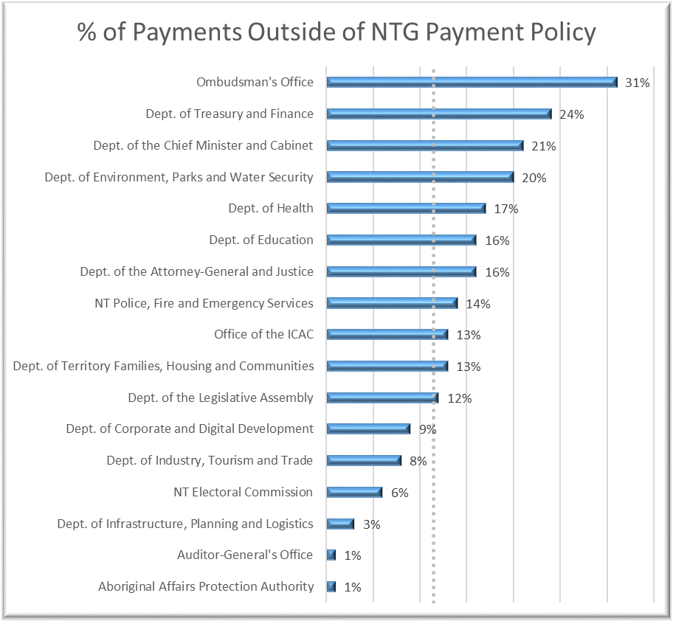
Source: Department of Corporate and Digital Development generated AP06 – Invoice Processing Report

Selected Agencies – Agency Compliance Audits cont…
I consider that two further matters identified during the agency compliance audits present increased risks and relate to the handling and management of funds on behalf of individuals/entities outside government. These two matters are summarised below.

Department of the Attorney-General and Justice
“Deposits Held” and “Accountable Officers Trust Accounts” at the Department of the Attorney-General and Justice were either not regularly or adequately reconciled or the documented reconciliation contained unexplained or unresolved variances.
Accountable Officer’s Trust Account
Monies Not Taken On Discharge*
Monies Not Taken On Discharge
Tab Telebet
Deposits Held - Other
ASCC Prisoner Private Monies*
DCC Prisoner Private Monies
Datjala Work Camp Private Money
Barkly Work Camp Private Money*
Prisoner Charity Trust Fund
Unidentified Prisoner Deposits*
* Variances were due to the absence of a reconciliation and not necessarily resulting from unreconciled differences.
Matters related to these accounts, and the management of Prisoners’ Monies were previously reported to the Agency in letters dated 8 November 2010, 19 June 2012, 23 October 2012, 4 October 2018, 24 February 2020 and 2 October 2020.
My performance management system audit of “Prisoner’s Money” was reported in my March 2020 Report to the Legislative Assembly where I stated:
“In my opinion, the performance management systems and processes related to the management of prisoner monies require improvement in order to enable management to assess whether prisoner monies are being managed economically, efficiently and effectively. Current processes may not be adequate to prevent fraud and error from occurring and/or being detected and addressed in a timely manner.”

Selected Agencies – Agency Compliance Audits cont…

Northern Territory Police, Fire and Emergency Services
A regional/remote Police Station (the Station) maintains its own official bank account to receive monies for the Fines Recovery Unit, NT Police, Motor Vehicle Registry, Receiver of Territory Monies and the Department of the Attorney-General and Justice and then to disburse those monies to the relevant payee entity by cheque.
The audit identified that:
- no process or procedural documents are available to the personnel at the Station with access to or responsibility for managing and reconciling the bank accounts;
- the account was overdrawn twice during the seven month period subject to audit;
- the descriptions associated with transactions affecting the account were not sufficiently detailed to identify the source of funds;
- funds received were not deposited in a timely manner;
- funds were not remitted to the relevant payee entity in a timely manner;
- cheque payments from the bank account were drafted or issued out of sequence;
- a deposit book was unable to be located;
- reconciliations of the bank statement did not occur with sufficient regularity; and
- documented bank reconciliations contained unresolved errors and were not subject to adequate review.
Selected Agencies – Agency Compliance Audits cont…
The Department of Corporate and Digital Development has commented:
The Department of Corporate and Digital Development notes the finding of 91% of invoices paid within the 20 day payment policy.
The department's Accounting and Property Manual has been updated, incorporating references to recently issued Treasurer's Directions.
A process has been established to assist panel chairs improve compliance with procurement rules.

The Department of Industry, Tourism and Trade has commented:
Two of the three audit issues raised relate to the "Incomplete register of Equity investments" and "Deficiency within the internal audit program". These issues were as a result of the Machinery of Government changes and have been resolved.
The third issue relates to the gifting of gift cards, in contravention of the Treasurers Direction (TD). All Agency staff have been reminded of the TD requirements.

The Department of the Attorney-General and Justice has commented:
We note the findings and specific matters of the audit and continue our efforts to address the recommendations made in this and previous reports. We are committed to better governance, management and accountability of the Accountable Officer's Trust Account and Deposits Held and in particular prisoner monies.
A dedicated resource is working through the accepted recommendations of March 2020. Policies and procedures have been developed and are being tested. We are continuing the investigation of unexplained or unresolved variances on reconciliations and improving internal controls and effective oversight of monies held in trust and deposits held.
I note that Tab Telebet is no longer an account controlled by the Department and is part of Licensing NT now with the Department of Industry, Tourism and Trade

The Department of the Chief Minister and Cabinet has commented:
The Department of Corporate and Digital Development generated AP06 - Invoice Processing Report calculates payments outside of the NTG Payment Policy from date of invoice and not from when invoice is received and uploaded by Accounts Payable into the Electronic Invoice Management System.
When removing the anomaly, the agency's non-compliance is reduced from 21 per cent to 13 per cent for the reporting period with a total of 5,829 invoices being paid.
The agency recognises the revised result is still too high and will implement reminders with delegates of their obligations in regards to the NTG Payment Policy.

Selected Agencies – Agency Compliance Audits cont…
The Department of Treasury and Finance has commented:
Northern Territory Government (NTG) Payment Policy – a weekly auditing process operates for the Department of Treasury and Finance (DTF), with appropriate follow up, to ensure creditor invoices are paid within the NTG payment policy guidelines. This is monitored by the Chief Financial Officer and the Deputy Under Treasurer, and compliance is reported monthly to the Senior Management Group. However, the report used to conduct the audit differs from the report DTF relies upon in that the former includes non-invoice payments such as tax and stamp duty refunds in addition to supplier invoices (which are the subject of the NTG Payment Policy). If these non-invoice payments are excluded, the percentage of payments processed outside the NTG Payment Policy is 3% (or 20 out of 794 creditor invoices). Nonetheless, DTF will provide further education within the agency on the policy and its timeframes, and encourage all suppliers to use the NTG invoice portal to minimise any delays in authorising payments.

Northern Territory Police, Fire and Emergency Services has commented:
Adherence to the Northern Territory Government policy requiring undisputed invoices to be processed within the required 20 day (under $1million) and 30 day (over $1million) periods:
- NTPFES notes the findings. Outstanding/ pending invoices are closely monitored within NTPFES and business units are advised weekly. Outstanding items are elevated for Executive action.
- Maintenance of own official bank account/ Advance Account at the Alyangula Police Station where inadequate controls were identified:
- NTPFES notes the findings. The following recommendations/ remedial actions will be implemented:
- All business processes and supporting cash transactions must be directed to the local post office where possible
- All cash and/ or cheques received are to be banked on a weekly basis, with associated reconciliations being done at the same time
- A formal documented governance process to be disseminated to the relevant staff outlining controls and processes and procedures to be adhered to; and
- To ensure business continuity, other staff to be trained in banking / reconciliation process

The Office of the Independent Commissioner Against Corruption commented:
The OICAC acknowledged the findings from the agency compliance audit. The OICAC values the Auditor-General’s oversight and constructive feedback. Recommendations to improve the OICAC’s compliance with the NTG payment policy have already commenced, and the OICAC continues to find efficiencies within its current practices whilst adhering to whole of government procedures.
Selected Agencies – Agency Compliance Audits cont…
The Ombudsman’s Office has commented:
The high proportion of invoices processed outside the 20 day period during 1 July 2020 to 31 March 2021 is regrettable. Steps have been taken to improve processes and prioritise payment within the 20 day period, with only three invoices processed outside that period between 1 April and 30 June 2021.

Selected Entities – Close-down leave

Background
Historically, many Northern Territory Government entities have announced a ‘close-down’ period between Christmas Day and New Year’s Day inclusive. Where these days include days that are a usual working day, public sector employees who are not required to work have applied their leave entitlements to those days with the entity considered ‘closed’ for usual operations. As many Northern Territory Government entities either close down or are staffed with minimal personnel over the Christmas period, it would be expected that in many entities, most employees would have submitted leave applications for 29, 30 and 31 December 2020.
Results of past data analytic exercises undertaken on employee leave entitlements have identified a risk of employees taking leave but not recording leave thus their leave entitlements are not appropriately adjusted. There is an increased risk of this occurring during periods where an entity is ‘closed’ for usual operations highlighting the need for increased scrutiny over this period.

Scope and Objectives
The objective of this data analytics exercise was to examine leave taken by ‘non-casual’ Northern Territory Public Sector employees during the period Friday 25 December 2020 to Friday 1 January 2021 in order to identify employees that did not take leave for the non-public holiday dates during that period and seek assurance from Accountable Officers that, where leave was not recorded for an employee, the employee was working.
Whilst analysis of the data occurred at all Northern Territory Government entities, it was expected that there would be a considerable number of frontline personnel who would be working during this period and therefore would not be on leave. As expected, Northern Territory Police, Fire and Emergency Services, Power Generation Corporation, Department of Health, Department of the Attorney-General and Justice, Power and Water Corporation and Power Retail Corporation had a significant number of staff who did not have a leave application recorded for the three days. The leave data for these entities were not subjected to further analysis and assurance was not sought from these Accountable Officers.

Overall Assessment
This analysis did not constitute an audit.
In the majority of instances, those employees who had not submitted an application for leave during one or more days of the close-down period were confirmed as present at the work place and not on any form of leave on the day/s when there was no approved leave application.
I note a number of the larger entities are undertaking further research in order to accurately respond to the findings related to their entities and are yet to respond to the findings.
A number of instances were identified where employees were not at work yet did not have approved leave applications. Appendix A to the Treasurer’s Direction - Fraud control identifies “deliberate failure to submit use of employee entitlements (eg. leave)” as one example of fraud. My review of the data related to leave taken highlights the necessity for entities to manage staff leave on a continual basis and ensure that, when staff take leave, they obtain an approved leave application prior to commencing leave.
Selected Entities – Close-down leave cont…

Parameters and Methodology

Close-down period
Historically, many Northern Territory government entities have announced a close-down period between Christmas Day and New Year’s Day inclusive.
Instructions to public sector employees in relation to the Christmas close-down leave entitlements state:
“If a close-down occurs, you must use any:
- recreation leave
- long service leave
- leave without pay
- time off in lieu (TOIL) (if eligible)
- flextime credits during the close-down period (if eligible).
If you don't have enough leave available, you will need to use leave without pay or request to work additional hours.
You cannot work additional hours to accrue TOIL/flex for the sole purpose of the close-down period, unless under exceptional circumstances.
Speak with your manager to work out which option is best for you.
How to apply
Submit your leave request in myHR selecting the appropriate leave type for your circumstances.”

Declared Public Holidays
Information relating to public holidays and weekends during the period 25 December 2020 to 1 January 2021 was sourced from the Office of the Commissioner for Public Employment’s website:
Table 1: Northern Territory Public Holiday dates over the period
Date | Day | Notation
25 December | Friday | Public Holiday
26 December | Saturday | Weekend
27 December | Sunday | Weekend
28 December | Monday | Public Holiday
29 December | Tuesday
30 December | Wednesday
31 December | Thursday | Part-day Holiday – 7pm to Midnight
1 January | Friday | Public Holiday
Source: Office of the Commissioner for Public Employment website
Selected Entities – Close-down leave cont…
The public holidays gazetted meant the standard working days (for non-shift workers) were 29 December, 30 December and 31 December 2020. In accordance with a government announcement in 2016, Thursday 31 December was a gazetted part-day holiday from 7pm to midnight thus normal office hours applied with a leave application required for that day if an employee was not working.

myHR
‘myHR’ is the Northern Territory Government system used by employees to access personal payslips, process higher-duty allowance applications, process temporary transfers, enter overtime claims, enter recreation and personal leave applications and check leave entitlement balances.

Time Off in Lieu
The ‘request time off in lieu (TOIL) work-life balance’ information states:
“Time off in lieu (TOIL) is time off work instead of being paid overtime for additional hours you have worked.
….
Who is eligible
To be eligible for TOIL, your salary needs to be less than the top increment of the AO6 classification, unless approved by the Commissioner for Public Employment.
You can't get TOIL if:
- your salary is more than the top increment of the AO6 classification or
- it is not part of your conditions of employment.
Before you apply
You must receive approval from an agency authorised delegate before you work TOIL.
Your manager will need to consider operational requirements.
How to apply
You must submit a miscellaneous leave application in myHR and select the time off in lieu option.”
Time off in lieu recorded within ‘myHR’ by the employee submitting a miscellaneous leave application for 29, 30 and 31 December 2020 has been recognised within this analysis as leave taken.

Flextime
An employee can accrue a maximum of two working days flextime credit (where they have worked additional hours to build up this time) and one working day debit (where the employee is required to subsequently work the hours). The employee must use the credit, or make up the debit time, within four weeks.
Selected Entities – Close-down leave cont…
Flextime may also be recorded within ‘myHR’ as miscellaneous leave (Flex Debit and Flex Time (Taken)), however the use of myHR is not mandated for flextime and there is an option of completing flex-sheets as opposed to entering the credits and leave within ‘myHR’.
Flextime that was recorded within ‘myHR’ by the employee submitting a miscellaneous leave application for 29, 30 or 31 December 2020 has been recognised within this analysis as leave taken.

Leave Applications Processed
To enable this analysis of leave, the Department of Corporate and Digital Development (DCDD) provided a listing of all processed Recreation, Personal and Miscellaneous Leave recorded between 21 December 2020 and 1 January 2021. The list included leave that commenced before 21 December 2020 or ended after 1 January 2021.
DCDD also provided a listing of people employed by the Northern Territory Government on any one or more days during the period. This report included employees who commenced with the Northern Territory Government before 21 December 2020 or separated after 1 January 2021 and personnel that commenced or separated during this period.
As Members of the Legislative Assembly (MLAs) do not have a leave entitlement they are excluded from this analysis. Employees working within electorate officers are not employees under the Public Sector Employment and Management Act 1993, they are contracted as employees under separate legislation. These individuals were captured in the payroll data because they are ‘allocated’ to the Department of the Legislative Assembly notwithstanding that the Accountable Officer of the Department of the Legislative Assembly has no authority or oversight in relation to these individuals.
The following entities were selected for individual reporting within this report:
- Aboriginal Areas Protection Authority
- Department of Corporate and Digital Development
- Department of Education
- Department of Environment, Parks and Water Security
- Department of Industry, Tourism and Trade
- Department of Infrastructure, Planning and Logistics
- Department of Territory Families, Housing and Communities
- Department of the Chief Minister and Cabinet
- Department of the Legislative Assembly
- Department of Treasury and Finance
- Northern Territory Legal Aid Commission
- Office of the Independent Commissioner Against Corruption
- Ombudsman's Office
Selected Entities – Close-down leave cont…
All personnel employed at the following entities took three days leave so no further analysis or reporting was undertaken:
- Land Development Corporation
- Northern Territory Auditor-General’s Office
- Northern Territory Electoral Commission
It was expected that there would be a considerable number of frontline personnel who would be working during this period and therefore would not be on leave. Whilst the data within the whole-of-government figures includes the results for these entities, the leave data for these entities was not subjected to further analysis or individual reporting and confirmation was not sought from the respective Accountable Officers that each employee had correctly recorded their leave. Consideration will be given to how best to undertake a similar analysis of leave for these entities in future years.
Those entities excluded from being individually reported as the employee cohort includes a significant proportion of medical staff, corrections officers or police officers or where the entity is a utility entity were:
- Department of Health
- Department of the Attorney-General and Justice
- Northern Territory Police, Fire and Emergency Services
- Power and Water Corporation
- Power Generation Corporation
- Power Retail Corporation
Selected Entities – Close-down leave cont…

Observations
Figure 1 presents the percentage of employees by entity who were recorded as taking all three days, being 29 December, 30 December and 31 December 2020, as leave.
Figure 1: Percentage of employees, by entity, who recorded 3 days leave
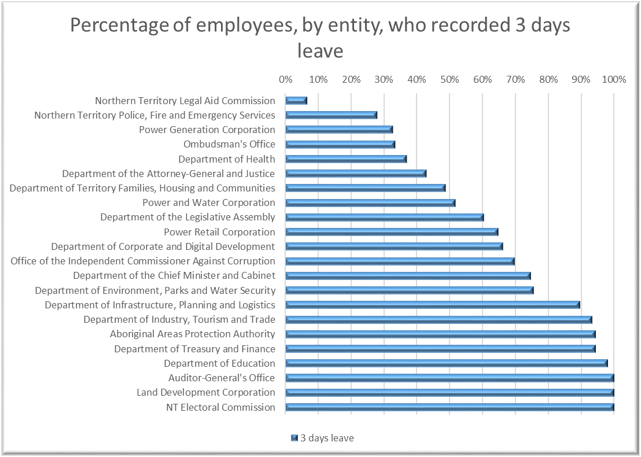
Source: NTAGO derived from DCDD leave records
Selected Entities – Close-down leave cont…
For the entities where individual analysis was conducted, the following table provides the number of employees during the period subject to analysis and the percentage of employees that recorded leave on all three days being 29, 30 and 31 December 2020.
Table 2: Percentage of employees by agency that recorded leave on all three days
Entity | Employee Numbers | % that recorded  leave on all three days
Northern Territory Legal Aid Commission | 104 | 7%
Ombudsman's Office | 18 | 33%
Department of Territory Families, Housing and Communities | 1,504 | 49%
Department of the Legislative Assembly | 78 | 60%
Department of Corporate and Digital Development | 1,232 | 66%
Office of the Independent Commissioner Against Corruption | 33 | 70%
Department of Environment, Parks and Water Security | 570 | 75%
Department of the Chief Minister and Cabinet | 488 | 75%
Department of Infrastructure, Planning and Logistics | 846 | 89%
Department of Industry, Tourism and Trade | 845 | 93%
Aboriginal Areas Protection Authority | 35 | 94%
Department of Treasury and Finance | 124 | 94%
Department of Education | 4,956 | 98%
Source: NTAGO derived from DCDD leave records
Selected Entities – Close-down leave cont…
Of the ten entities reporting the lowest number of employees taking the full close-down period as leave, the four entities excluding the Northern Territory Police, Fire and Emergency Services, Power Generation Corporation, Department of Health, Department of the Attorney-General and Justice, Power and Water Corporation and Power Retail Corporation) where more than 40% of non-casual personnel were recorded as working (did not submit leave applications) for the three days leave are:
- Northern Territory Legal Aid Commission – 7% of personnel were recorded as being on leave over the full three-day closure period
- Ombudsman's Office – 33% of personnel were recorded as being on leave over the three-day closure period
- Department of Territory Families, Housing and Communities – 49% of personnel were recorded as being on leave over the three-day closure period
- Department of the Legislative Assembly – 60% of personnel were recorded as being on leave over the three-day closure period. The Department has since confirmed that all individuals recorded as not being on leave are personnel at the electorate offices and not departmental personnel. Employees at the electorate offices are outside the Public Sector Employment and Management Act 1993 and electorate offices are not subject to the close-down period.
As reported above, Thursday 31 December was a gazetted part-day holiday from 7pm to midnight thus normal office hours applied with a leave application required for that day if an employee was not working. Figure 2 shows the percentage of employees, by entity, where a leave application was not recorded for 31 December 2020.
Figure 2: Percentage of employees, by entity that recorded leave on 31 December 2020
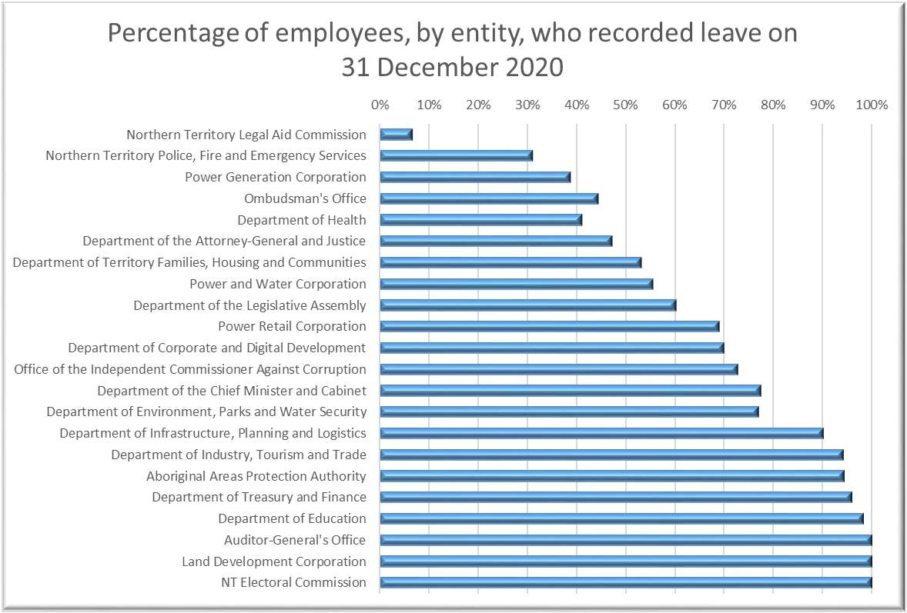
Source: NTAGO derived from DCDD leave records
Selected Entities – Close-down leave cont…
Of the ten entities reporting the lowest number of employees taking the full close-down period as leave, the percentage of staff that recorded leave on each specified day is presented in Figure 3.
Figure 3: Percentage of employees who recorded leave on the specified day
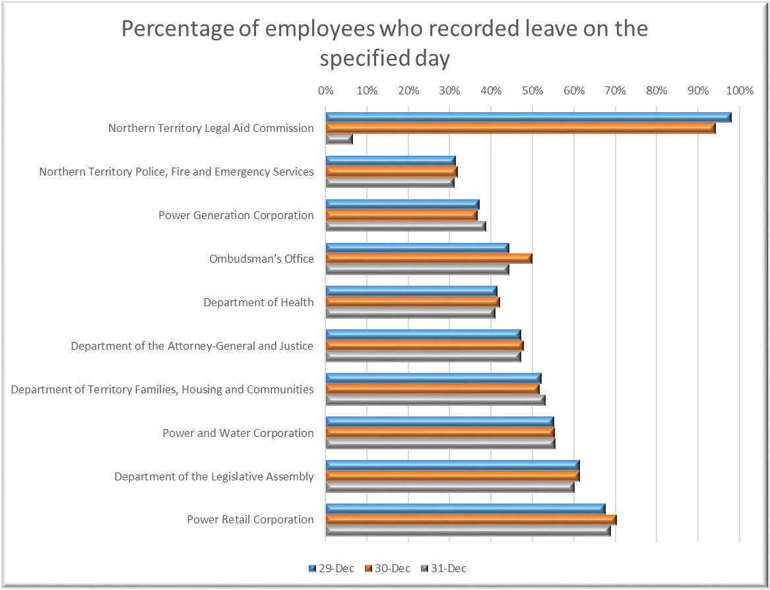
Source: NTAGO derived from DCDD leave records
Selected Entities – Close-down leave cont…
The four entities (excluding the Northern Territory Police, Fire and Emergency Services, Power Generation Corporation, Department of Health, Department of the Attorney-General and Justice, Power and Water Corporation and Power Retail Corporation) where 60% or less of the employees allocated to the entity submitted leave applications for the three days leave are:
- Northern Territory Legal Aid Commission
- Ombudsman's Office
- Department of Territory Families, Housing and Communities
- Department of the Legislative Assembly

Figure 4: Entities where 60% or less of the employees recorded leave for the three days
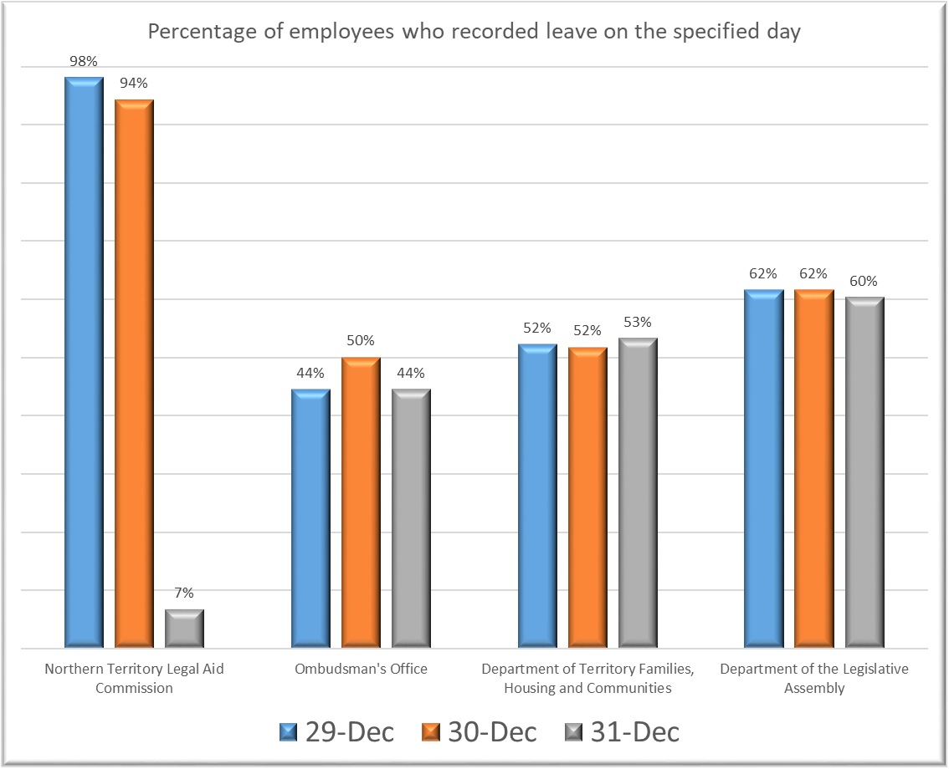
Source: NTAGO derived from DCDD leave records
Selected Entities – Close-down leave cont…

Northern Territory Legal Aid Commission
During the period under review, the Commission had 104 non-casual employees.
Only seven (six full time, one part time) of the 104 employees (7%) took leave for all three days. Five of these seven employees were on long term leave that encompassed the period under analysis. The remaining two took leave specifically for the three days in question.
For the remaining 97 employees:
- 91 employees (79 full time, 12 part time) took two days leave on 29 and 30 December, none of them took leave on 31 December;
- four employees (one full time, three part time) took one day of leave with that day being 29 December; and
- two employees (one full time, one part time) did not take any leave on the three days.
Figure 5: Percentage of employees recorded as taking leave and not taking leave – Northern Territory Legal Aid Commission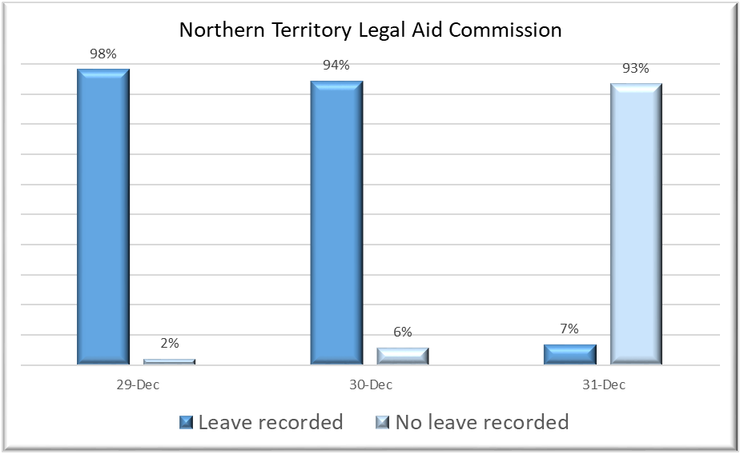
Source: NTAGO derived from DCDD leave records

Selected Entities – Close-down leave cont…

Ombudsman's Office
During the period under review, the Agency had 18 non-casual employees.
Six (all full time) of the 18 employees (33%) took leave for all three days.
For the remaining 12 employees:
- three employees (one full time, two part time) took two days leave;
- one employee (a full time employee) took one day of leave; and
- eight employees (six full time, two part time) took no leave on any of the three days.
Figure 6: Percentage of employees recorded as taking leave and not taking leave – Ombudsman’s Office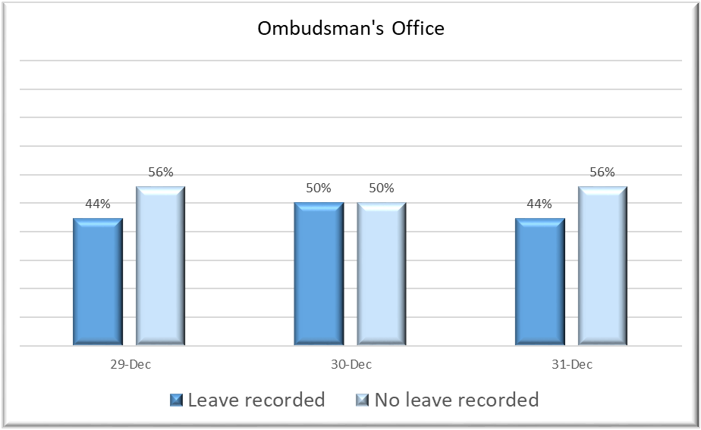
Source: NTAGO derived from DCDD leave records
In responding to the reported findings, the Ombudsman’s Office confirmed that the Accountable Officer has approved an Agency policy whereby personnel are permitted to utilise flextime during the office closure. The flextime arrangements allow for overtime recorded in the months prior to December to be taken during the Christmas break. The flextime was recorded by the use of time sheets and has not been recorded in myHR. I note there is no mandatory requirement to record flextime in myHR and the use of timesheets as an alternative means of recording is acceptable.

Selected Entities – Close-down leave cont…

Department of Territory Families, Housing and Communities
During the period under review, the Agency had 1,504 non-casual employees.
733 (688 full time, 45 part time) of the 1,504 employees (i.e. 49%) took leave for all three days.
For the remaining 711 employees:
- 37 employees (30 full time, seven part time) took two days leave;
- 90 employees (77 full time, 13 part time) took one day of leave; and
- 644 employees (605 full time, 39 part time) took no leave on any of the three days.
Figure 7: Percentage of employees recorded as taking leave and not taking leave – Department of Territory Families, Housing and Communities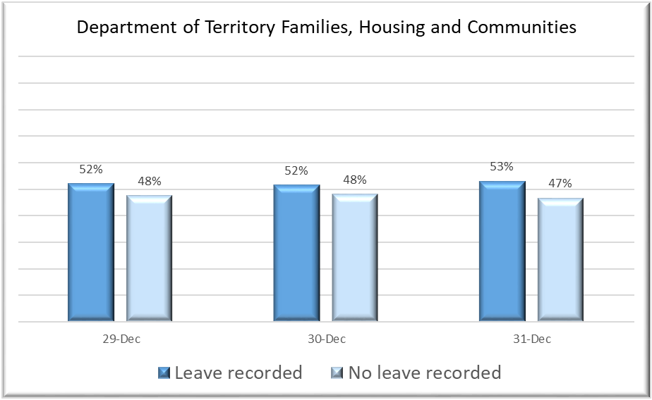
Source: NTAGO derived from DCDD leave records

Selected Entities – Close-down leave cont…

Department of the Legislative Assembly
During the period under review, the Agency had 78 non-casual employees (excluding MLAs) allocated to the Agency. Of these, 47 represent public sector employees working for the Department of the Legislative Assembly and 31 represent individuals working for electorate offices and are thus outside the scope of the analysis.
47 (43 full time, four part time) of the 78 non-MLA employees (60%) took leave for all three days.
The 31 employees that did not record three days of leave were all employed at electorate offices.
- 30 employees (12 full time, 18 part time) did not take any leave on the three days in question.
- One employee (a full time employee) took two days leave.
Figure 8: Percentage of employees recorded as taking leave and not taking leave – Department of the Legislative Assembly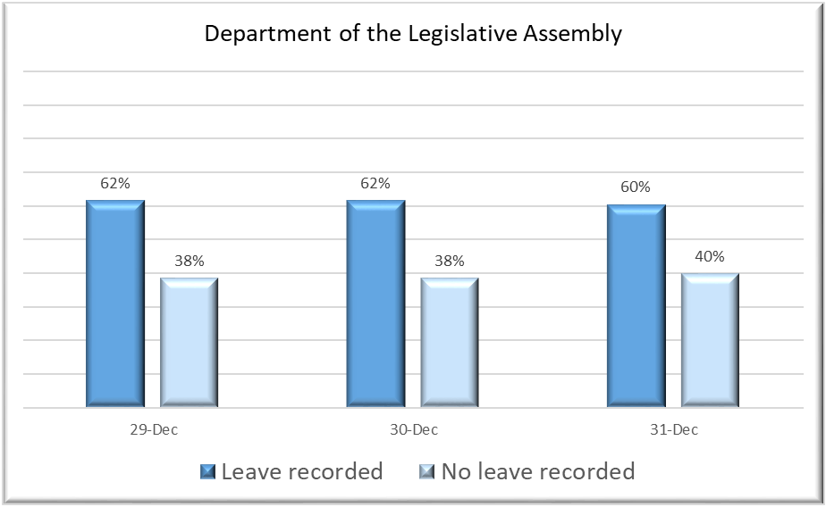
Source: NTAGO derived from DCDD leave records
In responding to the reported findings, the Department of the Legislative Assembly has confirmed that all employees reported as taking no leave or one day of leave were employed at electorate offices and that all departmental personnel had taken leave over the closure period. Responsibility for monitoring and managing employee leave entitlements associated with these individuals therefore rests with the relevant Member of the Legislative Assembly.
Selected Entities – Close-down leave cont…
The following agencies had more than 60% of agency personnel recording approved leave applications for one or more days during the close-down period.

Department of Corporate and Digital Development
During the period under review, the Agency had 1,232 non-casual employees.
815 (766 full time, 49 part time) of the 1,232 employees (i.e. 75%) took leave for all three days.
For the remaining 417 employees:
- 39 employees (33 full time, six part time) took two days leave;
- 39 employees (35 full time, four part time) took one day of leave; and
- 339 employees (318 full time, 21 part time) took no leave on any of the three days. This represents 27.5% of the Agency’s non-casual employees.

Office of the Independent Commissioner Against Corruption
During the period under review, the Agency had 33 non-casual employees.
23 of the 33 employees (i.e. 70%) took leave for all three days.
For the remaining 10 employees:
- two employees (both full time) took one day of leave;
- eight employees (all full time) took no leave on any of the three days. This represents 24% of the Agency’s non-casual employees.

Department of the Chief Minister and Cabinet
During the period under review, the Agency had 406 non-casual employees designated as being assigned to “Chief Minister and Cabinet” (DCMC) and 82 non-casual employees designated as “CMI Chief Ministers ECO and Ministerial” (within the Office of the Chief Minister (OCM)) making a total of 488 non-casual employees.
364 (346 full time, 18 part time) of the 488 employees (i.e. 75%) took leave for all three days being 340 (84%) DCMC employees and 24 (29%) OCM employees.
For the remaining 124 employees:
- 15 employees (nine full time, six part time) took two days leave, nine of these employees are recorded as full time employees;
- 14 employees (all full time) took one day of leave, all of these employees are recorded as full time employees; and
- 95 employees (90 full time, five part time) took no leave on any of the three days. This represents 19.5% of the Agency’s non-casual employees.

Selected Entities – Close-down leave cont…

Department of Environment, Parks and Water Security
During the period under review, the Agency had 570 non-casual employees.
430 (394 full time, 36 part time) of the 570 employees (i.e. 75%) took leave for all three days.
For the remaining 140 employees:
- 21 employees (16 full time, five part time) took two days leave;
- nine employees (all full time) took one day of leave; and
- 110 employees (107 full time, three part time) took no leave on any of the three days. This represents 19.3% of the Agency’s non-casual employees.

Department of Infrastructure, Planning and Logistics
During the period under review, the Agency had 846 non-casual employees.
757 (724 full time, 33 part time) of the 846 employees (i.e. 89%) took leave for all three days.
For the remaining 89 employees:
- nine employees (six full time, three part time) took two days leave;
- seven employees (all full time) took one day of leave; and
- 73 employees (71 full time, two part time) took no leave on any of the three days. This represents 8.6% of the Agency’s non-casual employees.

Department of Industry, Tourism and Trade
During the period under review, the Agency had 845 non-casual employees.
788 (743 full time, 45 part time) of the 845 employees (i.e. 93%) took leave for all three days.
For the remaining 57 employees:
- 12 employees (five full time, seven part time) took two days leave;
- eight employees (five full time, three part time) took one day of leave; and
- 37 employees (36 full time, one part time) took no leave on any of the three days. This represents 4.4% of the Agency’s non-casual employees.

Aboriginal Areas Protection Authority
During the period under review, the Authority had 35 non-casual employees.
33 (28 full time, five part time) of the 35 employees (i.e. 94%) took leave for all three days.
For the remaining two employees:
- One employee took two days leave being 29 and part of 30 December. Specifically this employee took leave from 07:30 hours 21 December to 12:30 hours 30 December, no leave is recorded for 31 December.
- One employee (full time) took no leave on any of the three days. This represents 2.9% of the Agency’s non-casual employees.
Selected Entities – Close-down leave cont…

Department of Treasury and Finance
During the period under review, the Agency had 124 non-casual employees.
117 (109 full time, eight part time) of the 124 employees (i.e. 94%) took leave for all three days.
For the remaining seven employees:
- four employees (one full time, three part time) took two days leave;
- one employee took one day of leave; and
- two employees took no leave on any of the three days. This represents 1.6% of the Agency’s non-casual employees.

Department of Education
During the period under review, the Agency had 4,956 non-casual employees.
4,858 (4,307 full time, 551 part time) of the 4,956 employees (i.e. 98%) took leave for all three days.
For the remaining 98 employees:
- 16 employees (ten full time, six part time) took two days leave;
- five employees (three full time, two part time) took one day of leave; and
- 77 employees (67 full time, ten part time) took no leave on any of the three days. This represents 1.5% of the Agency’s non-casual employees.

Confirmations requested
As outlined in my previous reports to the Legislative Assembly relating to excessive leave entitlements one of the risks identified in relation to employee entitlements is that “leave may have been taken by an employee but the leave application forms were not submitted and/or approved correctly”. This data analysis was undertaken to identify and bring to the attention of Accountable Officers, an overview of leave taken to assist them in identifying instances where the above risk may have materialised.
The results of the analysis were provided to entity Accountable Officers and assurance was sought that, where leave was not recorded for an employee, the employee was working during the close-down period. The following confirmation was sought:
- For full time employees – I requested Accountable Officers to confirm in writing that the employees that did not have an approved leave application for one or more of the three days in question were present at the work place and not on any form of leave on the day/s when there was no approved leave application.
- For part time employees – I requested Accountable Officers to confirm in writing that the part time employees that did not have an approved leave application for one or more of the three days (29, 30 and 31 December 2020) were either present at the work place or not expected to work on those day/s due to being part time employees.
Selected Entities – Close-down leave cont…

Confirmations received
As at 30 July 2021, confirmations have been received from the Accountable Officers of the following entities:
- Aboriginal Areas Protection Authority
- Department of Industry, Tourism and Trade;
- Department of Treasury and Finance;
- Department of the Legislative Assembly;
- Department of the Chief Minister and Cabinet; and
- Office of the Independent Commissioner Against Corruption; and
- Ombudsman’s Office.
Confirmations received identified:
- As a result of this analysis, at least 40 employees have been identified as not having submitted a leave application despite needing to do so.
- In the majority of instances, those employees who had not submitted an application for leave during one or more days of the close-down period were confirmed as present at the work place and not on any form of leave on the day/s when there was no approved leave application.
- Employees who took leave but had no leave application recorded and have since ceased employment with the Northern Territory Government. Debt recovery is being initiated in one instance however the extent to which those employees should have submitted leave applications has not been investigated in all instances.
- Employees who have submitted leave, time off in lieu or flextime applications since my analysis was provided to the Accountable Officer on 2 July 2021.
- Employees who were not subject to compulsory agency shutdown.
- Employees who utilised flextime during the office closure. The flextime was recorded by the use of time sheets and has not been recorded in myHR. Employees were allowed to accrue flextime beyond the standard limit and take flextime during the Christmas break.
- Employees who were part time, on leave without pay or on maternity leave and therefore leave was not required.
- Individuals classified as ‘employees’ who were actually employees at electorate offices and not public sector employees of an agency therefore the responsibility for monitoring and management of the leave entitlements is not within the remit of the agency.
- Staff will be reminded of the need to ensure that leave forms are submitted prior to the Christmas/New year leave period this year and assurance will be sought from supervisors that all leave applications are appropriately submitted prior to the shutdown period.
Selected Entities – Close-down leave cont…

Confirmations not received
As at 30 July 2021, confirmations had not been received from the Accountable Officers of the following entities:
- Department of Corporate and Digital Development;
- Department of Education;
- Department of Environment, Parks and Water Security;
- Department of Infrastructure, Planning and Logistics;
- Department of Territory Families, Housing and Communities; and
- Northern Territory Legal Aid Commission.
Of these entities, I am aware that a number have commenced undertaking a detailed review of the leave data for the three days in order to accurately inform their response to my request for confirmation.

Selected Entities – Close-down leave cont…
The Department of Corporate and Digital Development has commented:
The department has considered the data provided and is reminding staff and managers of their responsibilities regarding leave applications.

The Department of Infrastructure, Planning and Logistics has commented:
The Department of Infrastructure, Planning and Logistics (DIPL) implemented a close down for the majority of the department with approved exemptions for operational areas. The department’s management monitors all employees leave. The vast majority of leave not entered was for approved operational areas that were required to continue to work during this time.

The Department of Treasury and Finance has commented:
Close down leave – four staff were part time and not due to work on the days showing as absent. Three staff have since entered (pre-approved) leave correctly into the payroll system. One person was overpaid, and that debt is now being recovered. In addition, further education has been undertaken in the agency on correct recording of flextime and time off in lieu, and this will be reiterated as part of our communications in the lead up to the Christmas office closure, and at other regular intervals to ensure all staff understand their obligations.

The Northern Territory Legal Aid Commission has commented:
On the information available to date, I believe that:
- Full time employees who did not have an approved leave application for one or more of the three days were either present at the work place or not expected to work, however due to a communication error, those staff who were not expected to work were not requested to apply for leave on that day.
- Part time employees who did not have approved leave for one or more of the three days were either present at the work place or not expected to work on those days due to being part time employees.
When we have completed a full review of our records, we will retrospectively amend the leave entered for the period in question. We also have reviewed and strengthened our procedures in relation to communicating leave needs during this period and believe that these measures will be sufficient to address the issues raised in the future.

Selected Entities – Close-down leave cont…
The Office of the Independent Commissioner Against Corruption commented:
The OICAC responded to the findings raised regarding the examination of leave taken by its staff during the close-down period. The OICAC acknowledges the importance of managing excess leave and is conscious of the risks associated with excessive leave entitlements. Staff members who did not take leave were present at work and performing their duties as the OICAC did not close over the relevant period. To provide continuity in its operations, the OICAC will continue this practice on an ongoing basis.

Selected Entities – Fuel Card Purchases

Background
The objective of this analysis was to examine transactions using fuel cards for fuel purchases that were undertaken by the selected entities between 1 July 2020 and 28 February 2021. This analysis is undertaken to identify any transactions that displayed unusual characteristics or characteristics that might suggest the existence of fraud, and to provide information about those transactions to the agencies’ management for review and follow-up. Fuel cards issued to officers of the agencies and pool vehicles were included in the analysis.

Scope and Objectives
The objective of this analysis was to examine transactions using fuel cards for fuel purchases that were undertaken by the selected entities between 1 July 2020 and 28 February 2021.
The analysis was performed for each of the following agencies during the six months covered by this report:
- Department of Environment, Parks and Water Security;
- Former Northern Territory Government entity;
- Northern Territory Legal Aid Commission;
- Power Generation Corporation; and
- Territory Wildlife Parks.
NT Fleet states that, when using a fuel card, the driver will:
- fill up using the fuel type shown on the card;
- provide the odometer reading when paying; and
- use the PIN provided with the card.
A driver must not use a government fuel card to buy fuel for:
- unauthorised vehicles;
- use in equipment (such as lawn mowers, concrete mixers and chainsaws) other than the specific vehicle to which the fuel card was assigned; or
- premium fuel, unless the fuel card says you can.
The NT Fleet Driver Handbook (page 12) states:
“The correct odometer reading, to the nearest kilometre, must be provided to the service station attendant. Accurate odometer readings must also be recorded on manual Fuel Card Dockets, Vehicle Maintenance Orders and all other fuel records.”
“Fuel for use in ancillary equipment such as lawn mowers, concrete mixers and chainsaws, etc., is not to be purchased using a fuel card specifically issued to a registered vehicle”.
Selected Entities – Fuel Card Purchases cont…

Overall Assessment
This analysis did not constitute an audit.
My review of the data related to fuel card purchases highlights the necessity for management to be vigilant at all times. Simply reviewing the data may not necessarily identify fraudulent or incorrect transactions. There are legitimate reasons for a driver to undertake two successive purchases of fuel within a few minutes, however, opportunities do exist for inappropriate purchases to be made and charged to the fuel cards.

Observations
The following table outlines the number of fuel cards identified as being in use at some time during the period 1 July 2020 and 28 February 2021.
Entity | Fuel Cards
Department of Environment, Parks and Water Security | 315
Former Northern Territory Government entity | 1
Northern Territory Legal Aid Commission | 13
Power Generation Corporation | 75
Territory Wildlife Parks | 29

Acceptable error rate
In analysing the transaction errors, I consider an error rate of less than 5 per cent to be reasonable. I also consider an error rate between 6 per cent and 25 per cent to be reasonable when taking into account the probability of some console operator error occurring, however, where identified, I recommended that the users of the fuel cards for these vehicles be reminded of the need to provide accurate odometer readings to the fuel supplier.
There were a significant number of anomalous transactions recorded by the agencies as outlined below:
Agency | Anomalous Transactions | Population | % of errors
Department of Environment, Parks and Water Security | 400 | 2,692 | 15%
Northern Territory Legal Aid Commission | 42 | 196 | 21%
Power Generation Corporation | 138 | 753 | 18%
Territory Wildlife Parks | 78 | 211 | 37%
Selected Entities – Fuel Card Purchases cont…
- Anomalous information included:
- the driver failing to provide an odometer reading;
- the console operator not recording the odometer reading provided;
- the accounts department of the fuel supplier not providing the odometer reading on the invoice; and
- the fuel card not allowing the odometer reading to be recorded.
- Incorrect odometer readings, such as a reading lower than the previous reading or an apparently incorrect reading. Possible reasons for this include:
- the driver misreading the odometer;
- the driver guessing the reading;
- the console operator mishearing the reading; or
- the console operator mistyping the reading.

Department of Environment, Parks and Water Security

Vehicles Unable to be Analysed
Of the 315 fuel cards, 46 cards appeared to be inactive as they had no transactions recorded. 30 fuel cards had incurred only one fuel purchase throughout the period under analysis with nine of these cards having no odometer readings recorded. There were 14 fuel cards allocated for multi-vehicle use, one fuel card for a boat and one for a generator, and 16 other fuel cards where there was insufficient data to permit a reasonable analysis to be performed because sufficient correct odometer readings were not provided.
Excluding multi-use and auxiliary cards, there were 15 fuel cards that were allocated to vehicles which were not recorded on the NT Fleet allocation report thus an assessment of purchases in comparison to fuel capacity was unable to be performed.

Analysis and error rate
102 fuel cards had what appeared to be correct odometer readings for more than 95 per cent of the transactions. I consider an error rate of less than 5 per cent to be reasonable.
93 fuel cards had missing or incorrect odometer readings for between 5 and 25 per cent of the transactions. I consider this to be reasonable (taking into account the probability of some console operator error occurring), however I recommended that the users of the fuel card for these vehicles be reminded of the need to provide accurate odometer readings to the fuel supplier.
For the 50 remaining fuel cards, errors were identified on more than 25 per cent of the transactions. Even taking into account the probability of some console operator or supplier error, I find this to be an unacceptable error rate. Of these 50 fuel cards, 28 had an error rate of 100 per cent.
Selected Entities – Fuel Card Purchases cont…

Other findings
The analysis of data pertaining to the fuel cards identified:
- There were 30 fuel cards allocated to vehicles where the NT Fleet allocation report does not provide details of the fuel capacity of the vehicle. Of the remaining fuel cards, there were 16 fuel cards that recorded purchases that were significantly higher than the reported fuel capacity of the vehicle.
- There were 22 fuel cards (excluding multi-use cards) recording a total of 108 mixed fuel purchases.
- There were 128 low quantity fuel purchases (less than 15 litres) recorded during the period analysed. Many of these purchases were for a fuel that is not the standard fuel for the vehicle allocated to the fuel card. Of particular note are two vehicles that recorded 18 and 12 low fuel purchases respectively. These low fuel purchases were all for a fuel type that was not standard for that vehicle and all purchases were on the same day and at the same location as a standard fuel purchase.
- Two fuel cards appear to have been used to pay for purchases for vehicles other than the vehicle that the fuel card was allocated to.
- There were seven fuel transactions recorded from the fuel statements as “Other O.P.P” or “Regular Oil” instead of the usual Unleaded Petrol or Diesel. Four transactions were identified where it appears that a significant quantity of product was purchased.
- The drivers of two vehicles always round the odometer to the nearest 100 kilometres and not to the nearest kilometre as required by the NT Fleet Driver Handbook. The driver of one vehicle often rounds to the nearest 100 whilst the drivers of two other vehicles frequently round to the nearest 10 or 100.
- There were 51 instances where a surcharge was applied due to the service station chosen when there is a supplier that offers a discount that is less than 1 kilometre away from the supplier used.

Former Northern Territory Government Entity
As previously reported in my letter to the then Acting Under Treasurer dated 13 February 2017, this former Northern Territory Government Entity was sold on 25 November 2015 and therefore ceased to be an Northern Territory Government entity however fuel purchase transactions were still occurring until 31 January 2017, under the auspices of the Northern Territory Government contract with Puma. This matter was reported in my March 2017 Legislative Assembly report (pages 120 to 122).
In response to that report, the Department of Treasury and Finance provided the following comment:
“In November 2014 the previous Government approved Department of Corporate and Information Services (DCIS) continuing to provide corporate and information technology services to a former Northern Territory Government entity on a full cost recovery basis for a transitional period not exceeding five years.
Selected Entities – Fuel Card Purchases cont…
The former Northern Territory Government entity is currently transitioning its commercial vehicle arrangements from NT Fleet to a private provider with a separate fuel card. Vehicles are progressively replaced as they reach end of lease period and are returned to NT Fleet for disposal.
To date over 50% of the former Northern Territory Government entity’s fleet has transitioned to the alternative supplier. This process will be completed prior to the expiry of the five year transitional period in 2019.
All other DCIS services to the former Northern Territory Government entity have transitioned to alternative supplier arrangements.”
A review of fuel card transactions during the period 1 July 2020 to 31 January 2021 demonstrated that $185.26 was recorded on the Northern Territory Government’s account relating to the former Northern Territory Government Entity. These transactions occurred after the five year transitional period ending in 2019.

Northern Territory Legal Aid Commission

Vehicles unable to be analysed
Of the 13 fuel cards, two fuel cards had incurred only one fuel purchase throughout the period under analysis with one of these cards not having an odometer reading recorded. There were two other fuel cards where there was insufficient data to permit a reasonable analysis to be performed because sufficient correct odometer readings were not provided. For one card, nine out of ten of the odometer readings were missing or obviously inaccurate. For the second card, all seventeen odometer readings were missing or obviously inaccurate.

Analysis and error rate
Seven fuel cards had missing or incorrect odometer readings for between 5 and 25 per cent of the transactions. I consider this to be reasonable (taking into account the probability of some console operator error occurring), however I recommended that the users of the fuel card for these vehicles be reminded of the need to provide accurate odometer readings to the fuel supplier.
For the three remaining fuel cards, errors were identified on more than 25 per cent of the transactions. Even taking into account the probability of some console operator or supplier error, I find this to be an unacceptable error rate. Of these three fuel cards, two had an error rate of 100 per cent. One of these fuel cards had only one transaction in the period analysed. The other fuel card had 17 transactions.
Selected Entities – Fuel Card Purchases cont…

Other findings
The analysis of data pertaining to the fuel cards identified:
- There were no fuel purchases that appeared to be significantly higher than the reported fuel capacity of the vehicle.
- There were two low quantity purchases (less than 15 litres) recorded during the period analysed:
- one purchase at Katherine was identified as “regular oil” with zero quantity and $28.42; and
- one purchase at Berrimah for 13.41 litres that was immediately followed by a purchase of 33.61 litres.
- There was one instance where a surcharge was applied due to the service station chosen when there is a supplier that offers a discount that is less than 300 meters away from the supplier used.
- At 24 March 2021, one card had no PIN Status recorded.

Power Generation Corporation

Vehicles unable to be analysed
Of the 75 fuel cards, 34 cards appeared to be inactive as they had no transactions recorded. Three fuel cards had incurred only one fuel purchase throughout the period under analysis. One fuel card is identified as “Katherine PS” that recorded one purchase of regular oil on 23 October 2020 at a cost of $369.10. I recommended that the Corporation ensure that this transaction is valid.
Four fuel cards had insufficient data to permit a reasonable analysis to be performed because sufficient correct odometer readings were not provided. In one instance, one odometer reading was missing. This reading was for a purchase in July 2020. The only other purchases were in September 2020 (85.49 litres) and 18 January 2021 (102.57 litres). Based on the two valid odometer readings this vehicle averages 5 km per day which appears to be unusually low.

Analysis and error rate
18 fuel cards had missing or incorrect odometer readings for between 5 and 25 per cent of the transactions. I consider this to be reasonable (taking into account the probability of some console operator error occurring), however I recommended that the users of the fuel card for these vehicles be reminded of the need to provide accurate odometer readings to the fuel supplier.
For the eight remaining fuel cards, errors were identified on more than 25 per cent of the transactions. Even taking into account the probability of some console operator or supplier error, I find this to be an unacceptable error rate.
Of these seven fuel cards, three had an error rate of 100 per cent. The driver of one vehicle provided 4,711 as the odometer reading for all purchases. The driver of another vehicle used no reading or entered “123”, “1111” or “999” for the readings. The driver of a further vehicle failed to provide any reading.
Selected Entities – Fuel Card Purchases cont…

Other findings
The analysis of data pertaining to the fuel cards identified:
- No fuel purchases appeared to be significantly higher than the reported fuel capacity of the vehicle.
- The driver of one vehicle rounds the odometer to the nearest 10 or 100 kilometres and not to the nearest kilometre as required by the NT Fleet Driver Handbook.
- There was one fuel transaction of $1.03 recorded on the fuel statement as “Other (O.P.P.)” instead of the usual Unleaded Petrol or Diesel.
- There were 11 low quantity fuel purchases (less than 15 litres) recorded during the period analysed. Of these:
- one was for oil ($369.10) referred to previously;
- nine were for purchases that appear to be a ‘top ups’ only;
- one was for the transaction of $1.03 for ‘Other (O.P.P.)’ as reported above;
- There were 12 instances where a surcharge was applied due to the service station chosen when there is a supplier that offers a discount that is less than 1.5 kilometres away from the supplier used.
- There were four cards that had no PIN Status recorded and 12 cards had ‘PIN Waiting Assignment’

Territory Wildlife Parks

Vehicles unable to be analysed
Of the 29 fuel cards, seven cards appeared to be inactive as they had no transactions recorded. Three fuel cards had incurred only one fuel purchase throughout the period under analysis.
Four fuel cards had insufficient data to permit a reasonable analysis to be performed because sufficient correct odometer readings were not provided. Two fuel cards were identified as generic cards (specifically ASDP Generic and TWP Generic Use). The generic fuel purchases include diesel, regular ULP, premium ULP and oil purchases. The use of generic cards increases the risk of fraudulent activity occurring and not being detected.

Analysis and error rate
Seven fuel cards had what appeared to be correct odometer readings for more than 95 per cent of the transactions. I consider an error rate of less than 5 per cent to be reasonable.
Seven fuel cards had missing or incorrect odometer readings for between 5 and 25 per cent of the transactions. I consider this to be reasonable (taking into account the probability of some console operator error occurring), however I recommended that the users of the fuel card for these vehicles be reminded of the need to provide accurate odometer readings to the fuel supplier.
For the eight remaining fuel cards, errors were identified on more than 25 per cent of the transactions. Even taking into account the probability of some console operator or supplier error, I find this to be an unacceptable error rate. Of these eight fuel cards, five had an error rate of 100 per cent.
Selected Entities – Fuel Card Purchases cont…

Other findings
The analysis of data pertaining to the fuel cards identified:
- There were three fuel purchases that appeared to be significantly higher than the reported fuel capacity of the vehicle. Specifically:
- One vehicle was refuelled with over 110 litres on three occasions (111.24, 112.73, and 122.83 litres) when the tank capacity is recorded as 100 litres.
- One vehicle was refuelled on five occasions with over 80 litres (80.15, 82.69, 84.47, 89.09, and 92.60 litres) when the tank capacity is recorded as 70 litres.
- Excluding purchases of oil, there was one low quantity fuel purchase (less than 15 litres) recorded during the period analysed. This was for 7.75 litres of diesel.
- At 24 March 2021, five cards had either a “PIN Waiting Assignment” status or no PIN Status recorded.
Selected Entities – Fuel Card Purchases cont…
The Department of Treasury and Finance has commented:
Fuel card purchases – the former NTG entity was removed from the NTG fuel account on 17 February 2021. No costs were incurred by NTG as the entity met the cost of all fuel purchased on the card.

The Northern Territory Legal Aid Commission has commented:
We considered the information in the analysis and took the following steps:
- provided the report to key staff;
- updated the Motor Vehicle Policy; and
- reviewed the fuel cards and updated the system where appropriate.

Power Generation Corporation has commented:
Territory Generation acknowledges the information provided in the report and has implemented process and procedures to ensure improvements are achieved.

Appendices

Appendix 1: The Role and Responsibilities of the Auditor-General

Responsibilities of the Auditor-General
The Auditor-General’s powers and responsibilities are established in the Audit Act 1995 by the Northern Territory's Parliament, the Legislative Assembly. The Auditor-General is required to report to the Legislative Assembly at least once each year on any matters arising from the exercise of the auditing powers established in that Act. Each report may contain findings from financial statement audits, agency compliance audits, information technology audits, controls and compliance audits, performance management system audits and findings from any special reviews conducted. Results of any reviews of referred information under the Public Information Act 2010 are included when the reviews are concluded.
In reporting these results, the Auditor-General is providing information to the Parliament to assist its review of the performance of the Executive Government, particularly the Government’s responsibility for the actions of the public sector entities which administer its financial management and performance management directives. The Parliament has a responsibility to conduct this review as the representative of the people of the Northern Territory.
The Auditor-General is also able to report to management of public sector entities on matters arising from the conduct of audits.
Reports provided to Parliament and public sector managers should be recognised as a useful source of independent analysis of government information, and of the systems and controls underpinning the delivery of that information.
The Auditor-General is assisted by personnel of the Northern Territory Auditor-General’s Office who plan audits and tasks conducted by private sector Authorised Auditors.
The requirements of the Audit Act 1995 in relation to auditing the Public Account and other accounts are found in:
- Section 13, which requires the Auditor-General to audit the Public Account and other accounts, with regard to:
- the character and effectiveness of internal control; and
- professional standards and practices.
- Section 25, which requires the Auditor-General to issue a report to the Treasurer on the Treasurer’s Annual Financial Statement.
Appendix 1: The Role and Responsibilities of the Auditor-General cont…

Audit of the Treasurer’s Annual Financial Statement
Using information about the effectiveness of internal controls identified in the overall control environment review, Agency Compliance Audits including End of Year Reviews and the results of financial statement audits, an audit approach is designed and implemented to obtain assurance that the balances disclosed in the Treasurer’s Annual Financial Statement are in accordance with the disclosure requirements adopted by the Treasurer, and are within acceptable materiality standards.
The audit report on the Treasurer’s Annual Financial Statement is issued to the Treasurer. The Treasurer then tables the audited Treasurer’s Annual Financial Statement to the Parliament as a key component of the accountability of the Government to the Parliament.
Statutory bodies, Government Owned Corporations and Government Business Divisions are required by various Acts of Parliament to prepare annual financial statements and to submit those statements to the Auditor-General for audit. Those statements are audited and audit opinions issued accordingly. The opinions are included in the various entities’ annual reports that are tabled in the Legislative Assembly. If matters of concern were observed during the course of an audit, specific comment is included in my report to the Legislative Assembly.
In addition, the Northern Territory Government controls, either directly or indirectly, a small number of companies that have been incorporated pursuant to the Commonwealth Corporations Act 2001. Audits of these companies are performed subject to the provisions of the Commonwealth legislation, with the Auditor-General being deemed by the Corporations Act 2001 to be a Registered Company Auditor.
Audits by my Office are conducted in accordance with Australian Auditing Standards. Those standards are issued by the Australian Auditing and Assurance Standards Board, a Commonwealth statutory body established under the Australian Securities and Investments Commission Act 2001. Auditing Standards issued by the Board have the force of law in respect of audits of corporations that fall within the ambit of the Corporations Act 2001, while the Audit Act 1995 also requires that the Auditor-General has regard to those standards.

The Public Account
The Public Account is defined in the Financial Management Act 1995 as:
- The Central Holding Authority; and
- Operating accounts of agencies and Government Business Divisions.
Appendix 1: The Role and Responsibilities of the Auditor-General cont…

Audits of Performance Management Systems

Legislative Framework
A Chief Executive Officer, as an Accountable Officer, is responsible to the appropriate Minister under section 23 of the Public Sector Employment and Management Act 1993 for the proper, efficient and economic administration of his or her agency. Under section 13 (2)(b) of the Financial Management Act 1995, an Accountable Officer shall ensure that procedures “in the agency are such as will at all times afford a proper internal control”. Internal control is defined in section 3 of the Financial Management Act 1995 to include “the methods and procedures adopted within an agency to promote operational efficiency, effectiveness and economy”.
Section 15 of the Audit Act 1995 complements the legislative requirements imposed on Chief Executive Officers by providing the Auditor-General with the power to audit performance management systems of any agency or other organisation in respect of the accounts of which the Auditor-General is required or permitted by a law of the Territory to conduct an audit.
A performance management system is not defined in the legislation, but section 15 of the Audit Act 1995 identifies that: “the object of an audit conducted under this section includes determining whether the performance management systems of an agency or organisation in respect of which the audit is being conducted enable the Agency or organisation to assess whether its objectives are being achieved economically, efficiently and effectively.” Performance management system audits can be conducted at a corporate level, a program level, or at a category of cost level, such as capital expenditure.

Operational Framework
The Northern Territory Auditor-General’s Office has developed a framework for its approach to the conduct of performance management system audits, which is based on the premise that an effective performance management system would contain the following elements:
- identification of the policy and corporate objectives of the entity;
- incorporation of those objectives in the entity’s corporate or strategic planning process and allocation of these to programs of the entity;
- identification of what successful achievement of those corporate objectives would look like, and recording of these as performance targets;
- development of strategies for achievement of the desired performance outcomes;
- monitoring of the progress toward that achievement;
- evaluation of the effectiveness of the final outcome against the intended objectives; and
- reporting on the outcomes, together with recommendations for subsequent improvement.

Appendix 2: Guide to Using this Report

Auditing
There are two general varieties of auditing undertaken in the Northern Territory Public Sector, independent auditing and internal auditing. Only independent audits are undertaken through the Office of the Auditor-General. I, and my Principal Auditors (as my representatives), do attend meetings of agencies’ audit and risk committees where invited, but only in the role of observer.

Independent Audit (also known as External Audit)
Independent audits are generally undertaken in order for an entity to achieve compliance with statutory or legal arrangements. Independent audits may be mandated by legislation or be required by a contractual arrangement. The audit work and resultant opinion is undertaken by an individual or entity independent of the agency or entity subjected to audit. These audits can take the form of financial statements audits, compliance audits or performance management system audits.

Internal Audit
Treasurer’s Direction Part 3, Section 2 requires an Accountable Officer to ensure his/her Agency has an adequate internal audit capacity. Internal audit is a management tool designed to provide assurance to Accountable Officers that systems and internal controls operating within agencies are adequate and effective. Internal audit carries out its functions by undertaking audits, reviews and other related tasks for improving the performance of organisations. The Accountable Officer is ultimately responsible for selection of audit topics, risk management and audit frameworks and the delivery of internal audit services.

Types of Financial Reports
Financial reports submitted for independent audit are prepared under either a general purpose or special purpose framework.

General Purpose Financial Report
A general purpose financial report comprises a complete set of financial statements, including the related notes, and an assertion statement by those responsible for the financial report, prepared in accordance with a financial reporting framework designed to meet the common financial information needs of a wide range of users. The financial reporting framework may be a fair presentation framework or a compliance framework.

Special Purpose Financial Report
A special purpose financial report comprises a complete set of financial statements, including the related notes, and an assertion statement by those responsible for the financial report, prepared in accordance with a special purpose framework. The requirements of the applicable financial reporting framework determine the format and content of a financial report prepared in accordance with a special purpose framework.
Appendix 2: Guide to Using this Report cont…

Types of Assurance Engagements
The amount of audit work performed, and the resultant independent opinion, varies between an audit and a review. The level of assurance provided by the opinion is either reasonable or limited.

Reasonable Assurance
A reasonable assurance engagement is commonly referred to as an audit. A reasonable assurance engagement is an assurance engagement where the auditor is required to perform sufficient work to reduce the risk of misstatement to an acceptably low level in order to provide a positive form of conclusion.

Limited Assurance
A limited assurance engagement is commonly referred to as a review. A limited assurance engagement is an assurance engagement where the assurance practitioner’s objective is to perform sufficient audit procedures to reduce the risk of misstatement to a level that is acceptable in the circumstances but where the risk is not reduced to the level of a reasonable assurance engagement. A negative opinion is provided that states that nothing has come to the attention of the reviewer that indicates material misstatement or non-compliance with established criteria.

Audit Opinions
There are two overarching categories of audit opinion, an unmodified audit opinion (sometimes referred to as a “clean” opinion) and a modified audit opinion.

Unmodified Audit Opinion
Unmodified opinions provide a reasonable level of assurance from the auditor that the financial statements present a true and fair reflection of an entity’s results for the period reported.
Notwithstanding an audit opinion may positively attest to the truth and fairness of the financial statements, additional paragraphs may be included in the audit opinion in relation to a matter the auditor believes requires emphasis.
An “Emphasis of Matter” paragraph means a paragraph included in the auditor’s report that refers to a matter appropriately presented or disclosed in the financial report that, in the auditor’s judgement, is of such importance that it is fundamental to users’ understanding of the financial report. The inclusion of an emphasis of matter paragraph in the audit opinion is intended to draw the reader’s attention to the relevant disclosure in the financial report.
An “Other Matter” paragraph means a paragraph included in the auditor’s report that refers to a matter other than those presented or disclosed in the financial report that, in the auditor’s judgement, is relevant to users’ understanding of the audit, the auditor’s responsibilities and/or the auditor’s report.
Australian Auditing Standard ASA 701 Communicating Key Audit Matters in the Independent Auditor’s Report deals with the auditor’s responsibility to communicate key audit matters in the auditor’s report. The purpose of communicating key audit matters is to enhance the communicative value of the auditor’s report by providing additional information to intended users of the financial report to assist them in understanding those matters that, in the auditor’s professional judgement, were of most significance in the audit of the financial report of the current period.
Appendix 2: Guide to Using this Report cont…

Modified Audit Opinion
Australian Auditing Standard ASA 705 Modifications to the Opinion in the Independent Auditor's Report, paragraph 2, establishes three types of modified opinions, namely, a qualified opinion, an adverse opinion, and a disclaimer of opinion. The decision regarding which type of modified opinion is appropriate depends upon:
- the nature of the matter giving rise to the modification, that is, whether the financial report is materially misstated or, in the case of an inability to obtain sufficient appropriate audit evidence, may be materially misstated; and
- the auditor’s judgement about the pervasiveness of the effects or possible effects of the matter on the financial report.

Qualified Opinion
An auditor shall express a qualified opinion when:
- the auditor, having obtained sufficient appropriate audit evidence, concludes that misstatements, individually or in the aggregate, are material, but not pervasive, to the financial report; or
- the auditor is unable to obtain sufficient appropriate audit evidence on which to base the opinion, but the auditor concludes that the possible effects on the financial report of undetected misstatements, if any, could be material but not pervasive. [ASA 705, paragraph 7]

Adverse Opinion
An adverse opinion is expressed when the auditor, having obtained sufficient appropriate audit evidence, concludes that misstatements, individually or in the aggregate, are both material and pervasive to the financial report. [ASA 705, paragraph 8]

Disclaimer of Opinion
An auditor shall disclaim an opinion when the auditor is unable to obtain sufficient appropriate audit evidence on which to base the opinion, and the auditor concludes that the possible effects on the financial report of undetected misstatements, if any, could be both material and pervasive. [ASA 705, paragraph 9]
The auditor shall disclaim an opinion when, in extremely rare circumstances involving multiple uncertainties, the auditor concludes that, notwithstanding having obtained sufficient appropriate audit evidence regarding each of the individual uncertainties, it is not possible to form an opinion on the financial report due to the potential interaction of the uncertainties and their possible cumulative effect on the financial report. [ASA 705, paragraph 10]
Appendix 2: Guide to Using this Report cont…

Assurance Engagements Conducted by the Auditor-General
The types of assurance engagements conducted through the Auditor-General’s Office include:
- Statutory Audits of Financial Statements;
- End of Year Reviews;
- Information Technology Audits;
- Controls and Compliance Audits; and
- Performance Management System Audits.

Statutory Financial Statements Audits
Statutory audits of financial statements are conducted on the full financial reports of government business divisions, government owned corporations and other government controlled entities that prepare statutory financial statements.
Agencies are required, by Treasurer’s Directions issued pursuant to the Financial Management Act 1995, to prepare financial statements that comply with Australian Accounting Standards. Agencies are not, however, required to submit those statements to the Auditor-General unless directed to do so by the Treasurer pursuant to section 11(3) of the Financial Management Act 1995. As no such direction has been given, agencies’ financial statements are not audited separately, but are reviewed as part of the audit of the Public Account and of the Treasurer’s Annual Financial Statement.
In the case of a financial statement audit, an ‘unqualified audit opinion’ means that the Auditor-General is satisfied that the agency or entity has prepared its financial statements in accordance with Australian Accounting Standards and other mandatory financial reporting requirements or, in the case of acquittal audits, the relevant legislation or the agreement under which funding was provided. It also means that the Auditor-General believes that the report is free of material error and that there was nothing that limited the scope of the audit. If any of these conditions should not be met, a ‘modified audit opinion’ is issued together with an explanation of why a modified audit opinion was issued.
Within this report, the audit opinions, key audit matters and summaries of audit observations represent the more important matters relating to each audit. By targeting these sections, readers can quickly understand the major issues faced by a particular agency or entity or by the public sector more broadly.

Information Technology Audits
Information technology audits are undertaken as stand-alone audits of key agency or across government systems. Each of the systems selected for audit plays an important role in processing data and providing information for the purposes of financial management and, more particularly, for the purposes of financial reporting and the preparation of the Treasurer’s Annual Financial Statement
Appendix 2: Guide to Using this Report cont…

End of Year Reviews
The End of Year Review provides an audit focus on year-end balances particularly within agencies. The nature of the review is determined annually whilst planning the audit of the Treasurer’s Annual Financial Statement, but includes testing of transactions occurring around year-end to provide a degree of confidence about the data provided to Treasury and which will form part of the overall reporting on the Public Account.

Controls and Compliance Audits
Controls and Compliance Audits are conducted of selected systems or accounting processes to determine whether the systems and processes achieve compliance with legislated or otherwise mandated requirements. These audits are intended to assist in the audit of the Public Account.

Performance Management System Audits
The audit process determines whether existing systems or practices, or management controls over systems, are adequate to provide relevant and reliable performance information that will assist intended users of the information make decisions relating to accountability and the achievement of results. These audits are also intended to assist in the audit of the Public Account.

Public Information Act 2010 Referrals
The Public Information Act 2010 requires the Auditor-General, upon receipt of a written request of an Assembly member, or on the Auditor-General’s initiative, to conduct a review of particular public information to determine whether the Act is contravened in relation to the information. If review of the information suggests a contravention, a preliminary opinion is issued to the public authority that gave the relevant public information. When preparing the report about the review, any comments provided by the public authority following the preliminary opinion are taken into consideration. The associated reports are included in my reports to the Legislative Assembly.

Appendix 3: Audit Opinions Issued

Issued between 1 March 2021 and 2 July 2021

Financial Statements for the year ended 30 June 2020
 | Date 2020 Financial Statements tabled to Legislative Assembly | Date of Audit report year ended  30 June 2020 | Date of Audit report year  ended  30 June 2019
Cobourg Peninsula Sanctuary and Marine Park Board | 24 June 2021 | 21 June 2021 | 13 May 2020
Jabiru Town Development Authority | 12 May 2021 | 3 March 2021 | 5 December 2019
Nitmiluk (Katherine Gorge) National Park Board | 5 May 2021 | 30 March 2021 | 17 December 2019
Northern Territory Police Supplementary Benefit Scheme | Not required | 7 April 2021 | 25 October 2019
Not yet tabled – as at 2 July 2021
Not required – Financial statements are not required to be tabled

Financial Statements for the year ended 31 December 2020
 | Date 2020 Financial Statements tabled to Legislative Assembly | Date of Audit report year ended 31 December 2020 | Date of Audit report year  ended 31 December  2019
Bridging the Gap Foundation (a company limited by guarantee) | Not required | 19 April 2021 | 24 June 2020
CDU Amenities Limited | Not required | 7 April 2021 | 12 June 2020
Charles Darwin University | Not yet tabled | 17 June 2021 | 25 June 2020
Charles Darwin University Foundation (a company limited by guarantee) | Not required | 29 March 2021 | 23 March 2020
Charles Darwin University Foundation Trust | Not required | 29 March 2021 | 23 March 2020
Menzies School of Health Research | Not yet tabled | 26 May 2021 | 24 June 2020
Not yet tabled – as at 2 July 2021
Not required – Financial statements are not required to be tabled
Appendix 3: Audit Opinions Issued cont…

Acquittals or other returns for the year ended 31 December 2020
 | Deadline for submission of Audited Financial Statements | Date of Audit report year ended 31 December 2020 | Date of Audit report year ended 31 December 2019
Charles Darwin University Higher Education Research Data Collection⁽¹⁾ | 30 June 2021 | 31 May 2021 | 19 June 2020
⁽¹⁾ Not separately reported within this report

Appendix 4: Status of Audit Activity
Listed below is the status of non-routine audits and reviews identified as not yet complete in Appendix 2 of my March 2021 Report to the Legislative Assembly:
Department of Infrastructure, Planning and Logistics
Accounting for Assets on Leased Land | Not yet completed as at 2 July 2021
The former Department of the Attorney-General and Justice
COVID-19 Stimulus Initiative – Gaming Tax | Refer June 2021 Report page 16
The former Department of Trade, Business and Innovation
COVID-19 Stimulus Initiative – Jobs Rescue and Recovery Plan | Refer June 2021 Report page 26
Department of Treasury and Finance
COVID-19 Stimulus Initiative | Refer June 2021 Report page 59

In addition to the routine audits, primarily being compliance audits of agencies and audits of financial statements, the following audits and reviews were identified in Appendix 3 of my March 2021 Report to the Legislative Assembly as scheduled to be conducted during the six months to 30 June 2021:
Department of Corporate and Digital Development
Incorrect Payment of Superannuation Follow-up | Not yet completed as at 2 July 2021
Shared Services | Not yet completed as at 2 July 2021
Identity and Access Management System (IAMS) Review | Refer page 45
Department of Treasury and Finance
Integrated Revenue Application (INTRA) Review | Refer page 48
Budget Repair | Not yet completed as at 2 July 2021

Appendix 5: Proposed Audit Activity in the Six Months Ending 31 December 2021
In addition to the routine audits, primarily being end of financial year audits of agencies and of financial statements, and follow-up of outstanding issues in previous audits the following audits have been scheduled for the period:
Department of Corporate and Digital Development
Data centre physical and environmental security
Service Continuity and Resilience
Department of the Chief Minister and Cabinet
Darwin City Deal Management
Department of Health
Procurement Audit
Selected Agencies
Grant/Stimulus Management
Root and Branch Review

Appendix 6: Abbreviations
AASB | Australian Accounting Standards Board
APRO | Agencies Purchase Requisitions Online
ASA | Australian Auditing Standard
ASCC | Alice Springs Correctional Centre
ASDP | Alice Springs Desert Park
CBC | Cairns Business College Pty Ltd
CDU | Charles Darwin University
CEA | Cairns Education Australia Pty Ltd
CLC | Cairns Language Centre Pty Ltd
COVID-19 | Coronavirus disease 2019
CSS | Commonwealth Superannuation Scheme
DCC | Darwin Correctional Centre
DCDD | Department of Corporate and Digital Development
DCIS | Department of Corporate and Information Services
DCMC | Department of the Chief Minister and Cabinet
ECO | Executive Contract Officers
ePASS | Electronic Passport – Electronic Identity Management System
GAS | Government Accounting System
HECS | Higher Education Contribution Scheme
HELP | Higher Education Loan Program
IAMS | Identity and Access Management System
ICHM | International College of Hotel Management Pty Ltd
INTRA | Integrated Revenue Application
IT | Information Technology
ITGC | Information Technology General Computer Controls
LAN | Local Area Network
MLA | Members of the Legislative Assembly
NT | Northern Territory
NTAGO | Northern Territory Auditor-General’s Office
OCM | Office of the Chief Minister
PIN | Personal Identification Number
TOIL | Time off in Lieu

Appendix 6: Abbreviations cont…
TRIPS | Travel Request Information Processing System
TRO | Territory Revenue Office
TWP | Territory Wildlife Park
ULP | Unleaded Petrol
VET | Vocational Education and Training

Appendix 7: Agencies not subject to audit relating to the year ended 30 June 2021
Section 13(3) of the Audit Act 1995 permits the Auditor-General to dispense with an audit of an Agency.
For activities relating to the financial year ended 30 June 2021, audits were or are intended to be conducted at all agencies.
The increasingly stringent requirements of Australian Accounting Standards and Australian Auditing and Assurance Standards has required that audit effort be directed towards financial audits of those agencies that are deemed to represent greater materiality and greater risk.
The annual financial statements of the Office of the Auditor-General are subject to independent audit in accordance with section 27 of the Audit Act 1995. The audit of the financial statements is scheduled to commence in late August 2021.

Contents by Entity
 | Page
Aboriginal Areas Protection Authority
Agency Compliance Audit | 50
Close-down leave | 59
Bridging the Gap Foundation
Audit Findings and Analysis of the Financial Statements for the Year Ended 31 December 2020 | 13
CDU Amenities Limited
Audit Findings and Analysis of the Financial Statements for the Year Ended 31 December 2020 | 16
Charles Darwin University
Audit Findings and Analysis of the Financial Statements for the Year Ended 31 December | 8
Charles Darwin University Foundation
Audit Findings and Analysis of the Financial Statements for the Year Ended 31 December 2020 | 20
Cobourg Peninsula Sanctuary and Marine Park Board
Audit Findings and Analysis of the Financial Statements for the Year Ended 30 June 2020 | 24
Department of Corporate and Digital Development
Agency Compliance Audit | 50
Close-down leave | 59
Identity and Access Management System (IAMS) Review | 45
Integrated Revenue Application (INTRA) Review | 48
Department of Education
Agency Compliance Audit | 50
Close-down leave | 59
Department of Environment, Parks and Water Security
Agency Compliance Audit | 50
Close-down leave | 59
Fuel Card Purchases | 80
Department of Health
Agency Compliance Audit | 50

Contents by Entity cont…
Department of Industry, Tourism and Trade
Agency Compliance Audit | 50
Close-down leave | 59
Department of Infrastructure, Planning and Logistics
Agency Compliance Audit | 50
Close-down leave | 59
Department of Territory Families, Housing and Communities
Agency Compliance Audit | 50
Close-down leave | 59
Department of the Attorney-General and Justice
Agency Compliance Audit | 50
Department of the Chief Minister and Cabinet
Agency Compliance Audit | 50
Close-down leave | 59
Department of the Legislative Assembly
Agency Compliance Audit | 50
Close-down leave | 59
Department of Treasury and Finance
Agency Compliance Audit | 50
Close-down leave | 59
Fuel Card Purchases | 80
Jabiru Town Development Authority
Audit Findings and Analysis of the Financial Statements for the Year Ended 30 June 2020 | 29
Menzies School of Health Research
Audit Findings and Analysis of the Financial Statements for the Year Ended 31 December 2020 | 34
Nitmiluk (Katherine Gorge) National Park Board
Audit Findings and Analysis of the Financial Statements for the Year Ended 30 June 2020 | 37
Northern Territory Electoral Commission
Agency Compliance Audit | 50

Contents by Entity cont…
Northern Territory Legal Aid Commission
Close-down leave | 59
Fuel Card Purchases | 80
Northern Territory Police, Fire and Emergency Services
Agency Compliance Audit | 50
Northern Territory Police Supplementary Benefit Scheme
Audit Findings and Analysis of the Financial Statements for the Year Ended 30 June 2020 | 41
Office of the Independent Commissioner Against Corruption
Agency Compliance Audit | 50
Close-down leave | 59
Ombudsman’s Office
Agency Compliance Audit | 50
Close-down leave | 59
Power Generation Corporation
Fuel Card Purchases | 80
Territory Wildlife Parks
Fuel Card Purchases | 80

https://ntgcentral.nt.gov.au/my-job/leave-entitlements/christmas-closedown
https://ntgcentral.nt.gov.au/my-job/work-life-balance/overtime-and-time-off-in-lieu
https://ntgcentral.nt.gov.au/my-job/work-life-balance/flextime

